# Ansible

## **Have u done any ansible deployment**

Yeah nigga

## **How to install ansible on master and node**

We just have to install ansible in master with python pre-installed depending upon the OS. We connect with the nodes using SSH connection.

<https://directdevops.blog/2020/03/07/devops-classroom-series-07-mar-2020/>

<https://directdevops.blog/2020/03/09/devops-classroom-series-08-mar-2020/>

Login to master

sudo apt update

sudo apt install software-properties-common

sudo apt-add-repository --yes --update ppa:ansible/ansible

sudo apt install ansible

Login into node

sudo apt update

sudo apt install software-properties-common

sudo apt-add-repository --yes --update ppa:ansible/ansible

sudo apt install python

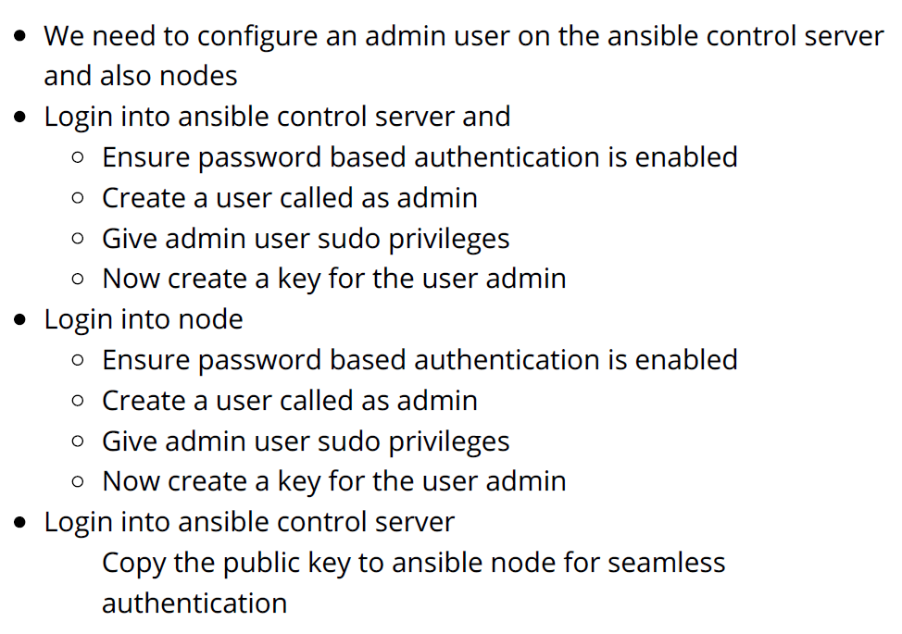

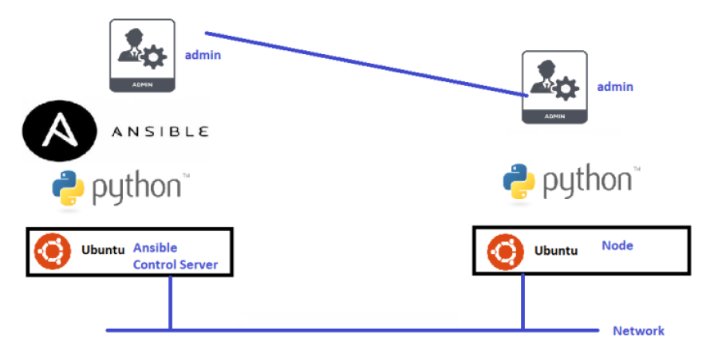

## **Have u written any playbooks**

Yes

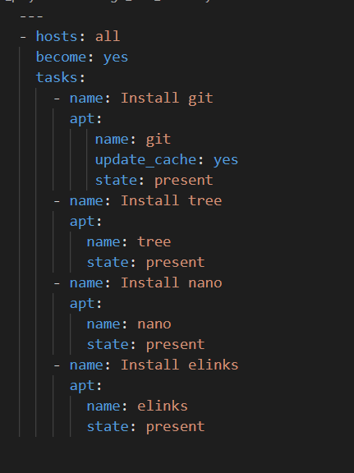

|  |
| --- |
| ---  - hosts: all  become: yes  tasks:  - name: Install git  apt:  name: git  update_cache: yes  state: present  - name: Install tree  aname: tree state: present  - name: Install nano  apt:  name: nano  state: present  - name: Install elinks  apt:  name: elinks  state: present |

## **How to execute a ansible playbook**

# ansible-playbook -i <inventory path> <path to playbook>

## **Ansible playbook -i option**

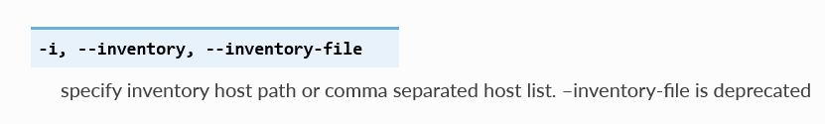

## **Group vars and host vars**

Ansible inventory has

groups: logical collection of hosts

hosts: individual machines ip address/hostname

host can be present in multiple groups

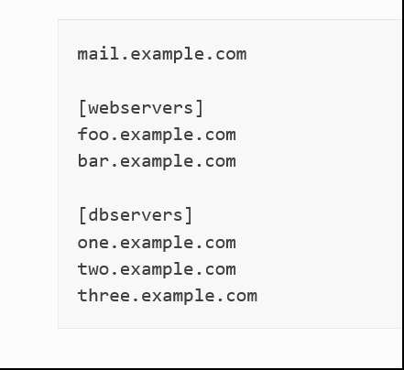

Group vars = variables declared at group level that will be used for every member of that group

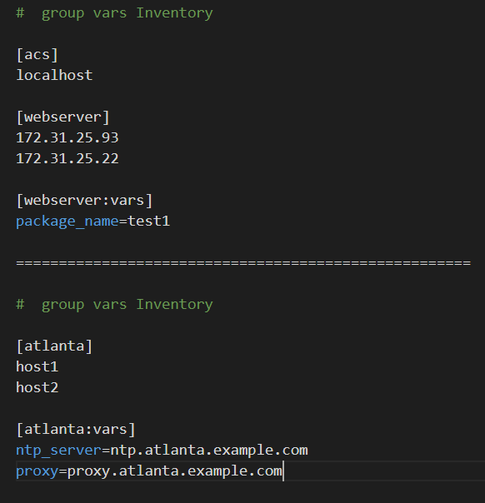

Host vars = variables declared at host level and is only limited to that host

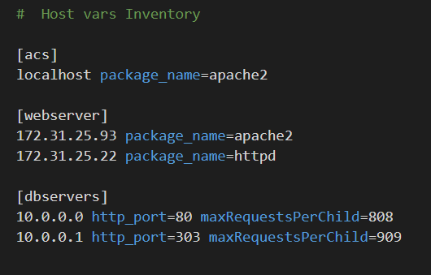

You can also create directories named after your groups or hosts. Ansible will read all the files in these directories in lexicographical order.

Organizing variable can be optimized by creating host_vars and

group_vars folder wherever your inventory is present.

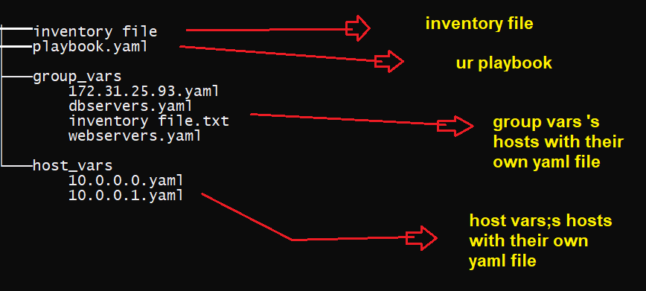

<https://docs.ansible.com/ansible/latest/user_guide/intro_inventory.html#organizing-host-and-group-variables>

## **20 ec2 servers are there , how to deploy in ansible**

1. Using dns hames

Copy the dns names of all those ec2 instances into ur inventory file and run ur playbook

1. Using IP

Since public ip changes everytime when u restart ur ec2 , first run the ec2.py aws dynamic invertory script to get all IP address of ue EC2 servers , and using that dynamic inventory ec2.py script , run ur play book

## **Explain how ansible playbook works**

* User writes declarative stuff in playbooks
* User creates inventory (list of nodes)
* User executes playbook with the inventory
* Now ansible converts the playbook into python objects
* With the user credentials configured ansible log’s using (ssh/any other communication protocol) and executes the converted python code and displays the result to the user.

## **Tomcat is hosted on 8080 on remote ex2 , we want it hosted on 5000 how to write playbook for that**

We will use ansible templates here

Lets say we are changing tomcat port 8080 to 8090. To do this edit here

/var/lib/tomcat8/conf/server.xml

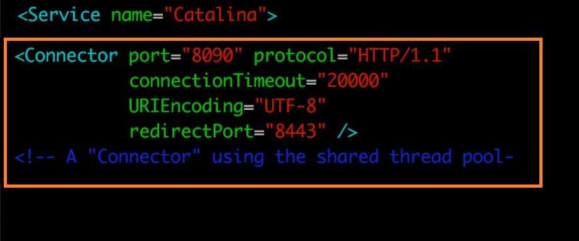

Save this content into server.xml.j2 and write ur playbook

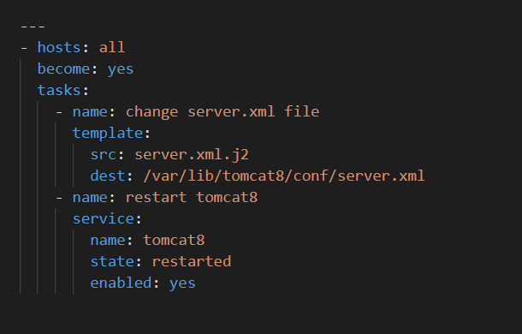

## **Explain ansible templates**

In Ansible we use Jinja templating for updating configuration files,

properties files etc during Deployments

Scenario: Write an Ansible Playbook to create a file called as Readme.txt

with the following content

#==============================================================

Hello,

This file is created using Ansible Automation.

The operating system family = <>

Operating system = <>

#==============================================================

For this we would be using Jinja2 templates in Ansible

Create a file called as readme.txt.j2 with following content

#==============================================================

This file is created using Ansible Automation.

The operating system family = {{ ansible_os_family }}

Operating system = {{ ansible_distribution }} {{ ansible_distribution_version }}

Thanks from {{ test_user }}

#==============================================================

Now create a playbook with the following content

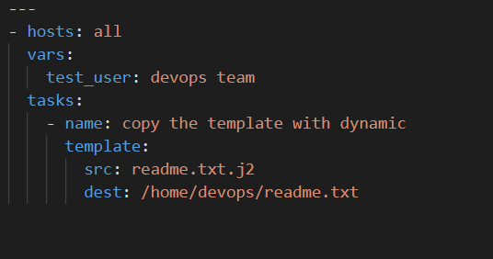

## **How to set up ansible server**

Done above

## **Explain push-based configuration management tool**

In this type of configuration management tool, the main server (where the configuration data is stored) pushes the configuration to the node (hence, the name). So, it is the main server that initiates communication, not the nodes.

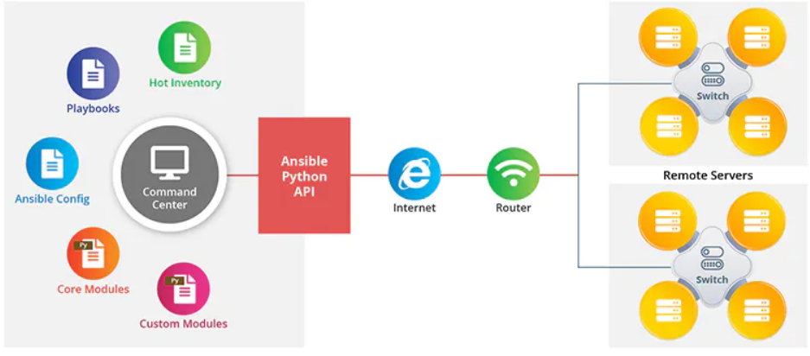



## **Ansible real time scenarios**

## **Write a sample playbook**

Sample playbook to install git , tree, nano, elinks on ubuntu

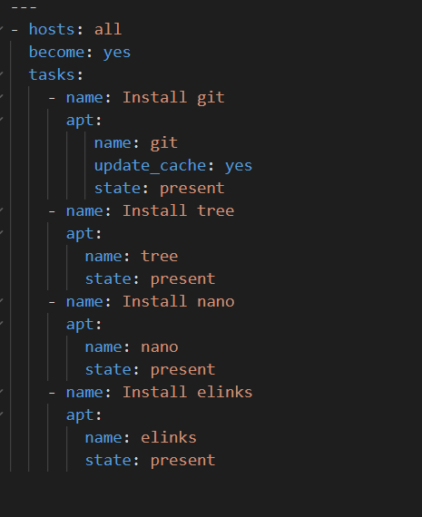

## **Advantage of ansible over chef**

Ansible Pros:

-- no agent

-- easy to use

-- Lower upfront installed dependencies. Chef and Puppet both require chef and puppet installed

on server X. Ansible only requires Python.

-- no need to learn ruby (required in chef)

-- great documentation

## **Explain the ansible architecture briefly**

Ansible works by connecting to your nodes and pushing out small programs, called "Ansible modules" to them. These programs are written to be resource models of the desired state of the system. Ansible then executes these modules (over SSH by default), and removes them when finished.

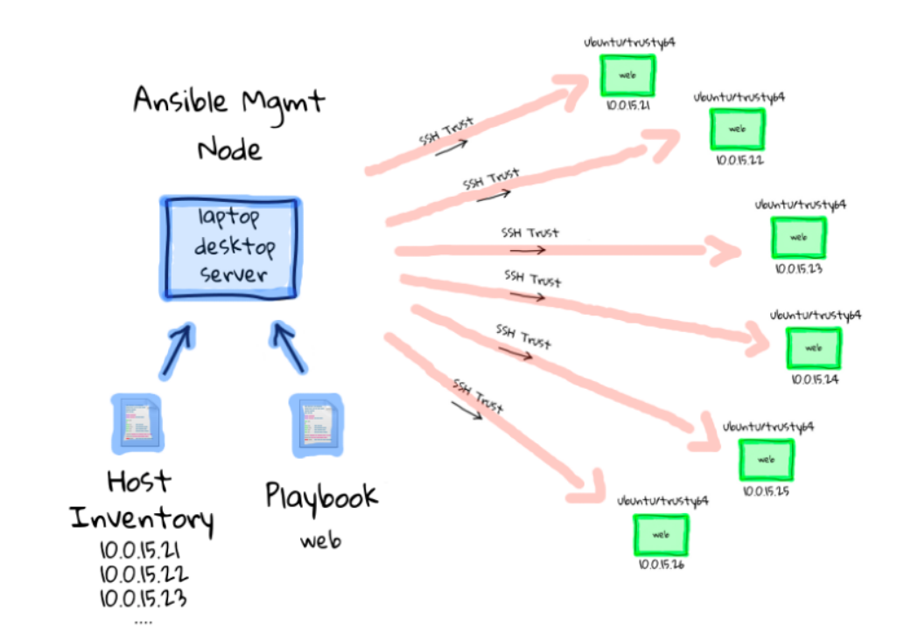

## **How to install ansible in centos and what are the minimum requirements? ( python)**

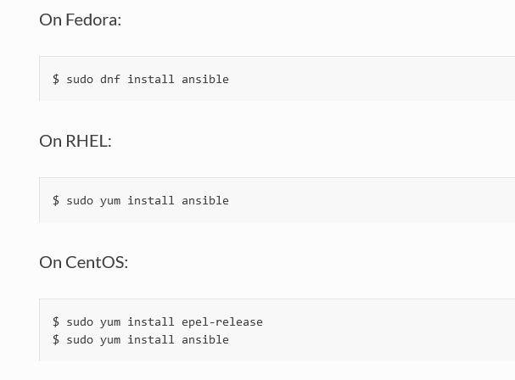

## **What is host key checking? ( see /etc/ansible/host which is default filename and /user/home/.ssh)**

When we ssh first time to any server , it asks us to reply yes or no

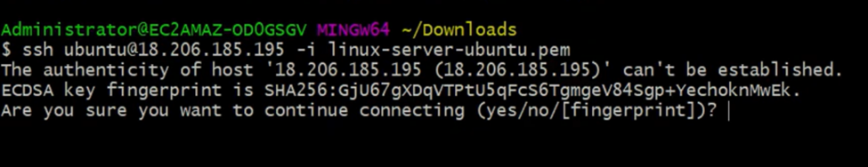

Ansible enables host key checking by default. Checking host keys guards against server spoofing and man-in-the-middle attacks, but it does require some maintenance.

If a new host is not in ‘known_hosts’ your control node may prompt for confirmation of the key

IF u want to disable it go here

/etc/ansible/ansible.cfg as:

[defaults]

host_key_checking = False

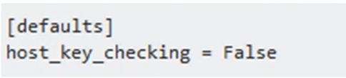

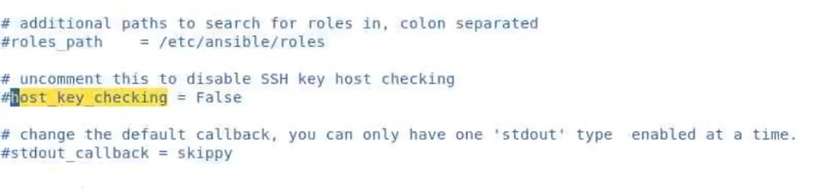

## **Agentless mechanism in ansible**

By operating in an agentless manner over SSH and WinRM, Ansible avoids this problem -- all connections are done over the standard remote-access services that you already have configuration for. Ansible can start managing remote machines immediately, without any agent software installed unlike chef .

## **What are the ansible modules have you used in your projects?**

Ping , Setup , Copy , Yum, Shell, yum , apt , package , Service, Debug, Template , User ,Include Modules

APT AND YUM MODULE – to install packages

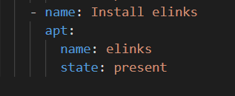

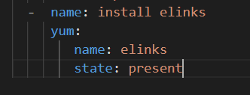

SERVICE MODULE = to enable and restart services

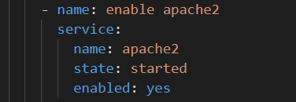

DEBUG MODULE = showing a message

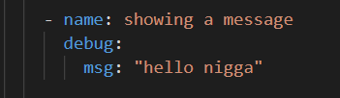

COMMAND MODULE AND DOCKER MODULE = to run linux commands and provisioning docker containeres

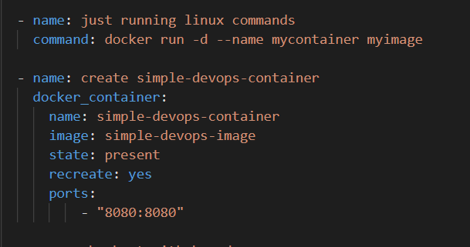

GIT AND COPY MODULE = git for git related stuffs and copy modules copies stuffs

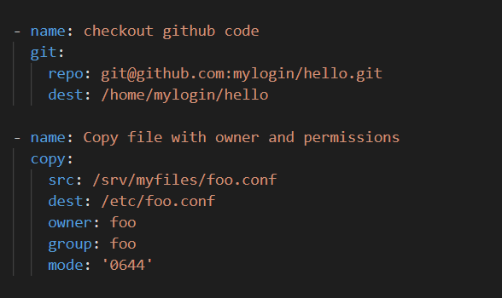

USER AND SHELL MODULE = user modules manages users and shell module is used to run shell scripts

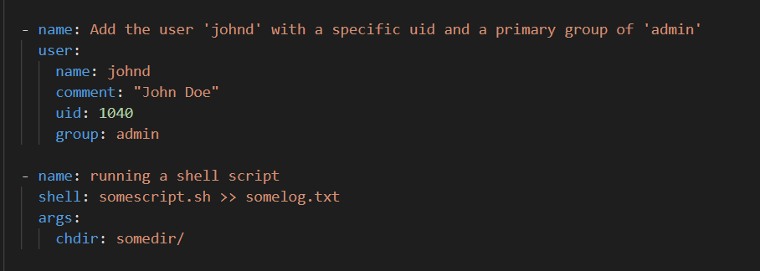

EC2 module = to provision ec2s

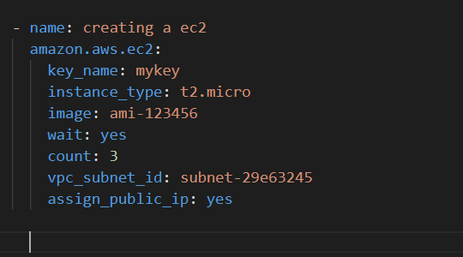

## **How to make changes in a line of a file ( with the use of expressions may be) in ansible? ( scd , from playbooks we can)**

Use lineinfile module

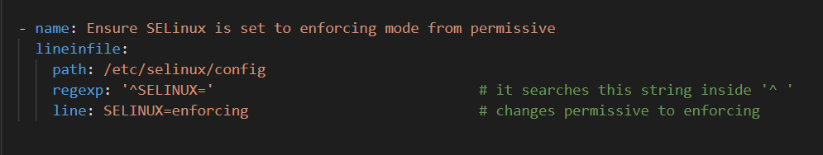

using shell and command module

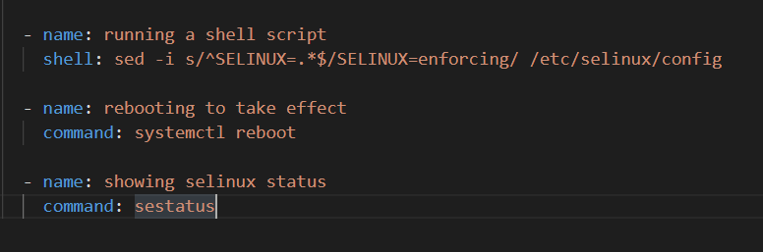

## **Have you worked on ansible roles and galaxy?**

Done below

## **How are you using ansible?**

## **How the link happens betn ansible and Jenkins**

Done in Jenkins

## **How are you using ansible in your current project? ( you can say for configuring upgradation process and deployment)**

## **Have you done any deployment automation?**

## **Why we need adhoc ansible cmds? Give scenario where you have used it?**

Basically they are used to run ansible tasks from commandline . no need to write playbook with multiple tasks . we can run individual tasks from ansible command line only.

You can use any Ansible module in an ad hoc task.

Ad hoc commands are commands which can be run individually to perform quick functions such as rebooting , copying files and stufffffffffffss.

Coz if u want to reboot all ur servers , instead a writing a playbbok for it , use a single line ad-hoc commands for simple use

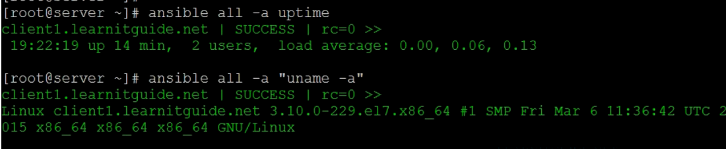

Here uptime and uname are modules

Here is an adhoc command creating user john using user module .

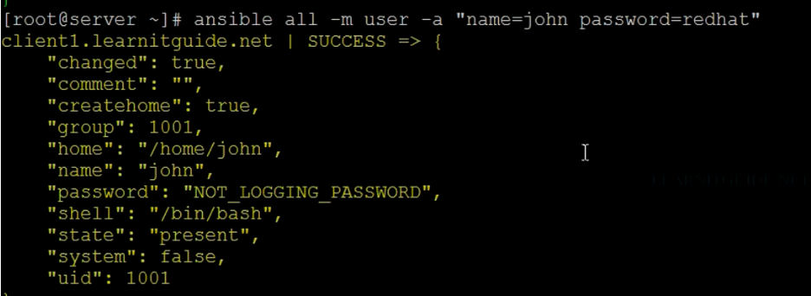

## **Why we need detailed logs on executing ansible playbook? What option we need to use? ( verbose with cmd)**

Whenever executing ansible, ensure you set verbosity whiledeveloping playbooks

ansible-playbook -v <playbook> (shows logs)

ansible-playbook -vv <playbook> ( shows more detailed logs )

ansible-playbook -vvv <playbook> (shows everything)

## **What is ansible.cfg file? ( there are 2 or 3 types)**

ansible ships with a default configuration file. This is the brain and the heart of Ansible, the file that governs the behavior of all interactions performed by the control node. In Ansible’s case that default configuration file is (ansible.cfg) located in /etc/ansible/ansible.cfg.

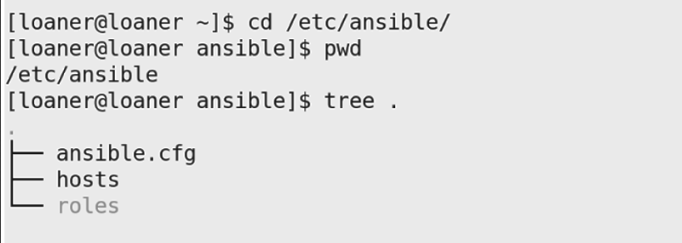

As you can see, the default Ansible configuration file is very large and divided into ten different sections. Each section denoted within the square brackets gives you an idea about this massive configuration file.

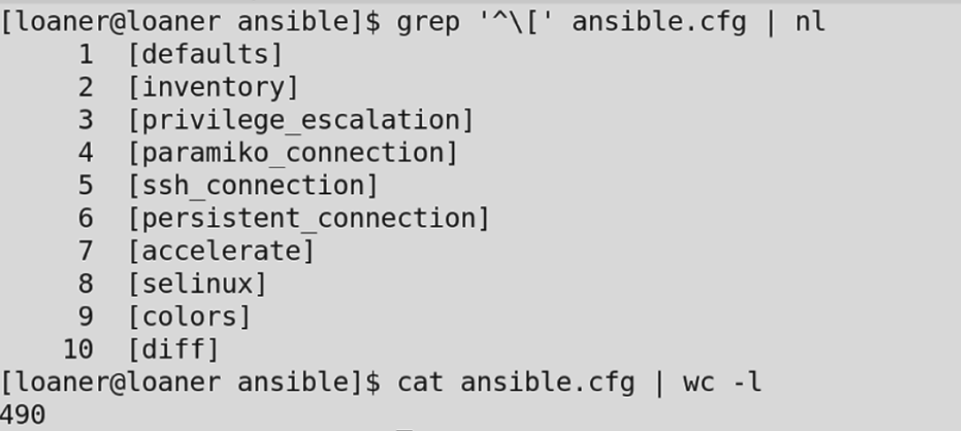

But u can create ur own ansible.cfg file for custom use , (same way u create ur own inventory file instead of using /etc/ansible/hosts ) . just crete a folder and create a ansible.cfg file inside it with following contents

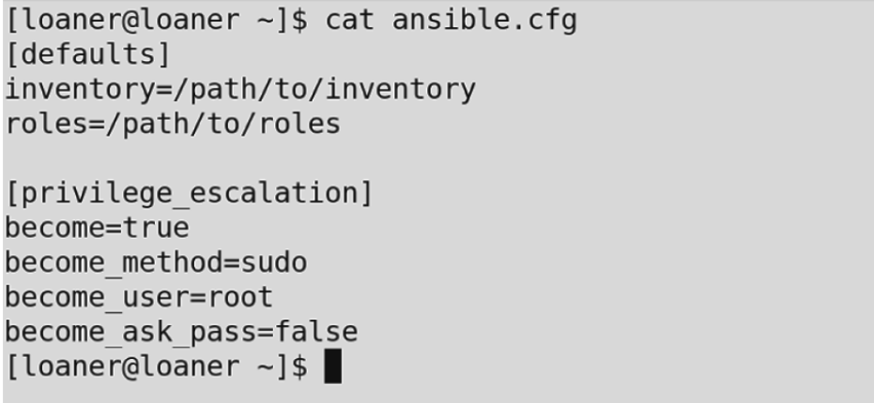

One use case where this might be useful would be managing a web server and a database server. You might need to gather facts from one host and not on the other one. Having an ansible.cfg in the current project working directory can facilitate this behavior. If we’re going to be working with multiple configuration files, it is important to understand the order of precedence on how it chooses its configuration file; we’ll go through them below.

By default Ansible reads its configuration file in /etc/ansible/ansible.cfg , however this behavior can be altered. The recommended practice is either to have an ansible.cfg in your current project working directory

## **What are the modules have you worked on? Which module will you use for getting the file from node to master? ( scenario: If there is a var/jar file or any file in node. So, how to transfer( or copy) from node to master( which module to use)?) ( reverse copy)**

Use copy module or fetch module , both have similar syntax , answered in above questions

## **How to assign tasks to master and nodes or among the nodes ( scenario: 3 tasks on nodes and 2 tasks on master(local machine) ) ? ( playbook)**

To assign tasks on specific node use this

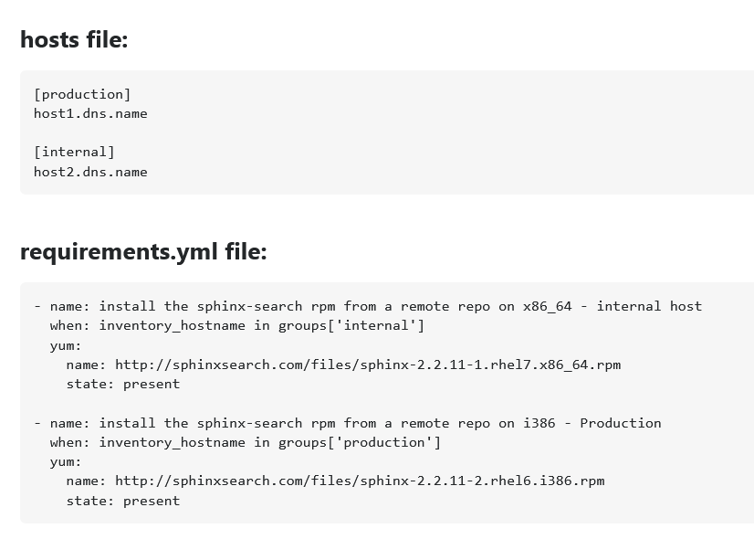

Or use delegate_ to

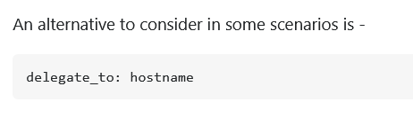

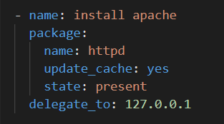

## **What are the basic steps you need to do to create ansible cluster?**

Ansible clustering is done by ansible tower

<https://www.ansible.com/blog/getting-started-installing-ansible-tower-cluster>

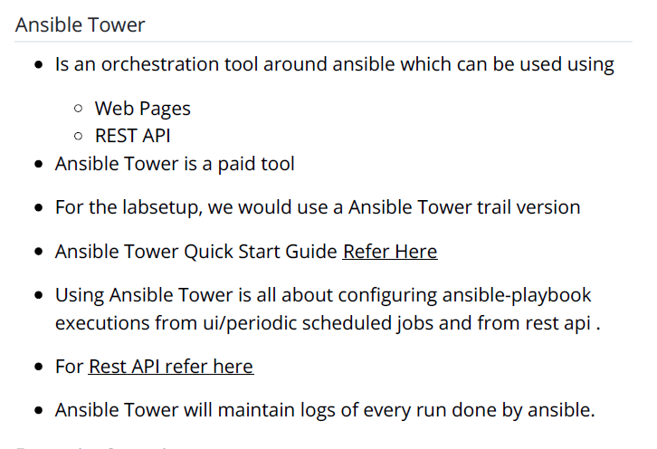

## **Ansible roles. Why we need it?**

Roles are just for providing abstraction . similar to modules in terraform , whenever we need those playbooks we can call them using roles. Create a roles folder once and u can call it infinite times and even u can customize it . it provides reusability

Roles are defined using YAML files with a predefined directory structure. A role directory structure contains directories: defaults, vars, tasks, files, templates, meta, handlers.

An Ansible role has a defined directory structure with eight main standard directories.

Tasks goes to task folder , handlers go inside handlers folder , templates go inside templates folder

So on and so forth.

You must include at least one of these directories in each role. You can omit any directories the role does not use. For example:

<https://docs.ansible.com/ansible/latest/user_guide/playbooks_reuse_roles.html>

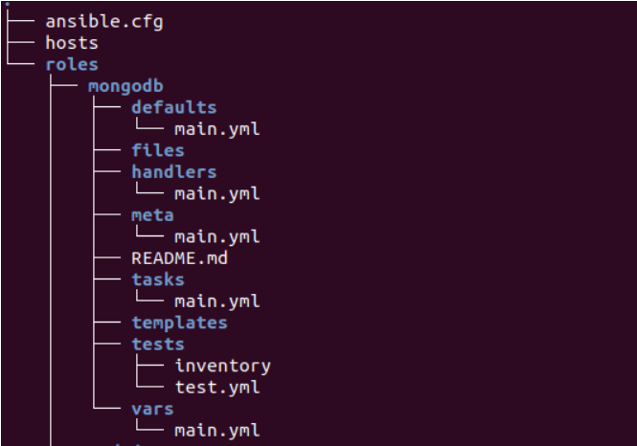

* tasks/main.yml - the main list of tasks that the role executes.
* handlers/main.yml - handlers, which may be used within or outside this role.
* library/my_module.py - modules, which may be used within this role (see [Embedding modules and plugins in roles](https://docs.ansible.com/ansible/latest/user_guide/playbooks_reuse_roles.html#embedding-modules-and-plugins-in-roles) for more information).
* defaults/main.yml - default variables for the role (see [Using Variables](https://docs.ansible.com/ansible/latest/user_guide/playbooks_variables.html#playbooks-variables) for more information). These variables have the lowest priority of any variables available, and can be easily overridden by any other variable, including inventory variables.
* vars/main.yml - other variables for the role (see [Using Variables](https://docs.ansible.com/ansible/latest/user_guide/playbooks_variables.html#playbooks-variables) for more information).
* files/main.yml - files that the role deploys.
* templates/main.yml - templates that the role deploys.
* meta/main.yml - metadata for the role, including role dependencies.

Creating a custom role

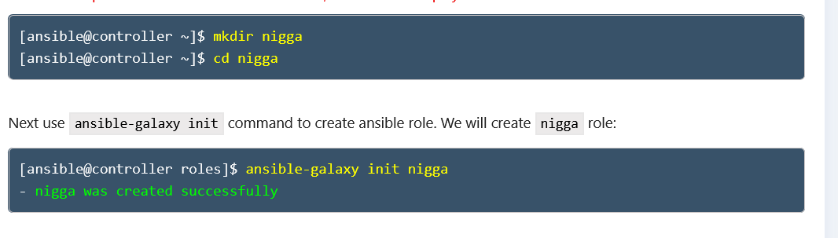

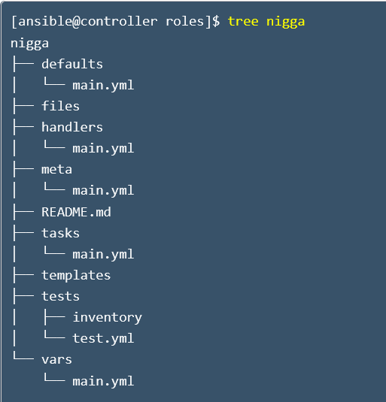

Caliing that role

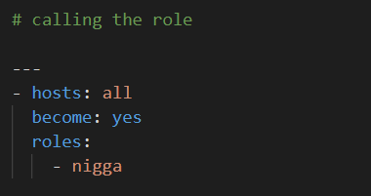

## **Have you worked on ansible galaxy?**

Ansible Galaxy is a repository for Ansible Roles that are available to drop directly into your Playbooks to streamline your automation projects.

* Repository of Reusable Ansible Artifacts
* Lets do a simple expermient of installing of installing nodejs using ansible-galaxy reusable assets.
* Reusability is provided by Ansible Roles.
* Now navigate to ansible galaxy and search for node js and select any role
* Install role using ansible-galaxy command

#ansible-galaxy install geerlingguy.nodejs

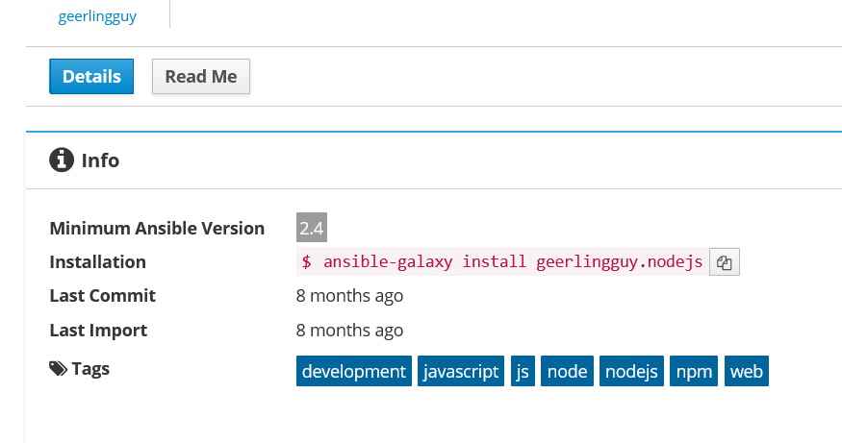

## **Ansible facts,**

Facts

Ansible facts are data related to your remote systems, including operating systems, IP addresses, attached filesystems, and more. You can access this data in the ansible_facts variable

Ansible facts gather information from the node where ansible is executed. These facts contain lot of information some of popular ones are

Operating SYtem

Free Memory

ethernet interfaces

free disk space

To collect facts ansible uses a module called as setup

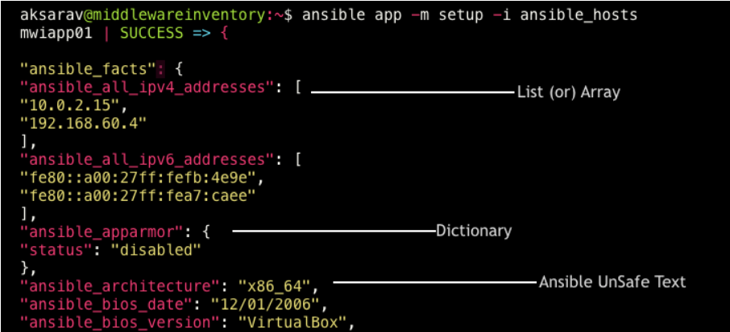

here os name is a fact ,

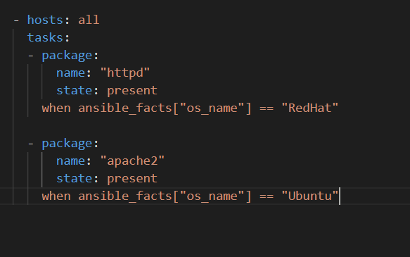

## **Can we have windows machine as ansible master and as a node? List a few.Do we need to do any extra configuration for this?**

Nooooooooooooooooooo,

Ansible cannot run on a Windows host and can only manage Windows hosts,

But Ansible can be run under the Windows Subsystem for Linux (WSL). The Windows Subsystem for Linux is not supported by Microsoft or Ansible and should not be used for production systems

## **Ansible tasks**

Each task executes a module with specific arguments. When a task has executed on all target machines, Ansible moves on to the next task.

A task is executed and has a result (ok, changed, failed).

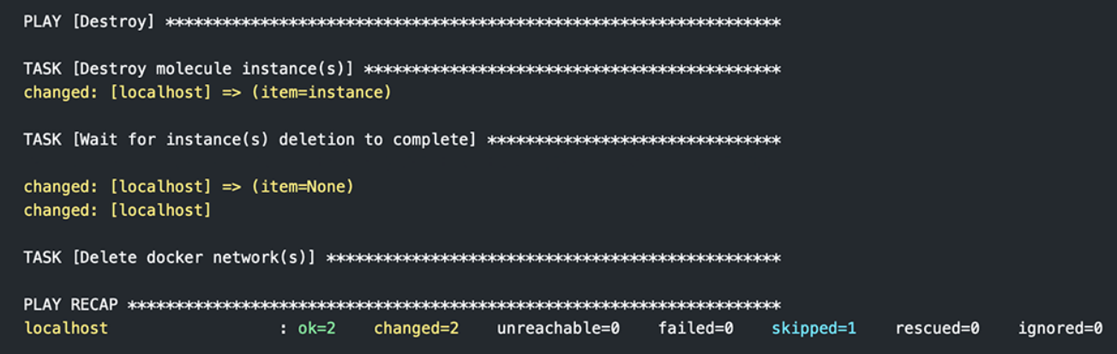

## **Ansible modules**

In Ansible smallest activity (atomic) is called as module . A module is a reusable, standalone script that Ansible runs on your behalf . common modules are , apt , package ,service ,git, file ,shell etc

Every linux commands which you have written find their respective modules in ansible

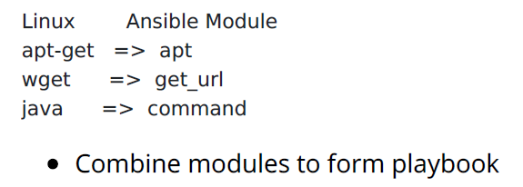

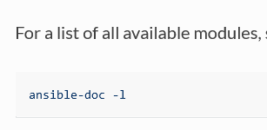

## **Ansible handlers**

Handlers are tasks that only run when notified.

Sometimes you want a task to run only when a change is made on a machine. For example, you may want to restart a service if a task updates the configuration of that service, but not if the configuration is unchanged.

To trigger this handler, you’ll need to include a notify directive in any task

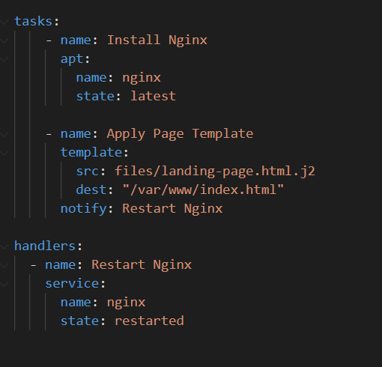

## **Playbook execution**

A playbook contains different tasks to be executed and a task includes modules.

When you run a playbook, it’s the modules that get executed on your hosts, and these modules contain action in them. So, when you run a playbook, those action takes place on your host machines.

Ansible executes tasks in sequential manner , if a task fails , ansible quits.

## **One inventory file in local dir and another in /etc/ansible/hosts.Which precedence is high? /etc/ansible /hosts has higher precedence, if u don’t mention -i tag in ur command , by default ur inventory file in /etc/ansible/hosts will be picked up**

Ansible-playbook -i /path/inventory1 -m playbook.yaml

## **How the master ansible controller machine can communicate with node?**

Via ssh

## **How the inventory works in ansible? Can you run it using domain name?**

Ansible ssh into every nodes , for ssh we need either , dns hostnames or IP address

## **Location of host file, inventory file in ansible configuration.**

This is the default location , but u want make ur own one too

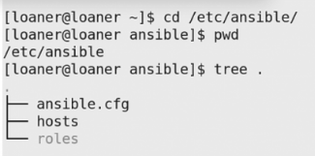

## **Can we call another playbook in one playbook? ( roles , import and include )**

Import

Importing incorporates playbooks in other playbooks statically.

Ansible runs the plays and tasks in each imported playbook in the order they are listed, just as if they had been defined directly in the main playbook.

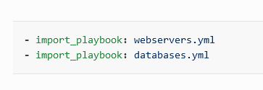

Here wordpress , mongodb and nginx .yml will be executed serially

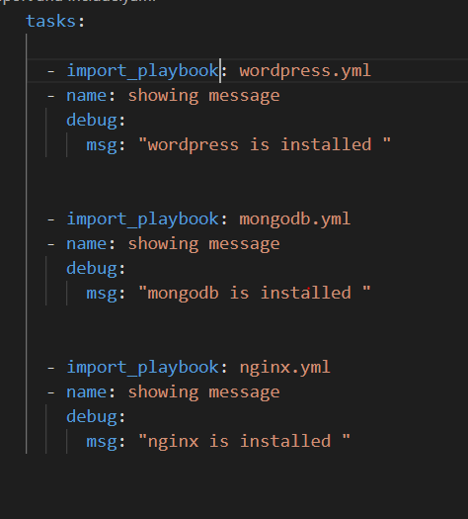

IMPORT IS STATIC

Here all playbooks will be run serially and will be independent of each other . for example

Consider 2 playbooks –

Playbook 1- install nginx and wordpress

Playbook 2 – install nginx

When U IMPORT BOTH OF THEM , playbook 1 will run , then playbook 2 will also also. Playbook 2 will not be skipped even if nginx is installed by playbook 1 .

Include

Include is similar to import but is dynamic

Ansible processes included files and roles as they come up in a playbook, so included tasks can be affected by the results of earlier tasks within the top-level playbook.

Included roles and tasks are similar to handlers - they may or may not run, depending on the results of other tasks in the top-level playbook.

Consider 2 playbooks –

Playbook 1- install nginx and wordpress

Playbook 2 – install nginx

When U use include BOTH OF THEM , playbook 1 will run , then playbook 2 will be skipped . coz nginx is already installed by playbook 1 .

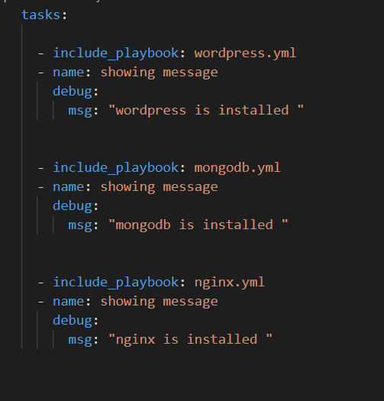

## **what is ansible.cfg file?**

It is the config file of ansible

## **what are the modules have you worked on? which module will you use for getting the file from node to master?**

Done in previous ques

Use fetch module to copy from node to master and copy module to copy from master to node

## **Lets say i have 4 machines consider 1 as ansible master other 3 as nodes, what are the basic setup you need to do for ansible cluster?**

## **Can we have windows machine as ansible master? as node?have you worked on any windows modules? can you list few?any extra configuration do we need to do?**

Ansible don’t work on windows , no I havet done anything windows related

## **What is the best method to make your ansible YAML files reusable?**

Roles , import and include

## **What is ansible vault and ansible tower?**

Ansible Vault is a feature of ansible that allows you to keep sensitive data such as passwords or keys in encrypted files, rather than as plaintext in playbooks or roles. These vault files can then be distributed or placed in source control.

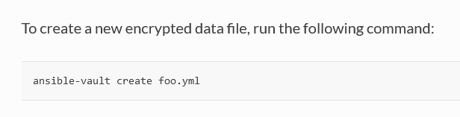

The Ansible Tower dashboard provides a heads-up NOC-style display for everything going on in your Ansible environment.

As soon as you log in, you'll see your host and inventory status, all the recent job activity and a snapshot of recent job runs. Adjust your job status settings to graph data from specific job and time ranges.

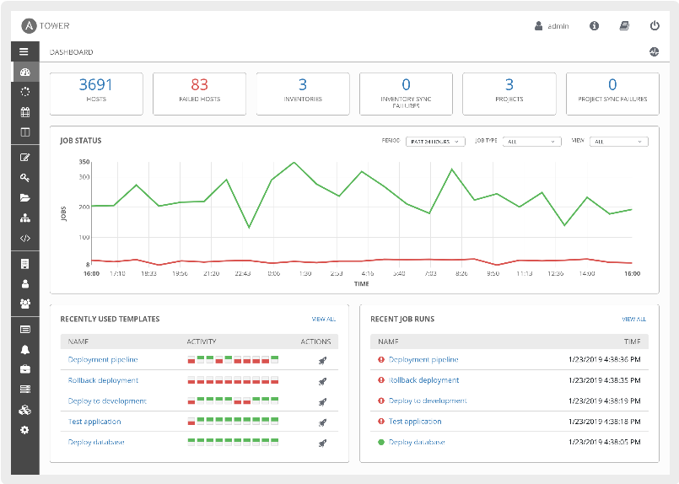

## **Lets say I have playbook need to be run with Root user how would you do this?**

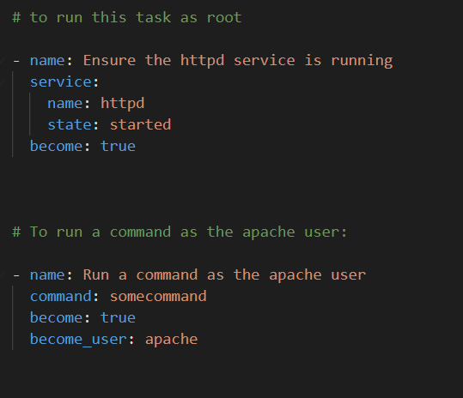

## **Difference between copy and fetch module?**

Copy – copies stuff from master to node

Fetch – copies from node to master

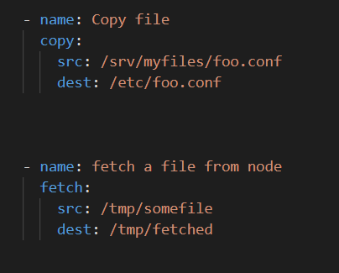

## **Why ansible ? What makes ansible powerful than other tools like chef and puppet?**

## **Can we create custom module ?**

U have to create ur own .py file and copy it to /lib/ansible/modules

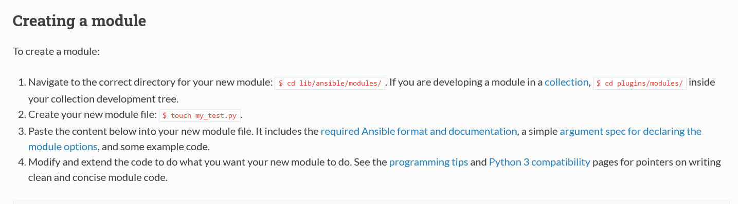

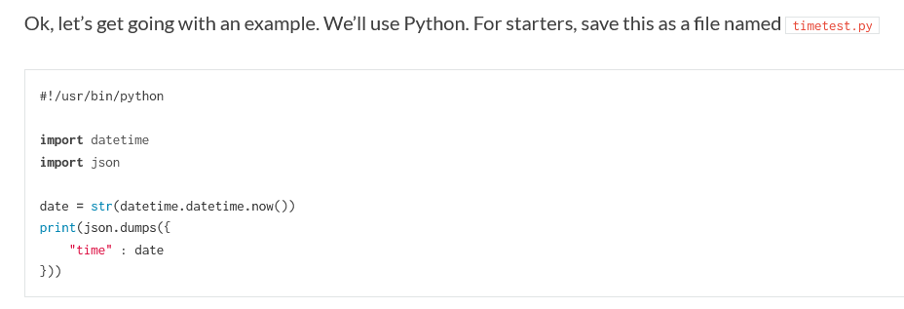

Very complicated stuff

<https://docs.ansible.com/ansible/latest/dev_guide/developing_modules_general.html>

<https://docs.ansible.com/ansible/2.3/dev_guide/developing_modules_general.html>

## **What is dynamic inventory in ansible?**

* Dynamic inventory is a script written in any language which returns a

json file in a particular structure .

* Ansible dynamic inventory is a concept that contains scripts that work as external APIs and pulls the information(facts) of a particular provider.
* The gathered facts will be dynamically dumped into the host file and further, we can create groups of these hosts according to requirement

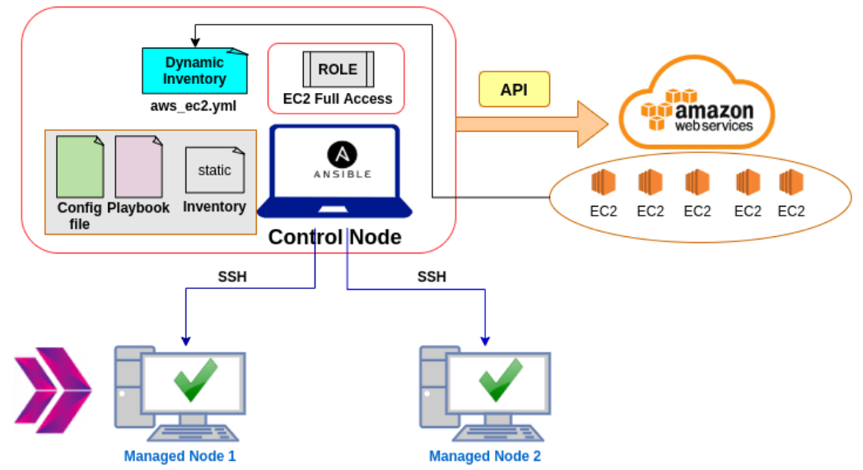

Suppose u have 100 ec2 servers and u don’t know its ip , coz its always changing .

* To fetch their IP , ansible provides ec2.py dynamic inventory script for AWS . U need to download that on ur ansible master .
* Before u run it , create a new ec2FullAccess Role and attach it to ur ansible master ec2 machine , otherwise AWS wont authenticate ur ansible master
* Now run the script ec2.py , it will show u all the data about ur 100 ec2 nodes
* Now execute the playbook with ec2.py ( dynamic inventory ) as ur inventory file

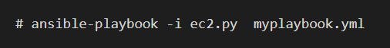

<https://medium.com/devopsjunction/ansible-dynamic-inventory-for-aws-how-to-use-it-3be210dde7>

see this youtube video

<https://www.youtube.com/watch?v=9nn21eHBkXg>

## **Lets say I have both Ubuntu and centos machines as nodes I want install application tree using same playbook, how would you approach this scenario?**

Use yum module to install on centos and apt module to install on ubuntu

But package module will install on both , doesn’t matter if its centos or ubuntu

## **How to handle prompts with ansible playbook?**

If you want your playbook to prompt the user for certain input, add a ‘vars_prompt’ section. Prompting the user for variables lets you avoid recording sensitive data like passwords.

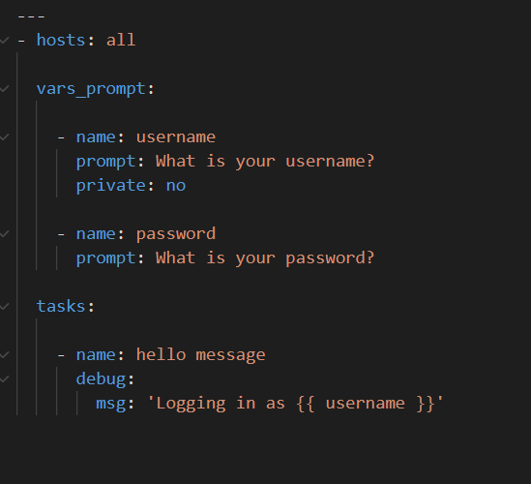

## **You have multiple nodes with different python versions. But a single command must be executed successfully across all of them. How you will achieve it?**

Install python3 with pip on all nodes

## **One of your node SSH key is changed. What needs to be changed for Ansible to connect to it?**

# Docker

## **Explain dockerfile structure**

A *Docker* *Dockerfile* contains a set of instructions for how to build a Docker image. The Docker build command executes the Dockerfile and builds a Docker image from it.

**FROM openjdk:8**

**RUN wget https://myjar.s3.amazonaws.com/spring-petclinic.jar**

**EXPOSE 8080**

**CMD ["java", "-jar", "spring-petclinic.jar"]**

**Dockerfile Instructions**

Instructions are phrases in the Dockerfile with some Behaviors

For complete list of instructions refer here (https://docs.docker.com/engine/reference/builder/)

**FROM** => to choose the base image

**RUN** => execute the command while building the image

**EXPOSE** => to expose ports used by container

**CMD** => command to be executed while container creation

**ADD**=>

The Dockerfile ADD instruction works in the same way as the COPY instruction with a few minor differences:

* The ADD instruction can copy and extract TAR files from the Docker host to the Docker image.
* The ADD instruction can download files via HTTP and copy them into the Docker image.

Here are a few Dockerfile ADD examples:

ADD myapp.tar /myapp/

This example will extract the given TAR file from the Docker host into the /myapp/ directory inside the Docker image.

Here is another example:

ADD http://jenkov.com/myapp.jar /myapp/

**COPY**=> Copies one or more files from the Docker host (the computer building the Docker image

from the Dockerfile) into the Docker image.

The COPY command can copy both a file or a directory from the Docker host to the Docker image.

Here is a Dockerfile COPY example:

COPY /myapp/target/myapp.jar /myapp/myapp.jar

**ENTRYPOINT** => Entrypoint instruction also executes when creating a new container, the differnce with CMD is ENTRYPOINT cannot be overriden.

**WORKDIR** => changes the default directory of the container

**USER** => By default docker container runs as a root user, if you want to create a user and run as that user

**ARG** => is a variable that can be set during image build.

Scope: This ARG value will be available till the image is built

**ENV** => this will be environment variable available in RUN container

These values can be set or changed while the container is created.

**MAINTAINER**=> Used to tell who is maintaining this Dockerfile. Here is an example:

MAINTAINER Joe Blocks [joe@blocks.com](mailto:joe@blocks.com)

**VOLUME=>**

The Dockerfile VOLUME instruction creates a directory inside the Docker image which you can later mount a volume (directory) to from the Docker host. In other words, you can create a directory inside the docker image, e.g. called /data which can later be mounted to a directory, e.g. called /container-data/container1 in the Docker host. The mounting is done when the container is started up. Here is an example of defining a volume (mountable directory) in a Dockerfile using the VOLUME instruction:

VOLUME /data

**HEALTHCHECK**=>

The Dockerfile HEALTHCHECK instruction can execute a health check command line command at regular intervals, to monitor the health of the application running inside the Docker container. If the command line command returns a value of 0 when exiting, Docker considers the application and container to be healthy. If the command line command returns a value of 1, Docker consider the application and container to be unhealthy. Here is a Dockerfile HEALTHCHECK example:

HEALTHCHECK java -cp /apps/myapp/healthcheck.jar com.jenkov.myapp.HealthCheck https://localhost/healthcheck

## **Docker container run commands and its parameters -t -i -d -p , -P**

**-it** is short for --interactive + --tty when you docker run with this command.. it would take you straight inside of the container

$ docker run -it <image> /bin/bash

**-d** is short for --detach which means you just run the container and then detach from it so basically you run container in the background.

Using the **-p** (lower case) flag at runtime lets you publish a container’s specific port(s) to the Docker host. It’s short for –publish.

$ docker run -p <hostPort>:<containerPort> <imageName>

Using the **-P** (upper case) flag at runtime lets you publish all exposed ports to random ports on the host interfaces. It’s short for –publish-all.

$ docker run -P <containerPort> <imageName>

## **How to check list of docker images and how to remove them**

docker image ls

docker image rm <image-id>

## **Diff between dockerization and virtualization**

Virtualization enables you to run multiple operating systems on the hardware of a single physical server.

Containerization enables you to deploy multiple applications using the same operating system on a single virtual machine or server.

Virtual machines are great for supporting applications that require an operating system’s full functionality when you want to deploy multiple applications on a server, or when you have a wide variety of operating systems to manage. Containers are a better choice when your biggest priority is to minimize the number of servers you’re using for multiple applications.

Your use case matters too. Containers are an excellent choice for tasks with a much shorter lifecycle. With their fast set up time, they are suitable for tasks that may only take a few hours. Virtual machines have a longer lifecycle than containers, and are best used for longer periods of time.

## **Explain namespace**

Namespaces are a kernel mechanism for limiting the visibility that a group of processes has of the rest of a system.

Docker uses a technology called namespaces to provide the isolated workspace called the container. When you run a container, Docker creates a set of namespaces for that container. These namespaces provide a layer of isolation.

Docker Engine uses the following namespaces on Linux:

* PID namespace for process isolation.
* NET namespace for managing network interfaces.
* IPC namespace for managing access to IPC resources.
* MNT namespace for managing filesystem mount points.
* UTS namespace for isolating kernel and version identifiers.

## **Explain cgroups**

cgroups, which stands for control groups, are a kernel mechanism for limiting and measuring the total resources used by a group of processes running on a system.

Cgroup is a linux feature to limit, police, and account the resource usage for a set of processes. It provides mechanism to limit and monitor system resources like CPU time, system memory, disk bandwidth, network bandwidth, etc. ... Docker uses cgroups to limit the system resources.

## **When u run a container it prints hello world , we need the output to    show hello nigga, how sort of docker container run parameter to  run**

## **How to manage Environment variables in dockerfile**

**Pass Docker Environment Variables During The Image Build**

Let’s look at all the ways you can pass variables while building a Docker image

**Option 1: Hardcoding Default ENV values**

Fixed ENV values can be good enough in some cases. You can specify a default value right next to your variable definition:

ENV env_var_name=some_value

If your variable values won’t change frequently in the future, you can use this method to configure sane defaults for your future containers. But what if you need to change those values every once and again?

Let’s look at a way to set dynamic ENV values during the build, directly from your command line, without reinventing the wheel.

**Intermission: ARG vs ENV**

To set environment variables during your image build, you will need either ENV or ARG and ENV at the same time.

Docker ENV and ARG are pretty similar, but not quite the same. One of the differences: ARG can be set during the image build with --build-arg, but there is no such flag for ENV. ARG values can’t do the job - you can’t access them anymore once the image is built. The ENTRYPOINT command, which runs inside the future container, can’t access those values.

ENV values are accessible during the build, and afterwards once the container runs. You can set ENV values in your Dockerfile - either by hardcoding them, or in a dynamic fashion.

**Option 2: Setting Dynamic ENV Values**

Hardcoded ENV values can be a tedious solution if they need to be changed often. Imagine having to edit your Dockerfile again and again with each build.

You can do better! Introduce a new ARG variable, and reference it to set your initial ENV variables dynamically during the build:

ARG var_name # you could give this a default value as well

ENV env_var_name=$var_name

the “env_var_name” environment variable value passed with “var_name” will be available to future containers. If needed, you can override it when starting up a container from the image. They are merely default values after all.

**Option 2.5: Using Host Environment Variable Values to Set ARGs**

What if you want to set the ARG value based on a variable in your current environment, without having to type it out each time? You can pass the value directly from your command line using bash command substitution.

$ docker build --build-arg var_name=${VARIABLE_NAME} (...)

The dollar-notation will be substituted with the value of the current environment variable. Alternatively, you can pass the value from the environment automatically, if your variable in the Dockerfile is named the same as the env var in question. Just don’t mention the value, and let Docker look it up:

$ docker build --build-arg var_name (...)

**Gotchas You Should Keep In Mind**

ARG and ENV values are not suitable to handle secrets without extra care. The stick around in your final images (unless you squash or use careful multi-stage builds).

ARG values, both dynamic and hard-coded, can be looked at by other people after the image is built. You can give it a try, with the docker history command on your own image. ENV values can be discovered in many ways, from within the container if they were not overwritten, with the inspect command or from the history as well if they were hard-coded.

To do better, you can use multi-stage builds or some shiny new BuildKit features.

**In Conclusion**

I hope that you’ll have an easier time to set Docker environment variables during the image build from now on. Remember to be cautious when considering ARG and ENV for secrets, as they are not safe. Consider looking into multi-stage builds or using BuildKit to handle build-time secrets.

## **Suppose there are 2 environments , stage and prod, httpd is  running on stage environment as user A and in prod environment its  running as User B , how to address this issue in docker file using environments**

**Dockerfile**

FROM alpine:3.9.5

**ENV** ENV_NAME stage

**ENV** USER_NAME A

USER $USER_NAME

RUN echo $CONT_IMG_VER

CMD echo $ENV_NAME

$docker container run –e ENV_NAME=stage –e USER_NAME=A test:0.5

$docker container run –e ENV_NAME=prod –e USER_NAME=B test:0.5

## **Explain docker**

Docker is a software platform for building applications based on containers — small and lightweight execution environments that make shared use of the operating system kernel but otherwise run in isolation from one another.

Docker uses OS-level virtualization to deliver software in packages called containers. Containers are isolated from one another and bundle their own software, libraries and configuration files; they can communicate with each other through well-defined channels.

## **Instruction in docker file**

Refer Q-1 answer

## **Docker cache**

Docker creates container images using layers. Each command that is found in a Dockerfile creates a new layer. Each layers contains the filesystem changes of the image between the state before the execution of the command and the state after the execution of the command.

Docker uses a layer cache to optimize the process of building Docker images and make it faster.

Docker Layer Caching mainly works on RUN, COPY and ADD commands.

Docker cache the results of the first build of a Dockerfile, allowing subsequent builds to be super fast.

If you do not want to use the cache at all, you can use the --no-cache=true option on the docker build command. Here the build will always start from scratch, writing a new image to the file system even if nothing in the Dockerfile has changed.

## **What is docker image**

A Docker image is a file used to execute code in a Docker container. ... A Docker image contains application code, libraries, tools, dependencies and other files needed to make an application run. When an user runs an image, it can become one or many instances of a container.

## **What is the default httpd port for docker deamon**

port **2376**

Locally, the Docker client uses this socket to communicate with the daemon. -H tcp://0.0.0.0:2376 makes the daemon available via any network interface on port 2376. This port needs to be opened in the security groups (and restricted to a white list of IP addresses if possible) so a remote client can access the daemon.

## **How to get a metadata of a running docker container data**

docker image inspect <image-id>

## **What sort of info docker inspect show**

docker inspect is a command that returns detailed, low-level information on Docker objects. Those objects can be docker images, containers, networks, volumes, plugins, etc.

By default, docker inspect will render results in a JSON array.

**Get an instance’s IP address**

$ docker inspect --format='{{range .NetworkSettings.Networks}}{{.IPAddress}}{{end}}' $INSTANCE_ID

**Get an instance’s log path**

$ docker inspect --format='{{.LogPath}}' $INSTANCE_ID

**Get an instance’s image name**

$ docker inspect --format='{{.Config.Image}}' $INSTANCE_ID

**List all port bindings**

$ docker inspect --format='{{range $p, $conf := .NetworkSettings.Ports}} {{$p}} -> {{(index $conf 0).HostPort}} {{end}}' $INSTANCE_ID

## **How to execute commands in a running container**

$docker exec -it <container name> /bin/bash to get a bash shell in the container

$docker exec -it <container name> <command> to execute whatever command you specify in the container.

## **What is docker swarm**

Docker Swarm is a clustering tool that turns a group of Docker hosts into a single virtual server. Docker Swarm ensures availability and high performance for your application by distributing it over the number of Docker hosts inside a cluster. ... You don't need any additional software tool to create or manage a swarm.

Docker swarm is a container orchestration tool, meaning that it allows the user to manage multiple containers deployed across multiple host machines. One of the key benefits associated with the operation of a docker swarm is the high level of availability offered for applications.

## **How are you using docker in your project?**

Build the app’s container image

In order to build the application, we need to use a Dockerfile. A Dockerfile is simply a text-based script of instructions that is used to create a container image.

Run the application in container using the image

## **How are you going to run a script initially in a container when the cont is getting started ? What to write in a Dockerfile for that?**

Run command in Docker Container only on the first start

**Step 1:**

Create a "myStartupScript.sh" script that contains this code:

CONTAINER_ALREADY_STARTED="CONTAINER_ALREADY_STARTED_PLACEHOLDER"

if [ ! -e $CONTAINER_ALREADY_STARTED ]; then

touch $CONTAINER_ALREADY_STARTED

echo "-- First container startup --"

# YOUR_JUST_ONCE_LOGIC_HERE

else

echo "-- Not first container startup --"

fi

**Step 2:**

Replace the line "# YOUR_JUST_ONCE_LOGIC_HERE" with the code you want to be executed only the first time the container is started

**Step 3:**

Set the scritpt as entrypoint of your Dockerfile:

**ENTRYPOINT ["/myStartupScript.sh"]**

In summary, the logic is quite simple, it checks if a specific file is present in the filesystem; if not, it creates it and executes your just-once code. The next time you start your container the file is in the filesystem so the code is not executed.

## **Diff betn Docker registry and Docker repository**

**A Docker repository is where you can store 1 or more versions of a specific Docker image. An image can have 1 or more versions (tags).**

A Docker image can be compared to a git repo. A git repo can be hosted inside of a GitHub repository, but it could also be hosted on Gitlab, BitBucket or your own git repo hosting service. It could also sit on your development box and not be hosted anywhere.

The same goes for a Docker image. You can choose to not push it anywhere, but you could also push it to the Docker Hub which is both a public and private service for hosting Docker repositories. There are other third party repository hosting services too.

The thing to remember here is a Docker repository is a place for you to publish and access your Docker images. Just like GitHub is a place for you to publish and access your git repos.

**It’s also worth pointing out that the Docker Hub and other third party repository hosting services are called “registries”. A registry stores a collection of repositories.**

**You could say a registry has many repositories and a repository has many different versions of the same image which are individually versioned with tags.**

## **What is docker image tagging?**

Docker tags convey useful information about a specific image version/variant. They are aliases to the ID of your image which often look like this: f1477ec11d12 . It's just a way of referring to your image.

**While Building the Image**

docker build -t <image-name>:<tag-name>

docker build -t tag-demo:my-ubuntu .

**Tagging the Image directly**

docker tag <imageId> <imageName>/<tagName>

docker tag f1477ec11d12 tag-demo/my-ubuntu-2

## **Different states of a docker container.**

There are different stages when we create a Docker container which is known as Docker Container Lifecycle. Some of the states are:

* **Created**: A container that has been created but not started
* **Running**: A container running with all its processes
* **Paused**: A container whose processes have been paused
* **Stopped**: A container whose processes have been stopped
* **Deleted**: A container in a dead state

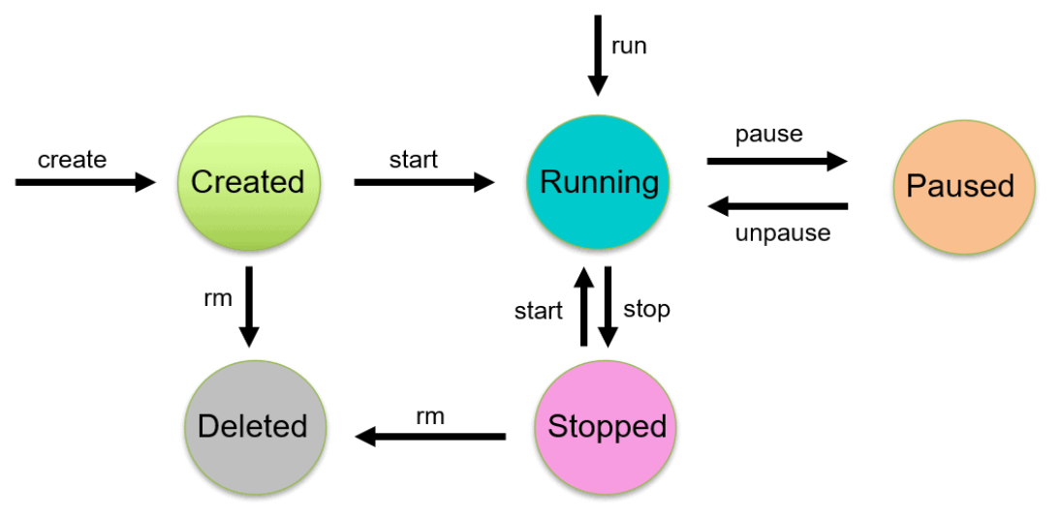

## **What is pause state of cont?**

**The docker pause command suspends all processes in the specified containers.**

On Linux, this uses the freezer cgroup. Traditionally, when suspending a process the SIGSTOP signal is used, which is observable by the process being suspended. With the freezer cgroup the process is unaware, and unable to capture, that it is being suspended, and subsequently resumed. On Windows, only Hyper-V containers can be paused.

$ docker pause my_container

## **How to remove paused cont?**

We can not directly remove a paused container

Steps to reproduce the issue:

Run a container.

# docker run -d ubuntu sleep 1000

acf0571d8fdc581a61428b7e9312b12f378d4d649a55cd6e0c199c597a53596e

Pause the container

# docker pause acf0571d8fdc581a61428b7e9312b12f378d4d649a55cd6e0c199c597a53596e

acf0571d8fdc581a61428b7e9312b12f378d4d649a55cd6e0c199c597a53596e

Remove the container

# docker rm -f acf0571d8fdc581a61428b7e9312b12f378d4d649a55cd6e0c199c597a53596e

Error response from daemon: Could not kill running container acf0571d8fdc581a61428b7e9312b12f378d4d649a55cd6e0c199c597a53596e, cannot remove - Container acf0571d8fdc581a61428b7e9312b12f378d4d649a55cd6e0c199c597a53596e is paused. Unpause the container before stopping

**To delete a paused container, first unpause it and then delete.**

$ docker unpause <container name>

$ docker rm -f <container name>

Stop all the running containers

$ docker stop $(docker container ls –aq)

Removing all stopped containers

$ docker container prune

Stop and remove all containers

$ docker container stop $(docker container ls -aq)

$ docker container rm $(docker container ls -aq)

Delete Container

$ docker stop <container name>

$ docker rm <container name>

$ docker rm $(docker ps -aq)

## **Recommended state to delete a cont**

Stop the container and delete it

## **Explain what u know about docker swarm**

A Docker Swarm is a group of either physical or virtual machines that are running the Docker application and that have been configured to join together in a cluster. Once a group of machines have been clustered together, you can still run the Docker commands that you're used to, but they will now be carried out by the machines in your cluster. The activities of the cluster are controlled by a swarm manager, and machines that have joined the cluster are referred to as nodes.

Docker swarm is a container orchestration tool, meaning that it allows the user to manage multiple containers deployed across multiple host machines. Docker Swarm Helps Guarantee High Service Availability

A given Docker host can be a manager, a worker, or perform both roles.

## **Have u used any docker monitoring tool?**

## **Have u configured any monitoring tool to alert u about an activity in the cluster when a services or anything?**

## **Which cmd to run for running a cmd in a running cont?**

$ docker exec -it <container-name> -- <command-name>

## **About Docker API and CLI**

**Docker Daemon**: A persistent background process that manages Docker images, containers, networks, and storage volumes. The Docker daemon constantly listens for Docker API requests and processes them.

**Docker Engine REST API**: An API used by applications to interact with the Docker daemon; it can be accessed by an HTTP client.

**Docker CLI**: A command line interface client for interacting with the Docker daemon. It greatly simplifies how you manage container instances and is one of the key reasons why developers love using Docker.

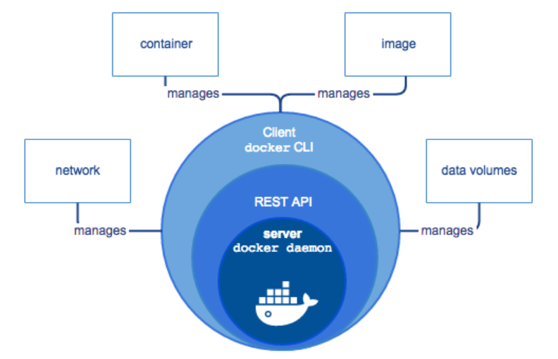

## **What will be your approach if there is any change in dependency ? What would you do or do with your dockerfile?**

## **What is container in docker?**

A container is an runnable instance of an image. You can create, start, stop, move, or delete a container using the Docker API or CLI. You can connect a container to one or more networks, attach storage to it, or even create a new image based on its current state.

A container is a standard unit of software that packages up code and all its dependencies so the application runs quickly and reliably from one computing environment to another. ... Secure: Applications are safer in containers and Docker provides the strongest default isolation capabilities in the industry.

## **Diff betn Docker and hyperviser**

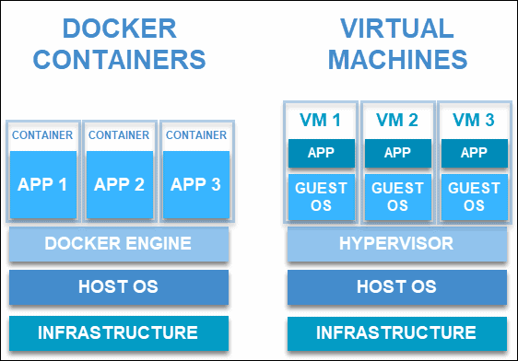

|  |  |  |
| --- | --- | --- |
|  | **Hypervisor** | **Docker** |
| Functioning Mechanism | Hypervisors are of two types – the bare metal works directly on the hardware while type two hypervisor works on top of the operating system. | Docker, on the other hand, works on the host kernel itself. Hence, it does not allow the user to create multiple instances of operating systems.  Instead, they create containers that act as virtual application environments for the user to work on. |
| Number of Application Instances Supported | A hypervisor allows the users to generate multiple instances of complete operating systems. | Dockers can run multiple applications or multiple instances of a single application. It does this with containers. |
| Memory Requirement | Hypervisors enable users to run multiple instances of complete operating systems. This makes them resource hungry.  They need dedicated resources for any particular instance among the shared hardware which the hypervisor allocates during boot. | Dockers, however, do not have any such requirements. One can create as many containers as needed.  Based on the application requirement and availability of processing power, the Docker provides it to the containers. |
| Boot-Time | A hypervisor might consume up to a minute to boot the OS and get up and running. | Docker can create containers in seconds, and users can get started in no time. |
| Architecture Structure | Hypervisor has the host OS and then also has the guest OS further. This creates two layers of the OS that are running on the hardware.  Hypervisors are much more secure since the additional layer helps keep data safe.  Hypervisor hs the capability to run operating systems | Docker engine sits right on top of the host OS.  It only creates instances of the application and libraries.  If you are to run a portable program and want to run multiple instances of it, then containers are the best way to go. Hence you can benefit significantly with a Docker. |
| OS Support | Hypervisors are OS agnostic. They can run across Windows, Mac, and Linux. | Dockers, on the other hand, are limited to Linux only. That, however, is not a deterrent for Dockers since Linux is a strong eco-system. Many major players are entering into the Dockers’ fray. |
|  |  |  |

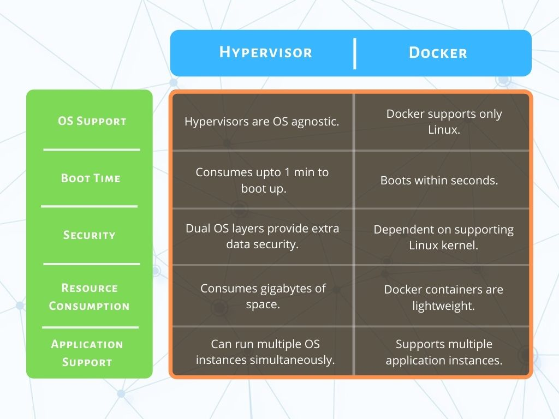

## **Cmd to start and restart a container**

**Starting a Docker Container**

Use the below command to start a Docker container:

# docker run [ OPTIONS ] IMAGE[:TAG] [COMMAND] [ARG...]

For example :

# docker run -it --name=centos7_lab centos:latest /bin/bash

**Restarting a Docker Container**

docker container restart [OPTIONS] CONTAINER [CONTAINER...]

$ docker restart <container_id OR container_name>

## **Explain about the attach cmd of cont in docker**

Attach local standard input, output, and error streams to a running container

Examples:

$ docker run -d --name topdemo ubuntu /usr/bin/top -b

$ docker attach topdemo

## **Why we use docker?**

Docker enables developers to package applications into containers—standardized executable components that combine application source code with all the operating system (OS) libraries and dependencies required to run the code in any environment.

**Benefits of Docker**

* Consistent and Isolated Environment. ...
* Cost-effectiveness with Fast Deployment. ...
* Mobility – Ability to Run Anywhere. ...
* Repeatability and Automation. ...
* Test, Roll Back and Deploy. ...
* Flexibility. ...
* Collaboration, Modularity and Scaling.

## **How to create a Docker Namespace?**

## **How to check the ip addr of Docker?**

docker inspect -f '{{range.NetworkSettings.Networks}}{{.IPAddress}}{{end}}' container_name_or_id

docker inspect <container_ID Or container_name> |grep 'IP'

## **Tell me about Docker Compose.**

Docker Compose is a tool that was developed to help define and share multi-container applications. With Compose, we can create a YAML file to define the services and with a single command, can spin everything up or tear it all down.

A Dockerfile is a simple text file that contains the commands a user could call to assemble an image whereas Docker Compose is a tool for defining and running multi-container Docker applications. ... It get an app running in one command by just running docker-compose up.

Using docker-compose is fine if you are working on a single machine or don't need to distribute containers across multiple inter-connected machines. ... If you just want to manage containers on single machines (even if there are multiple ones), docker-compose is a great tool.

You can set the desired amount of containers counts, their builds, and storage designs, and then with a single set of commands you can build, run and configure all the containers. Docker Compose is great for development, testing, and staging environments, as well as continuous integration workflows.

## **Have you deployed any application and selenium and automation test cases using cont? ( related to QA persons and real time scenario)**

## **Do you know about selenium?**

## **Do you know about x-pass?????????????????????**

## **What happens to data if cont exits?**

By default, all files created inside a container are stored on a writable container layer. This means that:

* The data doesn’t persist when that container no longer exists, and it can be difficult to get the data out of the container if another process needs it.
* A container’s writable layer is tightly coupled to the host machine where the container is running. You can’t easily move the data somewhere else.
* Writing into a container’s writable layer requires a storage driver to manage the filesystem. The storage driver provides a union filesystem, using the Linux kernel. This extra abstraction reduces performance as compared to using data volumes, which write directly to the host filesystem.

Volumes are the preferred mechanism for persisting data generated by and used by Docker containers.Volumes can be more safely shared among multiple containers.

## **What is docker commit(in case of docker stop,exit)?**

docker commit is basically taking a "snapshot" of the current state of the "running" container and save it as an image. This basically means if your "running" container are generating logs files, update packages, or making file changes, they will be saved into the image.

It can be useful to commit a container's file changes or settings into a new image. This allows you to debug a container by running an interactive shell, or to export a working dataset to another server.

## **How will you monitor a docker?**

12 Best Monitoring Tools for Docker

* AppOptics Docker Monitoring with APM. AppOptics provides a robust monitoring solution for Docker containers. ...
* SolarWinds Server & Application Monitor. ...
* Prometheus. ...
* Docker API. ...
* ManageEngine Applications Manager. ...
* cAdvisor. ...
* SolarWinds Librato. ...
* Dynatrace.

## **How to copy something from a cont?**

We can do so using Bind Mounts and Volumes. There's not a lot of difference between the two, except Bind Mounts can point to any folder on the host computer, and are not managed by Docker directly. This will map that folder to the logs subfolder in the user's home directory.

## **Can we use docker in Jenkinsfile as a node?**

Using Docker with Pipeline

Pipeline has built-in support for interacting with Docker from within a Jenkinsfile.

pipeline {

agent {

docker { image 'node:14-alpine' }

}

stages {

stage('Test') {

steps {

sh 'node --version'

}

}

}

}

## **best practices of docker?**

Docker development best practices

* keep your images small.Small images are faster to pull over the network and faster to load into memory when starting containers or services.
* Use multistage builds in Dockerfile
* When building images, always tag them with useful tags which codify version information, intended destination (prod or test, for instance), stability, or other information that is useful when deploying the application in different environments. Do not rely on the automatically-created latest tag.
* Avoid storing application data in your container’s writable layer using storage drivers. This increases the size of your container and is less efficient from an I/O perspective than using volumes or bind mounts.
* Instead, store data using volumes.

## **Diff betn docker kill and docker stop**

docker kill will stop the main entrypoint process/program abruptly. In case of docker kill any pending file system changes that the main process still had in memory will be lost, so the file system might end up damaged.

docker stop will try to stop it gracefully

## **Cmd to list only exited conts?**

The exited filter matches containers by exist status code. For example, to filter for containers that have exited successfully:

$ docker ps -a --filter 'exited=0'

CONTAINER ID IMAGE COMMAND CREATED STATUS PORTS NAMES

ea09c3c82f6e registry:latest /srv/run.sh 2 weeks ago **Exited (0) 2 weeks ago** 127.0.0.1:5000->5000/tcp desperate_leakey

106ea823fe4e fedora:latest /bin/sh -c 'bash -l' 2 weeks ago **Exited (0) 2 weeks ago** determined_albattani

48ee228c9464 fedora:20 bash 2 weeks ago **Exited (0) 2 weeks ago** tender_torvalds

## **Cmd to clean up docker host ( deleting stopped conts, dangling images and unused networks)**

Docker takes a conservative approach to cleaning up unused objects (often referred to as “garbage collection”), such as images, containers, volumes, and networks: these objects are generally not removed unless you explicitly ask Docker to do so. This can cause Docker to use extra disk space. For each type of object, Docker provides a prune command. In addition, you can use docker system prune to clean up multiple types of objects at once.

**Prune images**

$ docker image prune [This will remove all dangling images]

$ docker image prune -a [remove all images which are not used by existing containers]

$ docker image prune -a --filter "until=24h" [remove all images created more than 24 hours ago]

**Prune containers**

$ docker container prune [This will remove all stopped containers]

$ docker container prune --filter "until=24h"

**Prune volumes**

$ docker volume prune [This will remove all volumes not used by at least one container]

$ docker volume prune --filter "label!=keep" [removes volumes which are not labelled with the keep label]

**Prune networks**

Docker networks don’t take up much disk space, but they do create iptables rules, bridge network devices, and routing table entries. To clean these things up, you can use docker network prune to clean up networks which aren’t used by any containers.

$ docker network prune [This will remove all networks not used by at least one container]

$ docker network prune --filter "until=24h" [removes networks older than 24 hours]

**Prune everything**

The docker system prune command is a shortcut that prunes images, containers, and networks. Volumes are not pruned by default, and you must specify the --volumes flag for docker system prune to prune volumes.

$ docker system prune

WARNING! This will remove:

- all stopped containers

- all networks not used by at least one container

- all dangling images

- all build cache

Are you sure you want to continue? [y/N] y

## **Which version of docker are you using and why?**

Current Docker Engine Version: 20.10.7

Docker Engine Version we are using : 19.03.15

A new version of the API is released when new features are added. The Docker API is backward-compatible, so you do not need to update code that uses the API unless you need to take advantage of new features.

## **Can we have multiple cmds in docker file?**

Docker will always run a single command, not more. So at the end of your Dockerfile, you can specify one command to run. Not more.

But you can execute both commands in one line:

**FROM centos+ssh**

**EXPOSE 22**

**EXPOSE 4149**

**CMD service sshd start && /opt/mq/sbin/rabbitmq-server start**

What you could also do to make your Dockerfile a little bit cleaner, you could put your CMD commands to an extra file:

**FROM centos+ssh**

**EXPOSE 22**

**EXPOSE 4149**

**CMD sh /home/centos/all_your_commands.sh**

And a file like this:

**service sshd start &**

**/opt/mq/sbin/rabbitmq-server start**

## **Why will we use docker save and docker load?**

How do I transfer a Docker image from one machine to another one without using a repository, no matter private or public?

docker save

You will need to save the Docker image as a tar file:

**docker save -o <path for generated tar file> <image name>**

**$ docker save -o busybox.tar busybox**

Then copy your image to a new system with regular file transfer tools such as cp, scp or rsync(preferred for big files).

After that you will have to load the image into Docker:

**docker load -i <path to image tar file>**

## **Have you worked on multistage dockerfile and why we need that?**

With multi-stage builds, you use multiple FROM statements in your Dockerfile. Each FROM instruction can use a different base, and each of them begins a new stage of the build. You can selectively copy artifacts from one stage to another, leaving behind everything you don't want in the final image.

Multi-stage builds are a method of organizing a Dockerfile to minimize the size of the final container, improve run time performance, allow for better organization of Docker commands and files, and provide a standardized method of running build actions. A multi-stage build is done by creating different sections of a Dockerfile, each referencing a different base image. This allows a multi-stage build to fulfill a function previously filled by using multiple docker files, copying files between containers, or running different pipelines.

Here is the Dockerfile for the multi-stage build.

**FROM node:10 AS ui-build**

**WORKDIR /usr/src/app**

**COPY WebApp/ ./WebApp/**

**RUN cd WebApp && npm install @angular/cli && npm install && npm run build**

**FROM node:10 AS server-build**

**WORKDIR /root/**

**COPY --from=ui-build /usr/src/app/WebApp/dist ./WebApp/dist**

**COPY package*.json ./**

**RUN npm install**

**COPY index.js .**

**EXPOSE 3070**

**ENTRYPOINT ["node"]**

**CMD ["index.js"]**

## **Can you copy a file from local to a running cont?**

The cp command can be used to copy files.

One specific file can be copied TO the container like:

**docker cp foo.txt mycontainer:/foo.txt**

One specific file can be copied FROM the container like:

**docker cp mycontainer:/foo.txt foo.txt**

For emphasis, mycontainer is a container ID, not an image ID.

Multiple files contained by the folder src can be copied into the target folder using:

docker cp src/. mycontainer:/target

docker cp mycontainer:/src/. Target

**The cleanest way is to mount a host directory on the container when starting the container:**

{host} docker run -v /path/to/hostdir:/mnt --name my_container my_image

{host} docker exec -it my_container bash

{container} cp /mnt/sourcefile /path/to/destfile

## **What happens to the volume if a cont attached to it gets crashed?**

Docker volumes are file systems mounted on Docker containers to preserve data generated by the running container. The volumes are stored on the host, independent of the container life cycle. This allows users to back up data and share file systems between containers easily.

Evenif container crashes, data remains persistent in volume.

## **Cmd to start a cont**

Run the Container in the Foreground

$ docker container run nginx

Run the Container in Detached Mode

$ docker container run -d nginx

Start existing container

**docker container start <CONTAINER_ID>**

## **Cmd to see cont history in docker**

Docker images are constructed in layers, each layer corresponding to a line in a Dockerfile. The history command shows these layers, and the commands used to create them.

**$ docker image history <image-name>**

The primary use case: figuring out why your image is too large

Extracting build arguments: This can be useful for security auditing. For example, you might discover the image made the mistake of using the ARG command for build secrets, thus unintentionally leaking credentials

## **Advantage of docker over any other vm ,server**

Docker: Top 7 Benefits of Containerization

Key Benefits of Docker Containers. ...

* Consistent and Isolated Environment. ...
* Cost-effectiveness with Fast Deployment. ...
* Mobility – Ability to Run Anywhere. ...
* Repeatability and Automation. ...
* Test, Roll Back and Deploy. ...
* Flexibility. ...
* Collaboration, Modularity and Scaling.

## **Why docker is called light weight?**

docker is sometimes described as "light weight" in comparison to virtual machines because it:

* does not boot a separate OS per VM and is therefore faster to start/stop
* In most scenarios requires less disk space due to sharing of common layers across images
* Again due to the image layering, incremental deployments of new app versions are smaller and therefore faster than VMs
* Shares a kernel across containers and therefore uses less memory

## **What -t in docker build cmd?**

This will build the image and tag the resulting image.

$ docker build -t vieux/apache:2.0 . [image-name="vieux/apache", tag="2.0"]

## **Docker volumes(attaching folder cmd)**

Docker volumes are file systems mounted on Docker containers to preserve data generated by the running container. The volumes are stored on the host, independent of the container life cycle. This allows users to back up data and share file systems between containers easily.

A volume is a persistent data stored in /var/lib/docker/volumes/... ... docker volume create creates a volume without having to define a Dockerfile and build an image and run a container. It is used to quickly allow other containers to mount said volume.

You can first create the volume and then start the container or .If you are trying to start a container with a volume that doesn't exist, docker will create a volume for you. Suppose you want to mount a volume (say vol1) into /app/ of the container (say mycontainer1).

You can do this either by using -v or --mount. Here's how you can do it.

$ docker run -d \

--name mycontainer1 \

--**mount** source=vol1,target=/app \

ubuntu:latest

You can achieve the same using -v instead of --mount as shown below:

$ docker run -d \

--name mycontainer1 \

**-v** vol1:/app \

ubuntu:latest

## **Killing conts directly**

**docker kill will kill a container. Stop main process in container abruptly.**

$ docker container kill <my_container> - [Kill my_container]

$ docker container kill $(docker ps -q) — [Kill all running containers.]

**docker rm will clean up a terminated container.**

$ docker container rm my_container — [Delete one or more containers.]

$ docker container rm $(docker ps -a -q) — [Delete all containers that are not running.]

## **Any 3 best practices of docker?**

Best Practices for writing Dockerfiles:

**Use a .dockerignore file**

The best way is to put the Dockerfile inside the empty directory and then add only the application and configuration files required for building the docker image. To increase the build’s performance, you can exclude files and directories by adding a .dockerignore file to that directory as well.

**Containers should be immutable & ephemeral**

The container created with the image produced by Dockerfile should be ephemeral and immutable. In other words, the container should be destroyed and a new one built and put in place with an absolute minimum set-up and configuration.

**Minimize the number of layers / Consolidate instructions**

Each instruction in the Dockerfile adds an extra layer to the docker image. The number of instructions and layers should be kept to a minimum as this ultimately affects build performance and time.

**Avoid installing unnecessary packages**

In order to reduce complexity, dependencies, file sizes, and build times, avoid installing unnecessary packages.

**Sort multi-line arguments**

Sorting multiline arguments alphanumerically will help avoid duplication of packages and make the list much easier to update.

RUN yum update -y && \

yum install -y apache2 \

git \

java \

python

**Build cache**

While building an image, Docker will step through the instructions mentioned in the Dockerfile, executing them in chronological order. As each instruction is examined Docker will look for an existing image layer in its cache that it can reuse, rather than creating a new image layer.

If you do not want to use the cache at all, then use the --no-cache=true option with the docker build command.

**Automatically fix container vulnerabilities in Docker**

* Sign and verify images to mitigate MITM attacks. ...
* Find, fix and monitor for open source vulnerabilities. ...
* Don't leak sensitive information to Docker images. ...
* Use fixed tags for immutability. ...
* Use COPY instead of ADD. ...
* Use metadata labels.

## **Command to list conatiners which state is exited?**

The exited filter matches containers by exit status code. For example, to filter for containers that have exited successfully:s

$ **docker ps -a --filter 'exited=0'**



## **Can we have multiple CMD in Dockerfile?**

At all times, there can be only one CMD. You are right, the second Dockerfile will override the CMD command of the first one. Docker will always run a single command, not more. So at the end of your Dockerfile, you can specify one command to run.

## **Lets say I have 1 GB file that has to be sent to docker daemon, as its 1GB it will take muchtime and network too. By which option while building dockerfile we can send the fileIn better manner?**

What you can do if your Docker image build context too large:

* make sure you don't have unused files in the context (unused files - those that still untouchable during image building);
* add unused files and/or directories to .dockerignore (as mentioned here);
* make sure you specify the right folder as an image build context (as mentioned here);
* try to use BuildKit with DOCKER_BUILDKIT=1 (as mentioned here);
* try to split your project into smaller parts to optimize content of build context;
* if you have a complex project you may want to manually collect all necessary files in separate folder before build and use it as a build context for a specific image.

## **What is the difference between ADD and COPY docker instructions in Dockerfile?**

**ADD**=>

The Dockerfile ADD instruction works in the same way as the COPY instruction with a few minor differences:

* The ADD instruction can copy and extract TAR files from the Docker host to the Docker image.
* The ADD instruction can download files via HTTP and copy them into the Docker image.

Here are a few Dockerfile ADD examples:

ADD myapp.tar /myapp/

This example will extract the given TAR file from the Docker host into the /myapp/ directory inside the Docker image.

Here is another example:

ADD http://jenkov.com/myapp.jar /myapp/

**COPY**=> Copies one or more files from the Docker host (the computer building the Docker image

from the Dockerfile) into the Docker image.

The COPY command can copy both a file or a directory from the Docker host to the Docker image.

Here is a Dockerfile COPY example:

COPY /myapp/target/myapp.jar /myapp/myapp.jar

## **Inside the container I did many changes like Creating, modifying and deleting file but I Wanted to check which files has been changed And what action has been taken what is the Command we need to use ?**

docker image history. Shows the history of an image, including changes made to it and its layers.

## **What does ONBUILD instruction do in Dockerfile?**

An ONBUILD command executes after the current Dockerfile build completes. ONBUILD executes in any child image derived FROM the current image. Think of the ONBUILD command as an instruction the parent Dockerfile gives to the child Dockerfile.

A Docker build executes ONBUILD commands before any command in a child Dockerfile.

The ONBUILD instruction is a tool used when creating images that will become the parameter to the FROM instructions in another Dockerfile. The ONBUILD instruction just adds metadata to your image, specifically a trigger that is stored in the image and not otherwise used. However, that metadata trigger does get used when your image is supplied as the parameter in the FROM command of another Dockerfile. Here is the ONBUILD instruction syntax:

# ONBUILD instruction syntax

ONBUILD [INSTRUCTION]

The ONBUILD instruction is kind of like a Docker time machine used to send instructions into the future. (You might laugh if you knew how many times I just typed Doctor time machine!) Let’s demonstrate the use of the ONBUILD instruction with a simple example. First, we will build an image named my-base using the following Dockerfile:

# my-base Dockerfile

FROM alpine

LABEL maintainer="Earl Waud <earlwaud@mycompany.com>"

ONBUILD LABEL version="1.0"

ONBUILD LABEL support-email="support@mycompany.com" support-phone="(123) 456-7890"

CMD ["sh"]

Next, let’s build an image named my-app that is built FROM the my-base image, like so:

# my-app Dockerfile

FROM my-base:1.0

CMD ["sh"]

## **What is the use of .dockerignore file?**

The . dockerignore file allows you to exclude files from the context like a . gitignore file allow you to exclude files from your git repository. It helps to make build faster and lighter by excluding from the context big files or repository that are not used in the build.

## **I have dockerfile that accepts arguments, if I supply value as “1” then it should use maven 2.x version for base image and if I supply “2” then it should take maven latest as base image**

To use an ARG in your Dockerfile's FROM:

ARG MYAPP_IMAGE=myorg/myapp:latest

FROM $MYAPP_IMAGE

...

Then if you want to use a different image/tag, you can provide it at runtime:

docker build -t container_tag --build-arg MYAPP_IMAGE=localimage:latest .

If you don't specify --build-arg, then Docker will use the default value in the ARG.

Typically, it's preferred that you set the FROM value in the Dockerfile itself—but there are many situations (e.g. CI testing) where you can justify making it a runtime argument.

**if (my_arg==1)**

**ARG MYAPP_IMAGE=maven:2.0**

**if (my_arg==2)**

**ARG MYAPP_IMAGE=maven:latest**

**ARG MYAPP_IMAGE=maven:latest**

**FROM $MYAPP_IMAGE**

**...**

**docker build -t container_tag --build-arg my_arg=1 .**

## **What is docker squash?**

Docker-Squash Is A Utility To Squash Multiple Docker Layers Into One To Create An Image With Fewer And Smaller Layers. It Retains Dockerfile Commands Such As PORT, ENV, Etc.. So That Squashed Images Work The Same As They Were Originally Built. In Addition, Deleted Files In Later Layers Are Actually Purged From The Image When Squashed.

Since it only needs to be run before publishing to a registry, the regular docker build caching is not changed and you don't lose any of the benefits of using Docker.

Building with Squash Option

Now, --squash option is available for the docker build command.

**docker build --squash -t chamilad/testdocker:0.1 .**

If you inspect the resulting Docker image using the docker history command, you will see that although the layers are mentioned, their resulting sizes are 0B and there is an additional layer with a comment similar to format merge sha256:<hash> to <hash> . This is all the previous layers (up to the parent image) being squashed to one layer. With the Union FS layers out of the question, the unified layer can then be used with less storage for the Docker image layers.

## **How Do You Slim Down Docker Images?**

How Do You Slim Down Docker Images?

That’s a good question. Gladly, the answer isn’t too complicated. I watched a talk from Codeship a little while ago, which advocates several steps, which form the basis of the following five steps. Let’s step through them.

**One: Think Carefully About Your Application’s Needs**

Do you genuinely think about the application that you’re deploying? Do you fully consider the language, framework, extensions, tools, and third-party packages which it needs? Or do you install everything, such as development tools and Linux headers, before installing your application?

Bear in mind that everything that you install increases an image’s size, as you’d expect. While it may be easier to work this way (some may argue that it is quick and efficient) is it useful — over the long term?

Alternatively, if you stop and consider your application’s needs in-depth, you may be surprised as to just how little it may need. Sure, you don’t get the thrill of jumping in straight-away and building something. Moreover, you might even see planning as somewhat dull and tedious.

However, remember the old saying: “Proper Planning Prevents Poor Performance”. It’s an adage well worth remembering!

**Two: Use a Small Base Image**

What base image are you using? For quite some time, the default Docker image used Ubuntu, which made sense for several reasons. Let’s consider two of the biggest.

Firstly, Ubuntu’s based on Debian, which uses the Apt package manager. Apt is one of the most well thought out and most feature-rich package managers available. What’s more, its interface is about as intuitive as you can get.

Secondly, Ubuntu is one of the most popular Linux distributions, so its conventions are well understood by a large percentage of developers and systems administrators.

That said, when using Ubuntu as a foundation, your base image won’t be particularly small. Weighing in at around 188 MB, Ubuntu comes packed with most of the tools that you’re likely to need, even if you don’t need them. It’s an excellent example of size being sacrificed for ease of use.

There’s nothing, necessarily, wrong with that, but if you want as small an image as possible, you’re going to have to use a different base image. Luckily, one is readily available and is the new default for Docker images; it’s called Alpine Linux.

Alpine Linux is:

A Small Linux Distribution Based On Musl And BusyBox, Primarily Designed For “Power Users Who Appreciate Security, Simplicity And Resource Efficiency.

As a result, an image based on Alpine Linux is typically around 5 MB in size. That’s a size saving of around 97%!

Compare that to Ubuntu’s size and you can see how making this one change alone is a significant saving. To make it easier, here’s an image size comparison, from Brian Christner:

Docker image size comparison, image by Brian Christner.

See what I mean?

However, changing the default base image isn’t without some cost. The first is that Alpine Linux doesn’t provide much functionality out of the box. As a result, you’re going to have to better understand what your image needs and the dependencies upon which it relies.

The second is that Alpine uses APK instead of Apt. APK, while a little different from Apt, follows similar conventions to other Linux package managers, such as Yum, ZYpp, and Portage. While I’ve been using Apt for over ten years, transitioning to APK wasn’t that difficult, as its commands are pretty intuitive.

That said, if you have scripts for building images, you’ll have to refactor them to use APK commands and package names instead, which will take a little bit of time. However, it should be a, relatively, straight-forward process.

**Three: Use as Few Layers As Possible**

How many layers compose your Docker image? Layers?, you may be asking. If you’re not familiar, every Docker image is composed of several layers, one for each command in a Dockerfile (and those in its base image).

FROM php:7.0-apache

COPY ./ /var/www/html/

RUN chown -R www-data:www-data /var/www/html \

&& chown www-data:www-data /var/www

RUN apt-get -y update

RUN apt-get install -y libmcrypt-dev libzip-dev libpng12-dev libicu-dev libxml2-dev wget build-essential

RUN apt-get install -y git vim

RUN apt-get install -y npm nodejs-legacy

In the example Dockerfile above, the resulting Docker image will be composed of 7 layers, in addition to any layers in the base image. Building Docker images in this way allows Docker to be as efficient as possible.

If a change is made in one layer, then only that layer needs to be changed. Every other layer can be fetched from cache.

That way, build times are as quick as possible.

To know how many layers your image is composed of, and how large they are, run the docker history command, as in the following example:

docker history ze-php7.1.11-alpine

IMAGE CREATED CREATED BY SIZE COMMENT

5e0644e052e4 7 days ago /bin/sh -c #(nop) ENTRYPOINT [“/bootstrap… 0B

6791d155bd2e 7 days ago /bin/sh -c #(nop) EXPOSE 80/tcp 0B

6db0e80c9902 7 days ago /bin/sh -c #(nop) COPY dir:67f62ca0a16622f… 12MB

b53ae8739f99 7 days ago /bin/sh -c chmod +x /bootstrap/start.sh 10.1kB

9fe7fa43babf 7 days ago /bin/sh -c #(nop) ADD file:9fef33a371bdaef… 10.1kB

70949f1e3e70 7 days ago /bin/sh -c mkdir /app && mkdir /app/public… 0B

969f39e455b7 7 days ago /bin/sh -c mkdir /run/apache2 && sed -… 17.8kB

6cfc7b7d4a34 7 days ago /bin/sh -c apk — no-cache update && apk … 70.6MB

946e205f9ff5 7 days ago /bin/sh -c echo “http://dl-cdn.alpinelinux… 149B

7bb295030e89 7 days ago /bin/sh -c #(nop) LABEL maintainer=Paul S… 0B

72dfe9e82e16 3 weeks ago /bin/sh -c #(nop) CMD [“/bin/sh”] 0B

<missing> 3 weeks ago /bin/sh -c #(nop) ADD file:682bfba4bfda1ed… 4.15MB

There, you can see that it’s composed of twelve layers. For each layer you can see:

The layer’s unique hash.

When that layer was created.

The command that created it.

The layer’s size.

If you want to see an image’s combined size, use the docker imagescommand, as in this example:

docker images ze-php7.1.11-alpine

REPOSITORY TAG IMAGE ID CREATED SIZE

ze-php7.1.11-alpine latest 5e0644e052e4 7 days ago 86.8MB

Then there’s the next aspect of how layers work. Referring again to the Dockerfile example above, notice the last three RUN commands. I’ve deliberately split up three calls to apt-get install to highlight this point.

It first installs the required development packages, which subsequent packages depend on. It then installs several system binaries. Finally, it installs the application’s software packages.

Working this way might make sense during development, as the Dockerfile’s easy to read and is ordered logically. However, while it might be logical, it will result in a larger image than if those steps were combined.

Moreover, gets even worse. Do you install packages in one RUN command only to remove them after a following RUN command? You may wonder what the problem is, as the packages are ultimately deleted. Well, no they’re not.

They’re deleted in a later layer — but they still exist in the one where they were installed! You see, anything that exists in one layer isn’t removed in a later one, it’s only covered over, so that following layers can’t see it, and that it appears as though it doesn’t exist.

It gets back to the point about caching that I spoke of earlier.

That’s why:

It’s better not to install a package in the first place if you don’t need it.

Don’t install a package in the first place if you can avoid it.

How we could do this? Well, here are four ways:

Develop the Dockerfile in logically separated blocks, but compact it in the final version.

Don’t create files if you don’t have to — use streams and pipes as much as possible.

Remove unnecessary files, such as cache files, or don’t use the cache in the first place.

If you have to install files, use the smallest one possible.

Let’s see some of those in practice:

# Add basics first

RUN apk — no-cache update \

&& apk upgrade \

&& apk — no-cache add apache2 ca-certificates openntpd php7 php7-apache2 php7-sqlite3 php7-tokenizer \

&& cp /usr/bin/php7 /usr/bin/php \

&& rm -f /var/log/apache/*

Here, you can see that I’ve combined the cache update and upgrade commands with the add command, by doing so, it’s not downloaded any extra files to the filesystem. Then, those commands were combined with the cp and rm command, which took care of some housekeeping and cleared out any unnecessary files.

Do some experimenting and see how you can compact your Dockerfile configurations.

**Four: Use .dockerignore files**

Referring back to the earlier Dockerfile example again, remember that it copied everything in its context into the images /var/www/html directory, in the second command? Are all those files necessary? Could some of them have been avoided?

If so, and it’s likely the case that some could have been, then do so by using [a .dockerignore file. These files, as their name implies, instruct Docker that specific files can be ignored.

If you’re familiar with .gitignore files, then you’ll know what I mean. If not, have a look at the example below.

vendor

.idea

data

mysql

Using this configuration Docker would not copy any files in the vendor, .idea, data, or mysql directories of my project, saving both time and space in the process. .dockerignore files are convenient, and I strongly encourage you to become a whiz with them.

**Five: Squash Docker Images**

The last tip I want to offer is on squashing Docker images.

The idea here is that after your image is created, you then flatten it as much as possible, using a tool such as docker-squash.

Docker-Squash Is A Utility To Squash Multiple Docker Layers Into One To Create An Image With Fewer And Smaller Layers. It Retains Dockerfile Commands Such As PORT, ENV, Etc.. So That Squashed Images Work The Same As They Were Originally Built. In Addition, Deleted Files In Later Layers Are Actually Purged From The Image When Squashed.

The idea is that your image is as small as possible so that when it’s transferred, it’s as quick as is possible. However, while the concept is quite appealing, I was never able to use it effectively.

Perhaps it’s something to do with running it on macOS versus on a Linux distribution, but despite leaving it running for over an hour on a small image, there seemed no end in sight as to when the process would complete.

Given that, while using docker-squash might drastically reduce my Docker image sizes, saving precious time pulling down and pushing up images, this time saving seems outweighed by the time to squash the image in the first place.

However, your mileage may vary, and I’m entirely new to the tool. So if you’ve found success with it, or a related tool, please share your thoughts in the comments.

# AWS

## **Diff between policy and roles in aws**

* User: Given typically to an employee in your to access AWS Resources. Eg: DBA, QA Engineer
* Group: Categorizing users by some name

Eg: Admin, Developer, tester ,DBA

* Role: Given to an AWS Service to get an access on other AWS service in your account. EG: Access to EC2 machine to delete s3 buckets

Ex- s3FullAccess , Ec2FullAcess is a role

* An IAM role is similar to an IAM user, in that it is an AWS identity with permission policies that determine what the identity can and cannot do in AWS. However, instead of being uniquely associated with one person, a role is intended to be assumable by anyone who needs it.



* Policy: JSON document that outlines permissions for users or groups. Authorization in AWS (users,groups, roles) is given by IAM Policies. A policy is an object in AWS that, when associated with an entity or resource, defines their permissions. AWS evaluates these policies when a principal, such as a user, makes a request. Permissions in the policies determine whether the request is allowed or denied.

Bsically policies means which users/grups get which roles assigned.

Two kinds of Policies

AWS Managed Policies

User Managed Policies

* Policies can be created from console using UI options/JSON



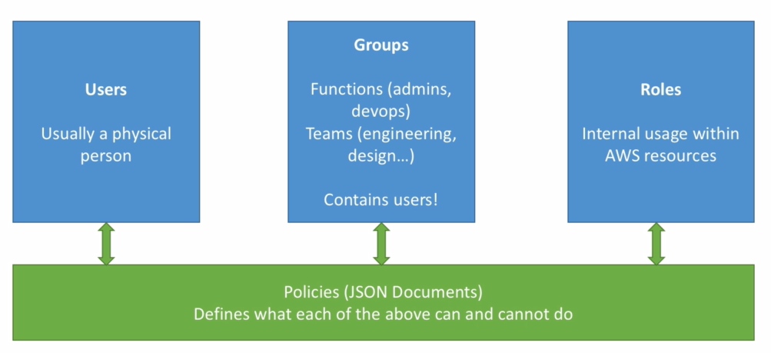

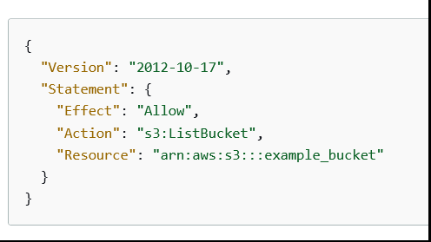

## **What are the IAM Security Tools**

* **IAM Credentials Report (account-level)**

a report that lists all your account's users and the status of their various credentials

* **IAM Access Advisor (user-level)**

Access advisor shows the service permissions granted to a user and when those services were last accessed.

You can use this information to revise your policies.

## **How to access my s3 bucket from my ec2 instance**

Done

## **Have u worked on aws**

## **Ebs volume is mounted on a ec2, we need to encrypt it and sent it to other aws account/region. How to do it**

How to Encrypt root AWS EBS Root Volume

---------------------------------------------------------------

1. Stop the ec2 instance
2. Create the snapshot of that ebs volume
3. Create encrypted volume from that snapshot ( make sure it is present in same AZ as the Ec2 )
4. Detach the existing volume on ec2
5. Attach the new encrypted one
6. Start the EC2 and check ur data

How to send ur volume to other aws account/region

1. Go to IAM , create a custom KMS encryption key , and add your other AWS account to which you want to send the snapshot
2. Stop the ec2 instance
3. Create the snapshot of that ebs volume
4. Create encrypted volume from that snapshot
5. While creating your encrypted volume , don’t used default KMS encryption , use a custom KMS key
6. When Your encrypted volume is created , click on that , go to modify permissions

And add your other AWS account to which you want to send .

<https://www.youtube.com/watch?v=wtwUqKvSZDA>

<https://www.youtube.com/watch?v=1_afazDNVPg>

## **U have a s3 buckets, now developers want to use it , what sort of information/permission will u give them so that they access those buckets**

-- Create a policy and provide the necessary roles for it .

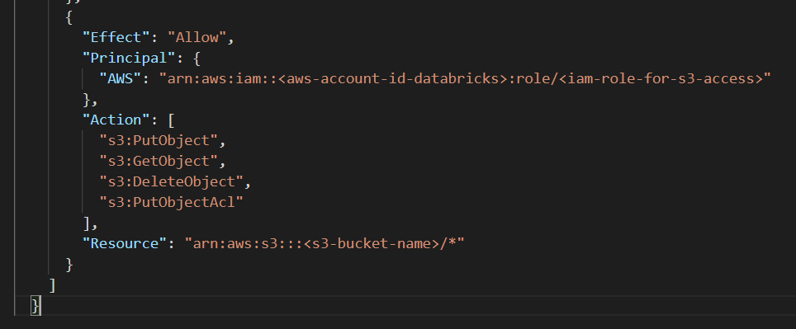

-- After policy is create attach the users to it

-- Restart ur Dev’s Ec2 instances for policy to take effet

## **Lost pem file of my ec2 instance, how do i connect to it now , how to retrieve data from it**

1st step

* First, create a new EC2 instance by creating new key pem file, call it 'helper' instance with same region and VPC as of the lost pem file instance.
* Now stop the lost pem file instance. Remember not to terminate instance but to stop it.
* Go to EBS volumes, select the root volume of the lost pem file instance and detach.
* Now again select the detached volume and this time you have to attach this volume to helper instance which we created before. Since helper instance already has a root volume by default as /dev/sda1, the newly attached volume will be secondary(eg: /dev/sdf).
* Login to your helper instance with its pem file.
* Execute below commands:

# mount /dev/xvdf1 /mnt

# cp /root/.ssh/authorized_keys /mnt/root/.ssh/

# umount /mnt

* Detach the secondary volume from helper instance.
* Again attach the volume back to our recovery instance. Start the instance. Terminate the helper instance.

There are other methods too , follow here

<https://aws.amazon.com/premiumsupport/knowledge-center/user-data-replace-key-pair-ec2/>

## **Diff between placement group and vpc peering**

VPC pering

A VPC peering connection is a networking connection between two VPCs that enables you to route traffic between them using private IP addresses. VPC peering allows you to deploy cloud resources in a virtual network that you have defined.

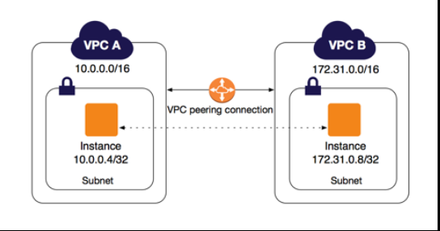

Placement groups

Placement Groups are logical groupings or clusters of instances in the selected AWS region.

When you launch a new EC2 instance, the EC2 service attempts to place the instance in such a way that all of your instances are spread out across underlying hardware to minimize correlated failures. You can use placement groups to influence the placement of a group of interdependent instances to meet the needs of your workload.

Types of placement groups

Cluster –

packs instances close together inside an Availability Zone. This strategy enables workloads to achieve the low-latency network performance necessary for tightly-coupled node-to-node communication that is typical of HPC applications.

Partition –

spreads your instances across logical partitions such that groups of instances in one partition do not share the underlying hardware with groups of instances in different partitions. This strategy is typically used by large distributed and replicated workloads, such as Hadoop, Cassandra, and Kafka.

Spread –

strictly places a small group of instances across distinct underlying hardware to reduce correlated failures.

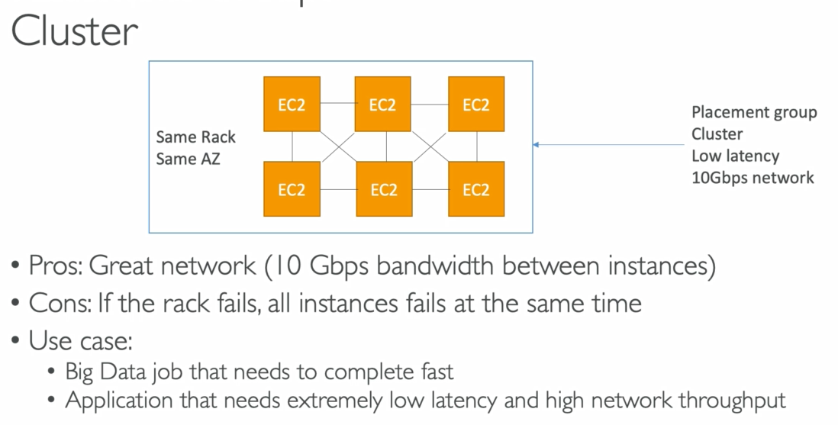

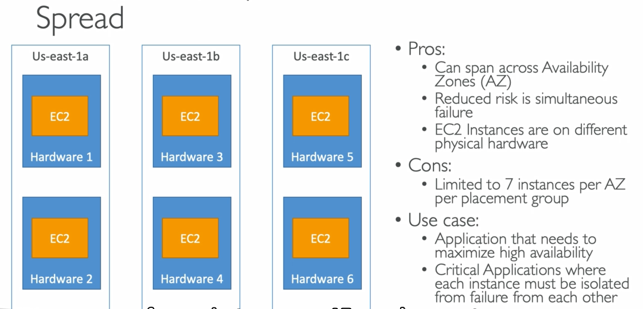

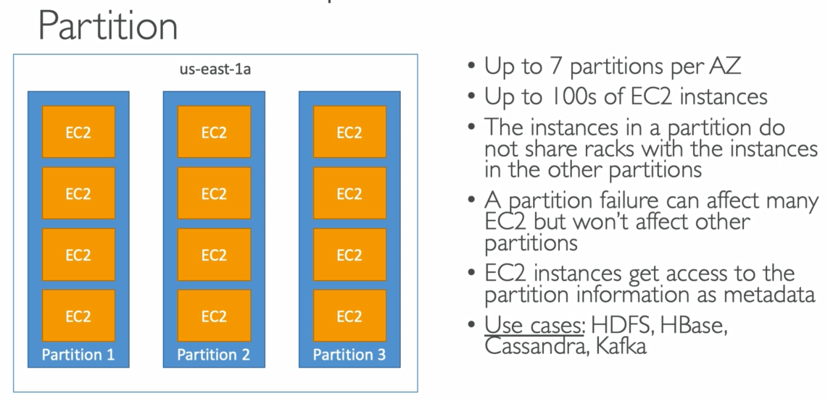

## **Why vpc endpoints are used**

VPC endpoints enables you to privately access specific AWS services from your own Amazon Virtual Private Cloud (VPC), without using public IP addresses and without requiring the traffic data to travel across the Internet.

They remove the need for NAT, IGW etc

Note: VPC endpoints are only supported within the same AWS region.

There are 2 types of endpoints

* Interface endpoint
* Gateway endpoint

## **What did u set up RDS instance**

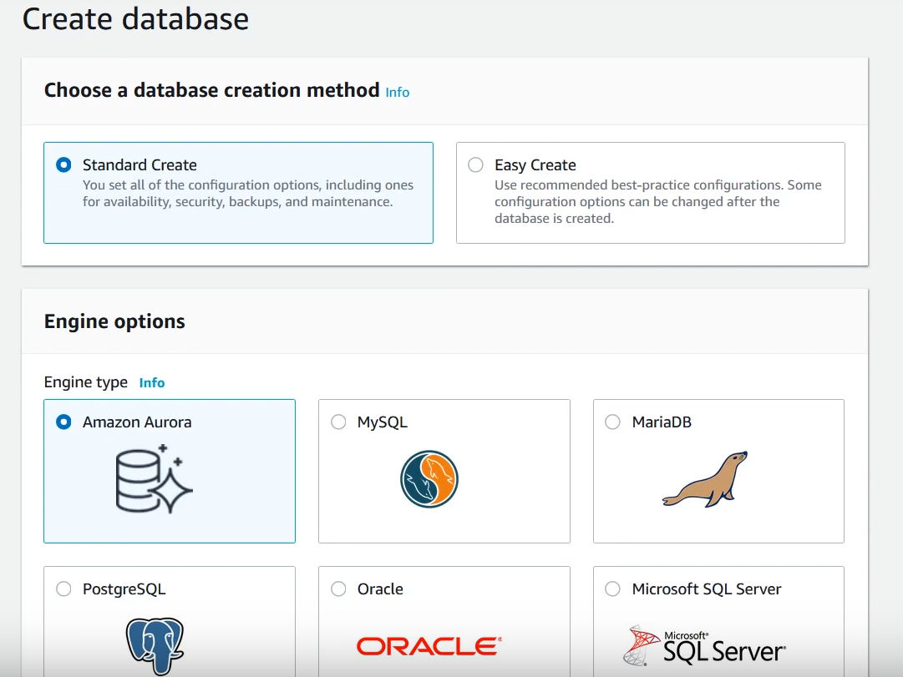

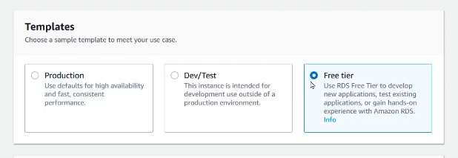

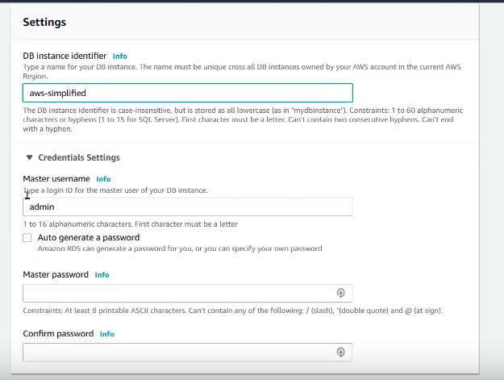

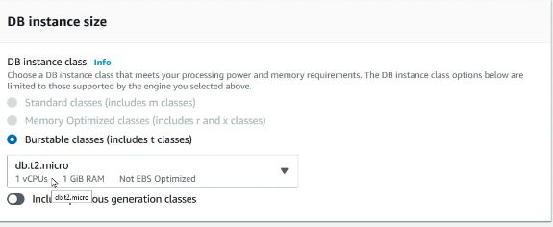

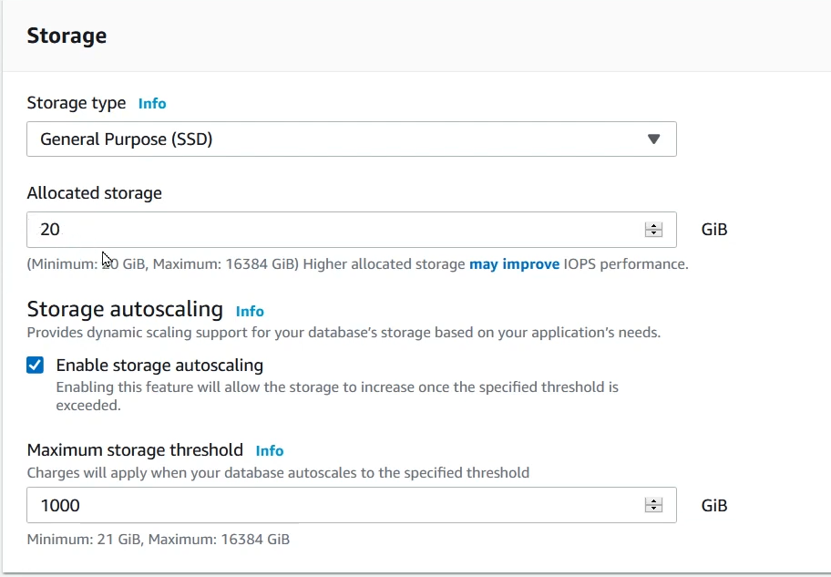

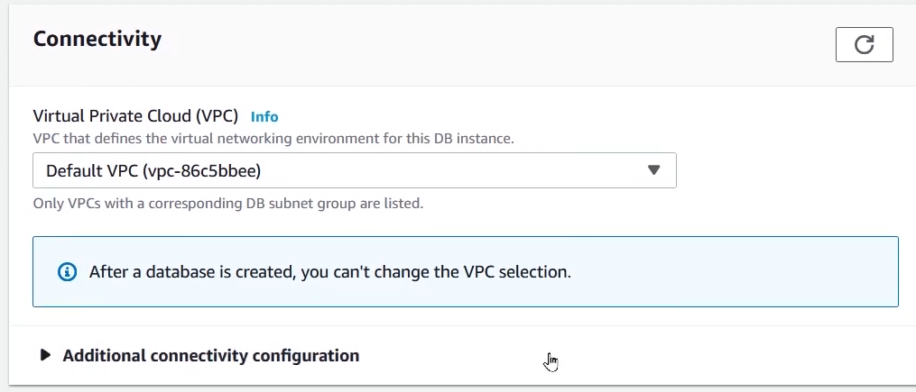

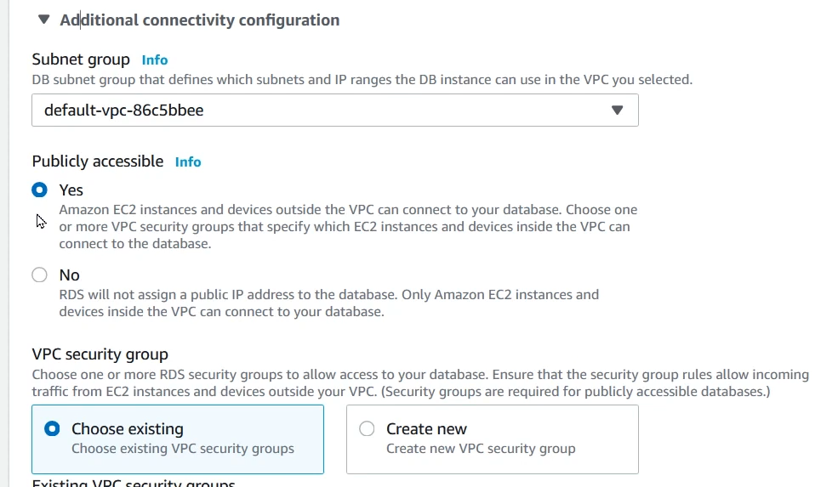

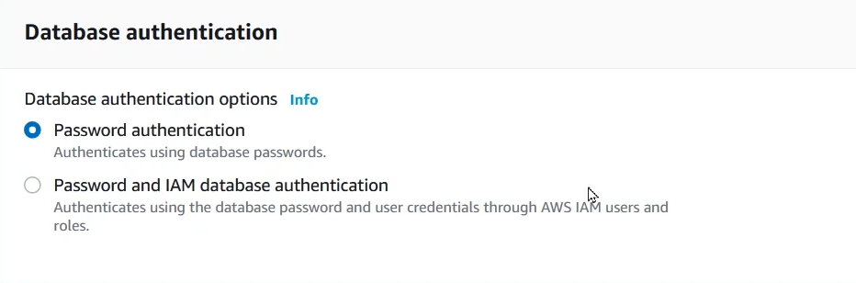

## **What kind of web servers do u use**

We used m5 . 4xl large , 16vCPUs , 64 GB ram

## **How did u determine what size of the RDS instance to be created**

Estimate size of each-

* Estimate size of each table
* Estimate size of each heap
* Estimate size of each clustered and non clustered index
* Estimate no of Read/writes per seconds

## **How are u deploying containers in ECS from Jenkins**

## **If a developer ask u to increase memory of the ec2 instance , how to do**

Stop the instance

Go to instance type and select a high ram instance like t2.large

## **Whats api gateway**

Amazon API Gateway is a fully managed service that makes it easy for developers to create, publish, maintain, monitor, and secure APIs at any scale.

Using API Gateway, you can create RESTful APIs and WebSocket APIs that enable real-time two-way communication applications.

## **Explain some scenarios in which we used api gateway**

We used api gateways while creating lambda functions

API Gateway can block improper requests without invoking the backing Lambda functions.

API Gateway can save Lambda invocation costs this way and can also offload request validation from your Lambda function.

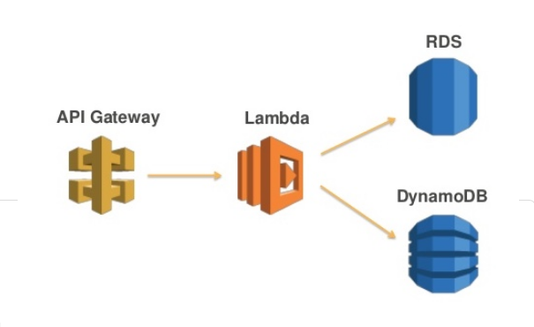

## **Can u write a aws cli command**

Creating a ec2

---------------

#aws ec2 run-instances --image-id ami-xxxxxxxx --count 1 --instance-type t2.micro --key-name MyKeyPair --security-group-ids sg-903004f8 --subnet-id subnet-6e7f829e

Creating a s3 bucket

----------------------------

# aws s3 mb s3://nigga-bucket

## **Give some python boto3 example scripts**

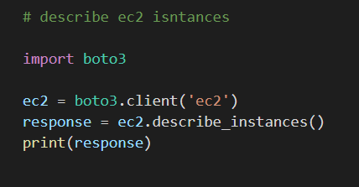

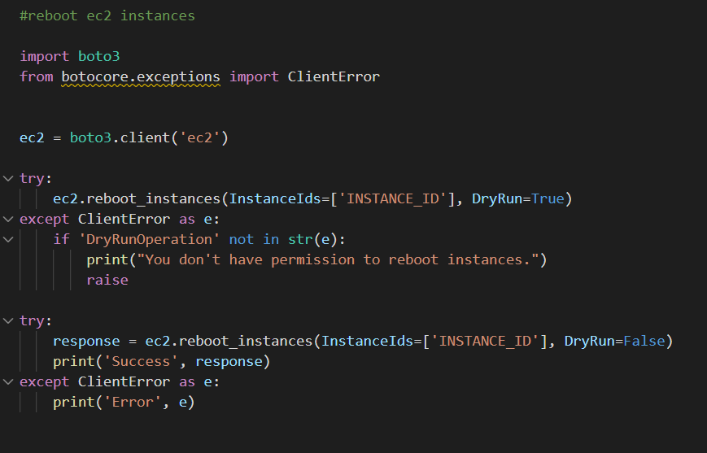

## **How did u set up monitoring in AWS**

We set up cloudwatch metrics, alarms and events

## **What parameters do u monitor in AWS**

CPUUtilization

DiskReadOps

DiskWriteOps

NetworkIn

NetworkOut

CPUCreditUsage

StatusCheckFailed

## **Can u detect a EC2 machine going down based on cloudwatch metrics**

1. Did u set up cloudwatch alarms

Step 1: Go to Alarms section and then click on Select Metric.

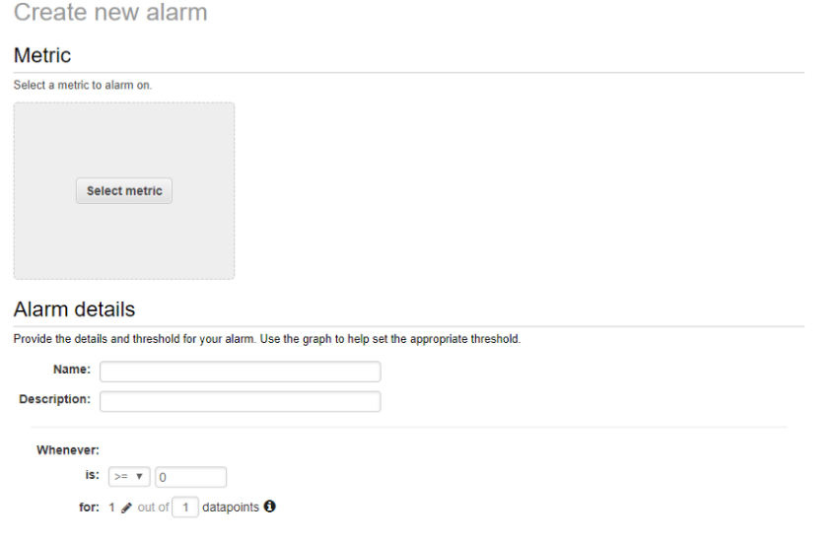

Step 2: One click on the Select Metric button will lead you to the metric selection page, where you can go to EC2> Per-Instance Metric and then click on the corresponding metric against the EC2 instance.

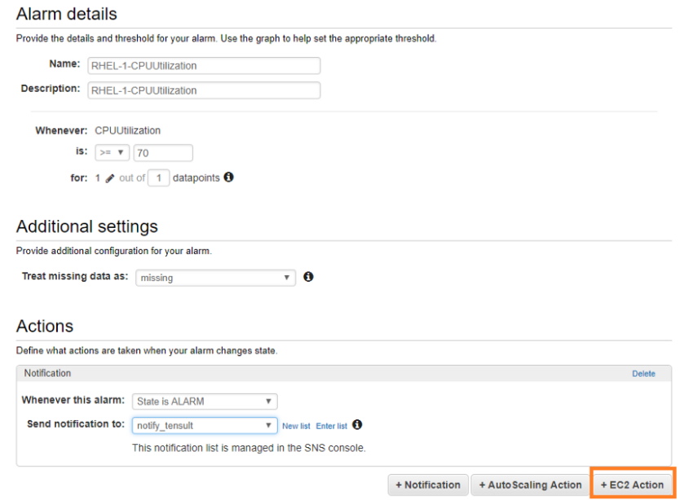

Step 3: You can name the alarm as I have shown above and set the threshold 70%. It means, every time the CPU Utilisation reaches 70% or goes above, we will get a notification. We can also set alarm to go off if the CPU Utilisation goes below a certain number, say 10%. In that case, you can also click on the EC2 Action button and perform an action whenever the CPU Utilisation goes below 10%. For reference, check below screenshot.

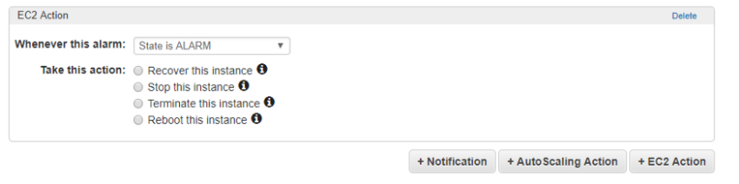

## **Daily tasks u did on AWS?**

## **How to backup jenkin artifacts to s3**

<https://tkssharma-devops.gitbook.io/devops-training/devops-01-continuous-integration/continuous-integration-and-continuous-delivery/ci-cd-using-jenkins-ci/jenkins-ci-cd-with-aws/jenkins-ci-with-s3>

Download the plugin in Jenkins

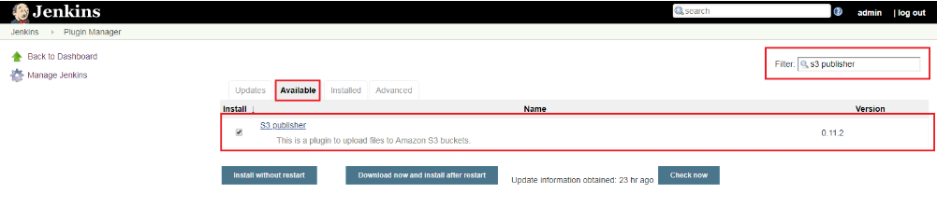

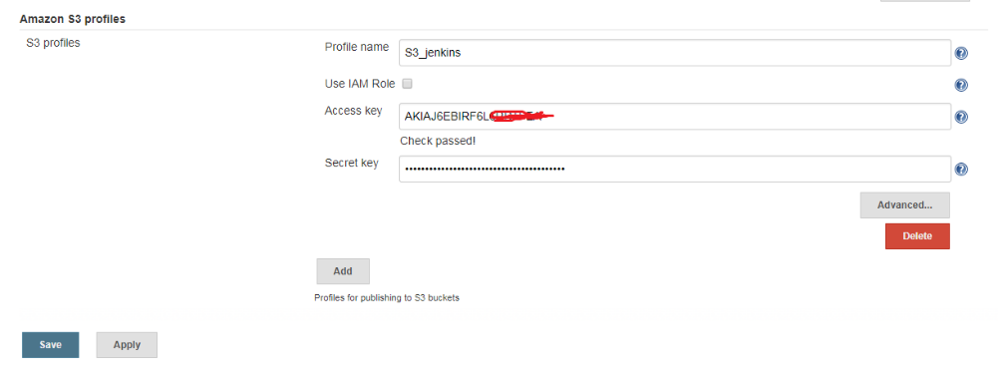

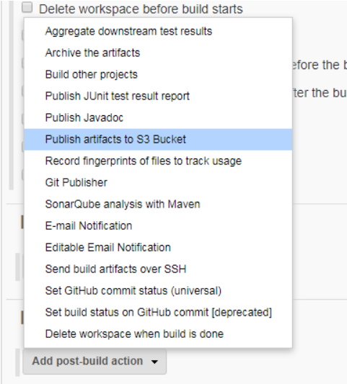

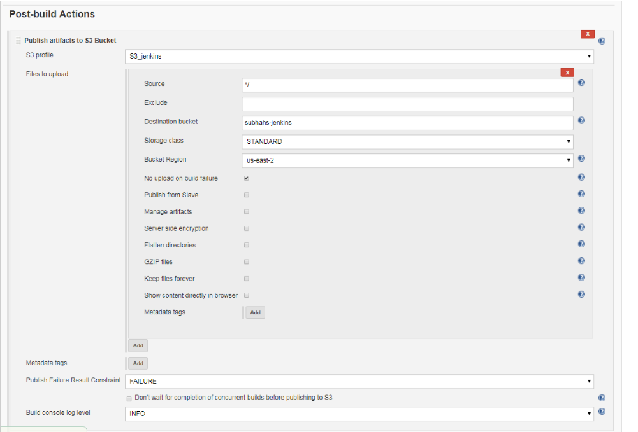

## **Tell about ec2, S3 , loadbalancer and autoscaling**

Ec2 = vm in cloud

S3 = provides object storage device

Loadbalancer = LB automatically distributes incoming application traffic and scales resources to meet traffic demands.

ASG= AWS Auto Scaling lets you build scaling plans that automate how groups of different resources respond to changes in demand. You can optimize availability, costs, or a balance of both. AWS Auto Scaling automatically creates all of the scaling policies and sets targets for you based on your preference.

## **Can I create S3 in ec2?**

Done

## **Have you created any IAM profile?**

Yes

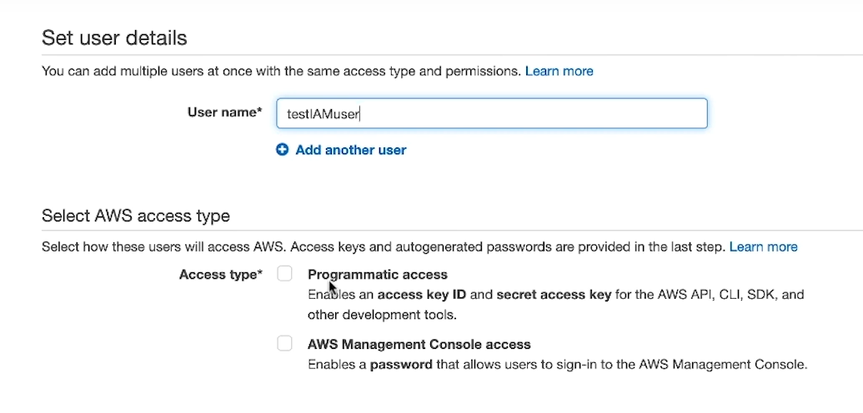

## **Cloudwatch and autoscaling.**

CloudWatch collects monitoring and operational data in the form of logs, metrics, and events, providing you with a unified view of AWS resources, applications, and services that run on AWS and on-premises servers.

AWS Auto Scaling lets you build scaling plans that automate how groups of different resources respond to changes in demand. You can optimize availability, costs, or a balance of both. AWS Auto Scaling automatically creates all of the scaling policies and sets targets for you based on your preference.

## **What services are you using in AWS?**

VPC,EKS,ECS,S3, Cloudwatch,ALB,ASG

## **Process to connect to AWS ec2 instance. ( 3 ways – git bash, cmd , vncp)**

1. Use ssh client like git bash, wsl ,putty
2. Use ec2 browser based ssh client
3. Use seession manager

## **Diff betn policy and roles**

done

## **How can I access S3 bucket from ec2 instance?**

* Create a role with s3fullacess and ec2fullaccess
* Attach that role to ur ec2
* Use aws cli to access s3
* To list buckets

# aws s3 ls

* To create a bucket nigga

# aws s3 mb s3://nigga

* To remove that bucket

# aws s3 rb s3://nigga

* To copy file from locat to s3

#aws s3 cp directory/path s3://nigga

## **Env. Running in AWS ( deployment purpose)**

## **How do you achieve autoscaling in AWS? What components do you need?**

We need following stuufs for asg

1. A laucnch template
2. Min size / max size capacity
3. Network subnet info
4. Load balancer info

launch templates

* Launch templates are newer version of launch configuration
* AWS don’t recommend LC , LC is immutable. Once you define it, you can't edit it. Only a replacement is an option. However, a single LT can have multiple versions
* Launch template include

1. AMI
2. Instance type
3. EBS volume
4. Security group
5. Key pair

* Launch Template (Recommended By AWS) :

1. Allows to edit and update.
2. Maintains versions.
3. Can use T2 unlimited burst feature.
4. Allow provisioning using both On-demand and Spot Instances.
5. Can also be used to launch a standalone instance using AWS Console, SDK and CLI.

## **What is the best way to access particular S3 resources or S3 bucket through ec2 machine?**

Done

## **Any exposure towards cloud formation?**

If you need to deploy more than just a handful of services or applications on AWS, you will quickly discover that it is tedious and time-consuming to set each one up manually.

CloudFormation is an infrastructure automation platform for AWS that deploys AWS resources at a scale much faster, more efficient, and more secure.

## **What is AWS VPC?**

Amazon Virtual Private Cloud (VPC) is a logical data center or virtual data center in Cloud. Its provide an isolated section to host your machine.VPC is a collection of the region, Internet Gateway(IG), Route table, ACL, Security group, Subnet, Instances.

## **What is AMI? ( also about customized AMI)**

Done

## **What is beanstalk in AWS?**

AWS Elastic Beanstalk provides tools to automate background tasks. Elastic Beanstalk employs Auto Scaling and Elastic Load Balancing to scale and balance workloads.

## **Explain terraform script use in AWS.**

Terraform scripts are used for infra automation just as cloudformation

## **What is key pair in AWS?**

A key pair, consisting of a public key and a private key, is a set of security credentials that you use to prove your identity when connecting to an EC2 instance.

Amazon EC2 stores the public key on your instance, and you store the private key.

You can have up to 5,000 key pairs per Region.

## **Two ways to work with terraform script in AWS.**

## **Services used AWS and tasks performed in AWS**

## **What are roles and policies in AWS IAM?**

done

## **Lets say I have 50 users , for all 50 users I need to provide same privileges how do it?**

## **I want to give programmatic access means They can access AWS services via api’s But should not be access AWS web console**

Programmatic access allows you to invoke actions on your AWS resources either through an application that you write or through a third-party tool.

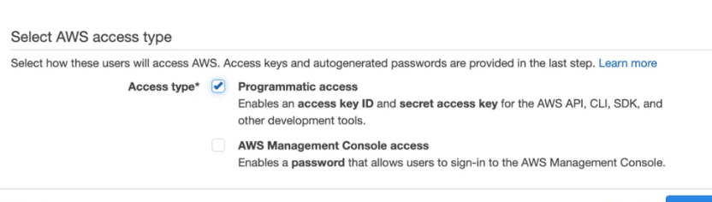

You use an access key ID and a secret access key to sign your requests for authorization to AWS.

## **As AMI is region specific I want create Machine with AMI which there in other Region is that possible?**

* When you launch an instance from an AMI, it resides in the same Region where the AMI resides.
* Similarly , When you create a AMI , it resides in the same Region where the Ec2 instance.
* You can copy ur AMI to different regions and even different accounts too.
* When you first copy an instance store-backed AMI to a Region, we create an Amazon S3 bucket for the AMIs copied to that Region. All instance store-backed AMIs that you copy to that Region are stored in this bucket.

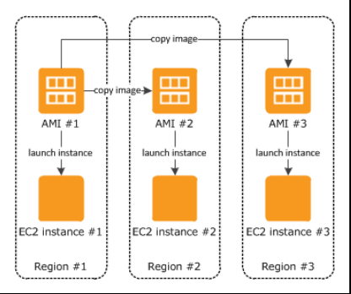

## **Why we need security groups? By default what is outbound rules?**

A security group acts as a virtual firewall for your EC2 instances to control incoming and outgoing traffic

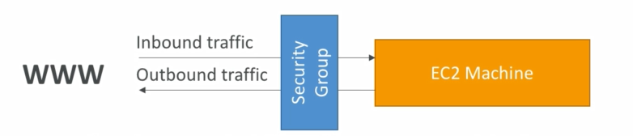

* If you don't specify a security group when you launch an instance, the instance is automatically associated with the default security group for the VPC.
* It is Security at ENI(Elastic Network Interface) Level
* Rules are broken down to two kinds

Incoming (Inbound, Ingress)

Outgoing (Outbound, Egress)

* Here you write rules only for ALLOW
* The following are the default rules for a security group that you create:

Allows no inbound traffic

Allows all outbound traffic ( cant be changed )

* Scope of Security Group is VPC, it means Security Group created for one VPC cannot be used in other VPCs (you need torecreate)

## **What is VPC? Give a brief about VPC?**

Done

## **Have you worked on Load balancers? If Yes, tell which load balancers you have used?**

Yes , mostly we used ALBs

## **Lets say I have created auto scaling rule when ever Load goes more than 60% create a new instance Currently I have 3 machines, 1st machine load is 62% , 2nd machine 30% and 3rd also 30%. Now will auto scale rule creates new machine ?**

## **AWS AMI Instance/Snapshot**

Every single ec2 has a root ebs volume attached to it .

Root EBS Volume is the underlying disk behind EC2.

SNAPSHOT

* EBS Snapshot very often represents a backup of specific EBS volume, it might be any volume (Root volume, data volume, etc.).
* EBS volume is incremental backup , of that pacticaular time , You cant boot from it
* They are used for backup drives of databases and stuffs

AMI

=============

* AMI (Amazon Machine Image) is a backup of Entire EC2 instance.
* When u create a AMI , in the backend a snapshot is created , from which AMI launches

A new EC2.

* AMI = snapshot + all its boot related metadata , kernel related info
* A EC2 instance may have many EBS volume attached. WHEn u create an AMI , it takes backups of those too . ( internally snapshots of all those volumes are created and are linked)
* You cant create AMI of a non root EBS volume , u can only take backup
* Basically used For disaster recovery in case current running EC2 instance corrupted and couldn't run for no reason.
* AMIs can be publicly shared across AWS accounts. (snapshot cant )

## **Where VPCs comes into picture in AWS?**

* At a high level, you can think of a VPC in AWS as a logical container that separates resources you create from other customers within the Amazon Cloud.
* It is you defining a network of your own within Amazon. You can think of a VPC like an apartment where your furniture and items are analogous to databases and instances. The walls of your apartment isolate and protect your things from being accessible to other tenants of the apartment complex.
* Subnets would then be analogous to the different rooms in your apartment. They are containers within your VPC that segment off a slice of the CIDR block you define in your VPC. Subnets allow you to give different access rules and place resources in different containers where those rules should apply. You wouldn't have a big open window in your bathroom on the shower wall so people can see you naked, much like you wouldn't put a database with secretive information in a public subnet allowing any and all network traffic. You might put that database in a private subnet (i.e. a locked closet).

## **Can you change your VPC after instance creation ?**

It's not possible to move an existing instance to another subnet, Availability Zone, or VPC. Instead, you can manually migrate the instance by creating a new Amazon Machine Image (AMI) from the source instance.

## **VPC belongs to region or AZ ?**

Each VPC belongs to a single Region and may contain multiple subnets;

each subnet belongs to a single Availability Zone within that region

## **What is S3 and EC2?**

Ec2 is just a vm running in cloud

Amazon S3 (Simple Storage Service) provides object storage, which is built for storing and recovering any amount of information or data from anywhere over the internet.

## **What are various EC2 Instance Types**

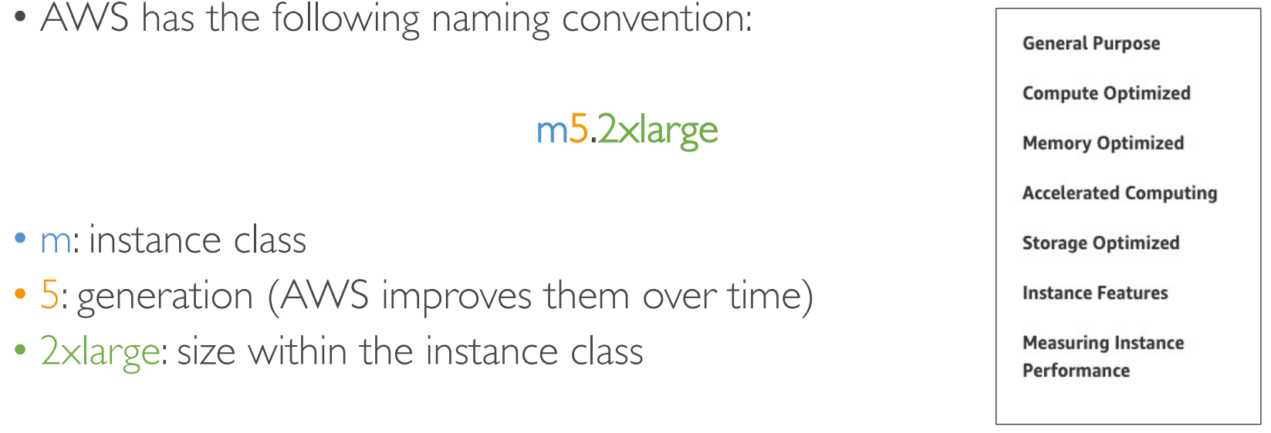

EC2Instances.info Easy Amazon EC2 Instance Comparison

<https://instances.vantage.sh/>

## **How many kinds of storage services in AWS ?**

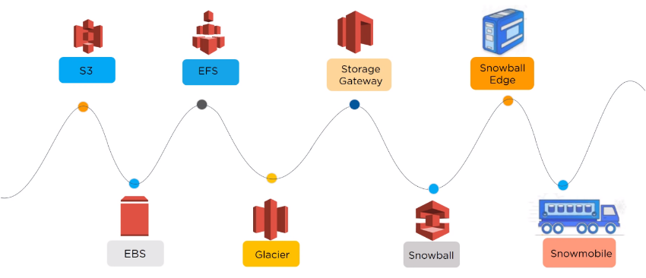

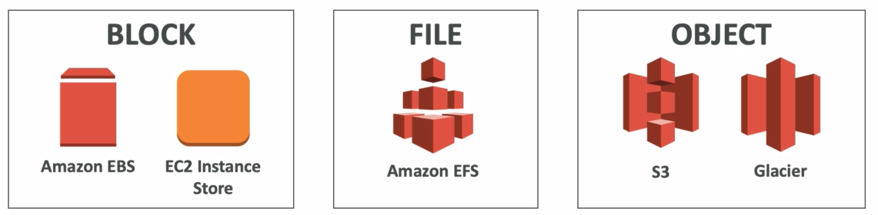

EFS

==========

Amazon Elastic File System (Amazon EFS) provides a simple, serverless, set-and-forget elastic file system for use with AWS Cloud services and on-premises resources.

Amazon EFS supports the Network File System version 4 (NFSv4.1 and NFSv4.0) protocol, so the applications and tools that you use today work seamlessly with Amazon EFS.

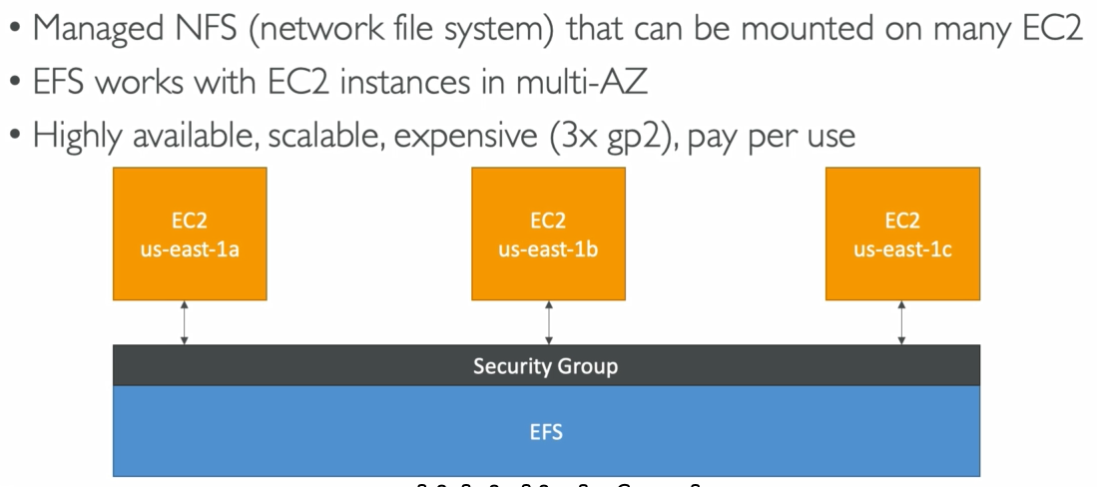

EBS

=====

Amazon Elastic Block Store (EBS) is an easy to use, high-performance, block-storage service designed for use with Amazon Elastic Compute Cloud (EC2) for both throughput and transaction intensive workloads at any scale.

Basically it’s a network drive

Its locked to an AZ. Ebs volume in 1 AZ cant be moved to another AZ . For that u need to take snapshots

It is provisioned on the basis of size GB and IOPS

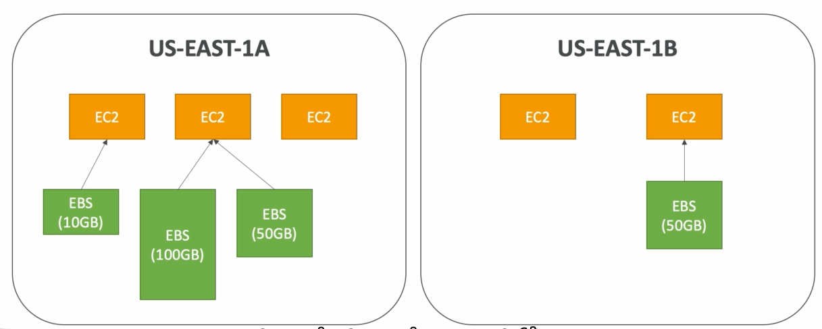

Storage Gateway

=============

Sometimes few servers are on premise , some are on cloud . We need connectionion between them .

Basically storage gateway is a bridge between on premise data and s3 data

AWS Storage Gateway is a set of hybrid cloud services that gives you on-​premises access to virtually unlimited cloud storage.

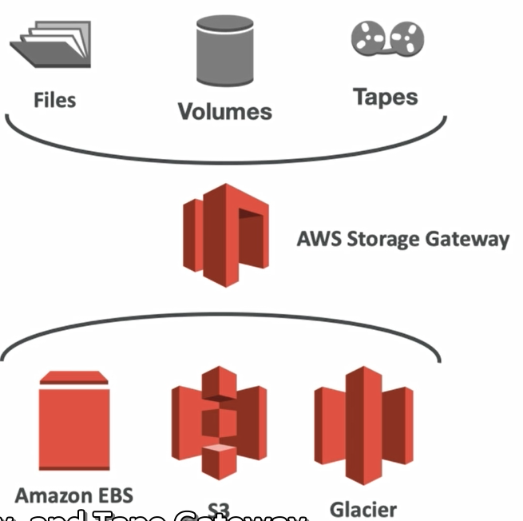

3 types of storage gateway are there

1. File gateway

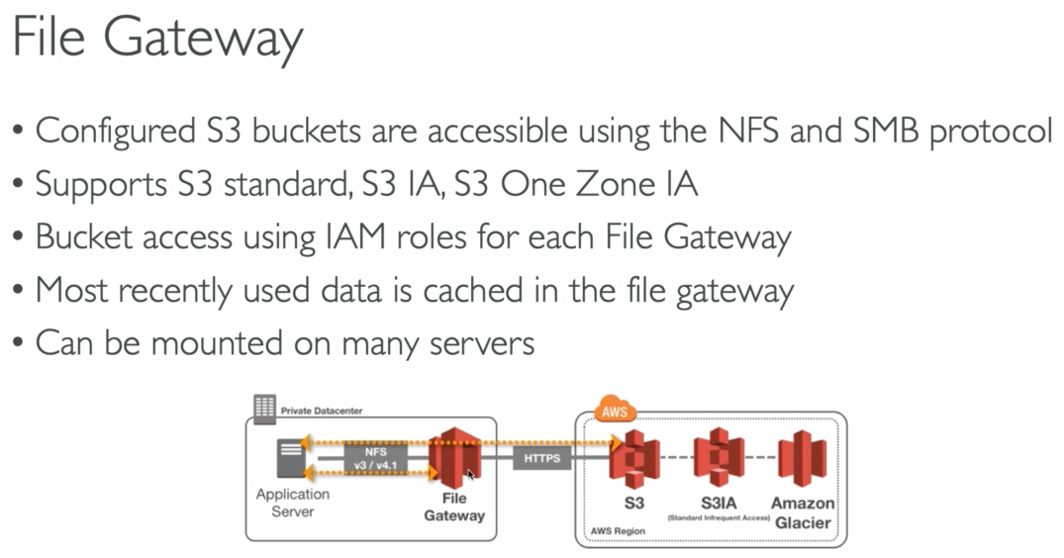

1. Volume gateway

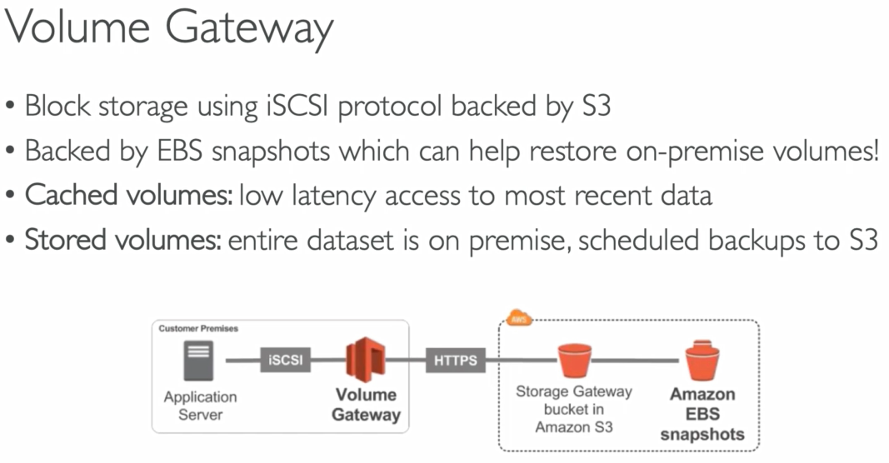

1. Tape gateway

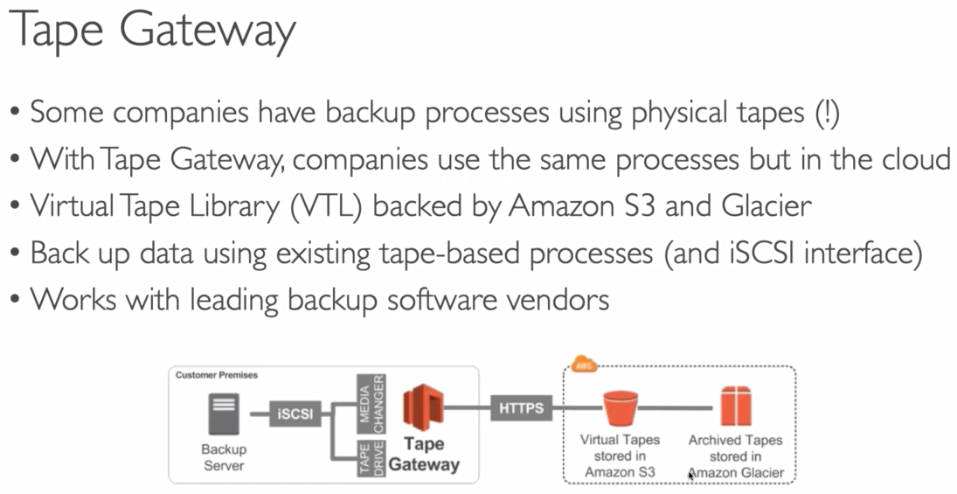

S3

=======

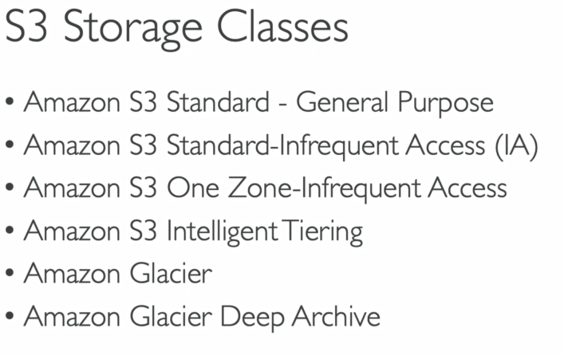

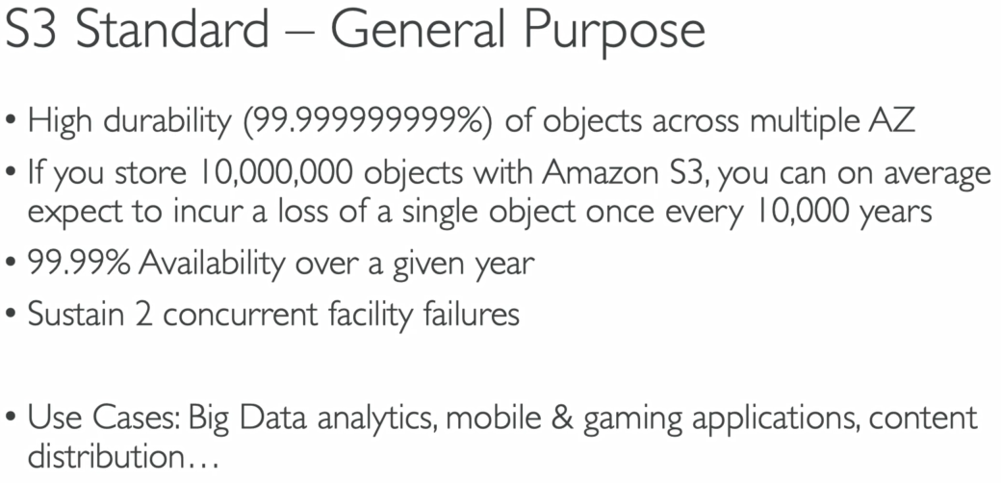

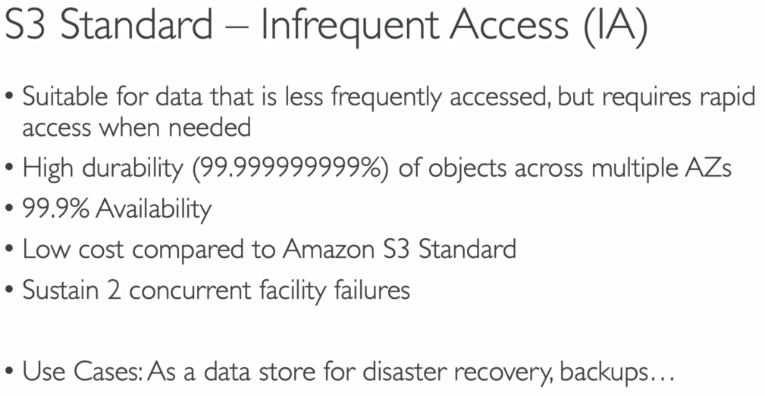

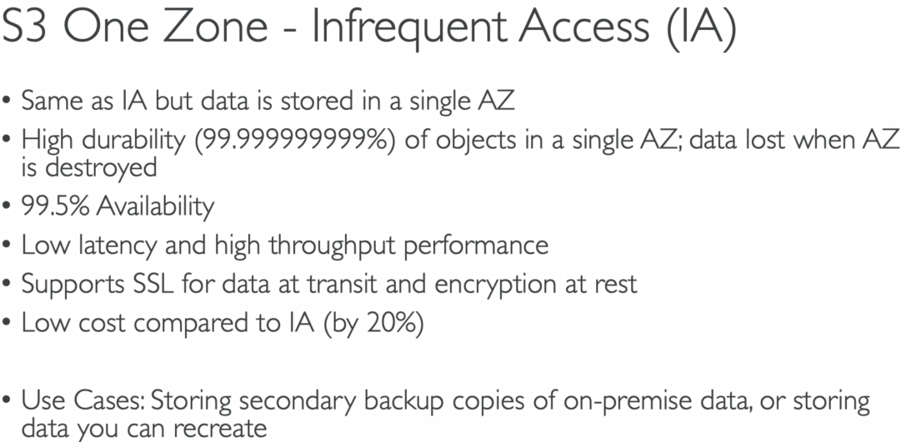

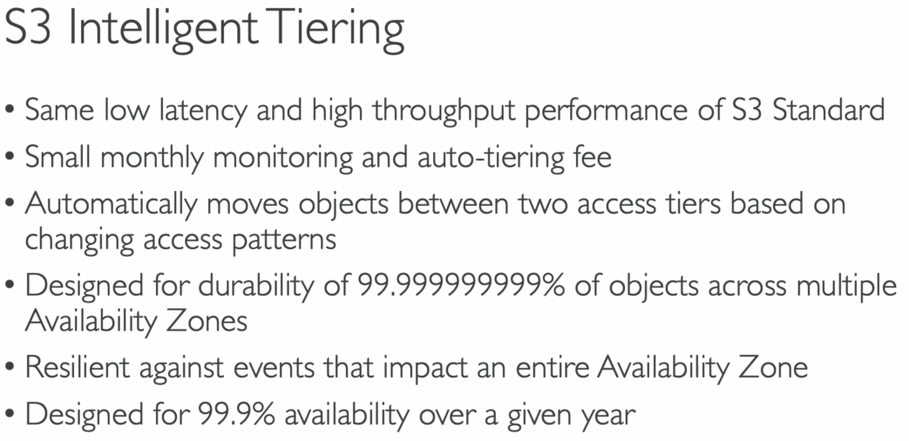

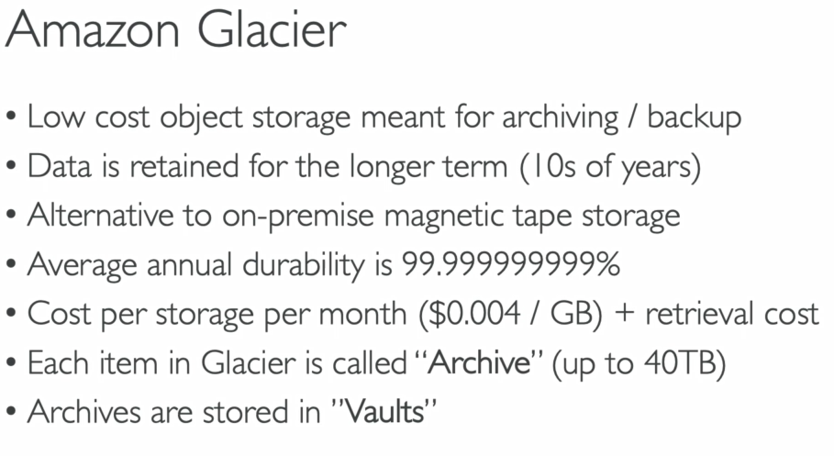

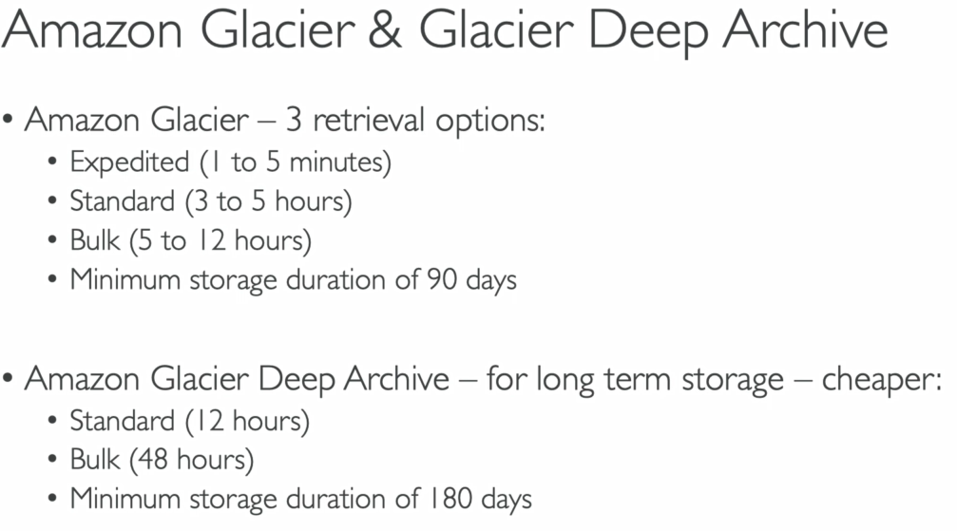

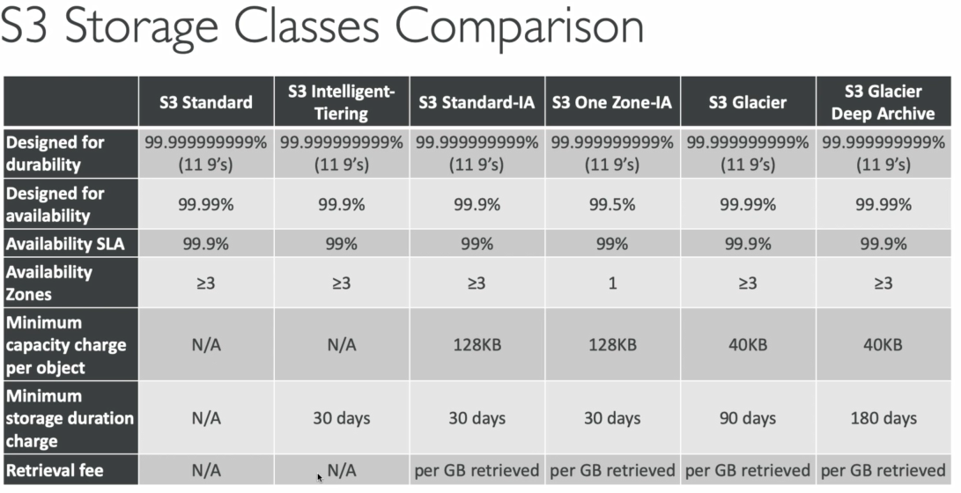

## **What is Route 53 ?**

Amazon route 53 is nothing but DNS servers. Route 53 DNS have some additional features which facilitate integration with other EC2 services.

If you wish to use it, you define your domain to use Route 53 nameservers instead of registrar or some 3-rd party nameservers.

Route53 is a Managed DNS (Domain Name System)

DNS is a collection of rules and records which helps clients understand

how to reach a server through URLs.

• In AWS, the most common records are:

• A: hostname to IPv4

• AAAA: hostname to IPv6

• CNAME: hostname to hostname

• Alias: hostname to AWS resource.

Route53 has advanced features such as:

• Load balancing (through DNS – also called client load balancing)

• Health checks (although limited…)

• Routing policy: simple, failover, geolocation, latency, weighted, multi value

## **Common Troubleshooting Issues**

4xx errors are client induced errors

5xx errors are application induced errors

Load Balancer Errors 503 means at capacity or no registered target

If the LB can’t connect to your application, check your security groups!

## **List of familiar Ports**

**Important ports:**

* FTP: 21
* SSH: 22
* SFTP: 22 (same as SSH)
* HTTP: 80
* HTTPS: 443

**vs RDS Databases ports:**

* PostgreSQL: 5432
* MySQL: 3306
* Oracle RDS: 1521
* MSSQL Server: 1433
* MariaDB: 3306 (same as MySQL)
* Aurora: 5432 (if PostgreSQL compatible) or 3306 (if MySQL compatible)

## **S3 Encryption for Objects**

• There are 4 methods of encrypting objects in S3

• SSE-S3: encrypts S3 objects using keys handled & managed by AWS

• SSE-KMS: leverage AWS Key Management Service to manage encryption keys

• SSE-C: when you want to manage your own encryption keys

• Client Side Encryption

## **S3 Security**

• User based

* IAM policies - which API calls should be allowed for a specific user from IAM console

• Resource Based

* Bucket Policies - bucket wide rules from the S3 console - allows cross account
* Object Access Control List (ACL) – finer grain
* Bucket Access Control List (ACL) – less common

• Note: an IAM principal can access an S3 object if

* the user IAM permissions allow it OR the resource policy ALLOWS it
* AND there’s no explicit DENY

S3 Bucket Policies

S3 Security - Other

• Networking:

* Supports VPC Endpoints (for instances in VPC without www internet)

• Logging and Audit:

* S3 Access Logs can be stored in other S3 bucket
* API calls can be logged in AWS CloudTrail

• User Security:

* MFA Delete MFA (multi factor authentication) can be required in versioned

buckets to delete objects

* Pre-Signed URLs: URLs that are valid only for a limited time (ex: premium video

service for logged in users)

## **What is CORS?**

An origin is a scheme (protocol), host (domain) and port

• E.g.: https://www.example.com (implied port is 443 for HTTPS, 80 for HTTP)

• CORS means Cross-Origin Resource Sharing

• Web Browser based mechanism to allow requests to other origins while

visiting the main origin

• Same origin: http://example.com/app1 & http://example.com/app2

• Different origins: http://www.example.com & http://other.example.com

• The requests won’t be fulfilled unless the other origin allows for the

requests, using CORS Headers (ex: Access-Control-Allow-Origin)

• If a client does a cross-origin request on our S3 bucket, we need to

enable the correct CORS headers

## **S3 Storage Classes**

• Amazon S3 Standard - General Purpose

• Amazon S3 Standard-Infrequent Access (IA)

• Amazon S3 One Zone-Infrequent Access

• Amazon S3 Intelligent Tiering

• Amazon Glacier

• Amazon Glacier Deep Archive

## **S3 Lifecycle Rules**

• Transition actions: It defines when objects are transitioned to another storage class.

Move objects to Standard IA class 60 days after creation

Move to Glacier for archiving after 6 months

• Expiration actions: configure objects to expire (delete) after some time

Access log files can be set to delete after a 365 days

Can be used to delete old versions of files (if versioning is enabled)

Can be used to delete incomplete multi-part uploads

## **S3 Performance**

• Multi-Part upload:

recommended for files > 100MB, must use for files > 5GB

Can help parallelize uploads (speed up transfers)

• S3 Transfer Acceleration

Increase transfer speed by transferring file to an AWS edge location which will forward the data to the S3 bucket in the target region

Compatible with multi-part upload

• S3 Byte-Range Fetches

Parallelize GETs by requesting specific byte ranges

Can be used to speed up downloads

Can be used to retrieve only partial data (for example the head of a file)

• S3 Select

Retrieve less data using SQL by performing server side filtering

Can filter by rows & columns (simple SQL statements)

## **AWS CloudFront**

• Content Delivery Network (CDN)

• Improves read performance, content is cached at the edge

• 216 Point of Presence globally (edge locations)

• DDoS protection, integration with Shield, AWS Web Application Firewall

• Can expose external HTTPS and can talk to internal HTTPS backends

## **CloudFront Signed URL vs S3 Pre-Signed URL**

**CloudFront Signed URL:**

• Allow access to a path, no matter the origin

• Account wide key-pair, only the root can manage it

• Can filter by IP, path, date, expiration

• Can leverage caching features

**S3 Pre-Signed URL:**

• Issue a request as the person who pre-signed the URL

• Uses the IAM key of the signing IAM principal

• Limited lifetime

## **AWS Global Accelerator**

• Leverage the AWS internal network to route to your application

• 2 Anycast IP are created for your application

• The Anycast IP send traffic directly to Edge Locations

• The Edge locations send the traffic to your application

• Works with Elastic IP, EC2 instances, ALB, NLB, public or private

• Consistent Performance

Intelligent routing to lowest latency and fast regional failover

No issue with client cache (because the IP doesn’t change)

Internal AWS network

• Health Checks

Global Accelerator performs a health check of your applications

Helps make your application global (failover less than 1 minute for unhealthy)

Great for disaster recovery (thanks to the health checks)

• Security

only 2 external IP need to be whitelisted

DDoS protection thanks to AWS Shield

## **AWS Global Accelerator vs CloudFront**

• They both use the AWS global network and its edge locations around the world

• Both services integrate with AWS Shield for DDoS protection.

• **CloudFront**

Improves performance for both cacheable content (such as images and videos)

Dynamic content (such as API acceleration and dynamic site delivery)

Content is served at the edge

• **Global Accelerator**

Improves performance for a wide range of applications over TCP or UDP

Proxying packets at the edge to applications running in one or more AWS Regions.

Good fit for non-HTTP use cases, such as gaming (UDP), IoT (MQTT), or Voice over IP

Good for HTTP use cases that require static IP addresses

Good for HTTP use cases that required deterministic, fast regional failover

## **AWS Storage Gateway**

• Bridge between on-premises data and cloud data in S3

• Use cases: disaster recovery, backup & restore, tiered storage

• 3 types of Storage Gateway:

* File Gateway
* Volume Gateway
* Tape Gateway

• On-premises data to the cloud => Storage Gateway

• File access / NFS – user auth with Active Directory => File Gateway (backed by S3)

• Volumes / Block Storage / iSCSI => Volume gateway (backed by S3 with EBS snapshots)

• VTL Tape solution / Backup with iSCSI = > Tape Gateway(backed by S3 and Glacier)

• No on-premises virtualization => Hardware Appliance

## **Storage Comparison**

• S3: Object Storage

• Glacier: Object Archival

• EFS: Network File System for Linux instances, POSIX filesystem

• FSx for Windows: Network File System for Windows servers

• FSx for Lustre: High Performance Computing Linux file system

• EBS volumes: Network storage for one EC2 instance at a time

• Instance Storage: Physical storage for your EC2 instance (high IOPS)

• Storage Gateway: File Gateway, Volume Gateway (cache & stored), Tape Gateway

• Snowball / Snowmobile: to move large amount of data to the cloud, physically

• Database: for specific workloads, usually with indexing and querying

## **Serverless in AWS**

• AWS Lambda

• DynamoDB

• AWS Cognito

• AWS API Gateway

• Amazon S3

• AWS SNS & SQS

• AWS Kinesis Data Firehose

• Aurora Serverless

• Step Functions

• Fargate

## **DynamoDB**

• Fully Managed, Highly available with replication across 3 AZ

• NoSQL database - not a relational database

• Scales to massive workloads, distributed database

• Millions of requests per seconds, trillions of row, 100s of TB of storage

• Fast and consistent in performance (low latency on retrieval)

• Integrated with IAM for security, authorization and administration

• Enables event driven programming with DynamoDB Streams

• Low cost and auto scaling capabilities

• DynamoDB is made of tables

• Each table has a primary key (must be decided at creation time)

• Each table can have an infinite number of items (= rows)

• Each item has attributes (can be added over time – can be null)

• Maximum size of a item is 400KB

• Data types supported are:

• Scalar Types: String, Number, Binary, Boolean, Null

• Document Types: List, Map

• Set Types: String Set, Number Set, Binary Set

## **Database Types**

• RDBMS (= SQL / OLTP): RDS, Aurora – great for joins

• NoSQL database: DynamoDB (~JSON), ElastiCache (key / value pairs),

Neptune (graphs) – no joins, no SQL

• Object Store: S3 (for big objects) / Glacier (for backups / archives)

• Data Warehouse (= SQL Analytics / BI): Redshift (OLAP), Athena

• Search: ElasticSearch (JSON) – free text, unstructured searches

• Graphs: Neptune – displays relationships between data

## **CIDR - IPv4(Classless Inter-Domain Routing)**

Quick memo:

• /32 – no IP number can change

• /24 - last IP number can change

• /16 – last IP two numbers can change

• /8 – last IP three numbers can change

• /0 – all IP numbers can change

Private IP can only allow certain values

• 10.0.0.0 – 10.255.255.255 (10.0.0.0/8) <= in big networks

• 172.16.0.0 – 172.31.255.255 (172.16.0.0/12) <= default AWS one

• 192.168.0.0 – 192.168.255.255 (192.168.0.0/16) <= example: home networks

• You can have multiple VPCs in a region (max 5 per region – soft limit)

• Max CIDR per VPC is 5. For each CIDR:

• Min size is /28 = 16 IP Addresses

• Max size is /16 = 65536 IP Addresses

• Because VPC is private, only the Private IP ranges are allowed:

• 10.0.0.0 – 10.255.255.255 (10.0.0.0/8)

• 172.16.0.0 – 172.31.255.255 (172.16.0.0/12)

• 192.168.0.0 – 192.168.255.255 (192.168.0.0/16)

AWS reserves 5 IPs address (first 4 and last 1 IP address) in each Subnet

• These 5 IPs are not available for use and cannot be assigned to an instance

• Ex, if CIDR block 10.0.0.0/24, reserved IP are:

• 10.0.0.0: Network address

• 10.0.0.1: Reserved by AWS for the VPC router

• 10.0.0.2: Reserved by AWS for mapping to Amazon-provided DNS

• 10.0.0.3: Reserved by AWS for future use

• 10.0.0.255: Network broadcast address. AWS does not support broadcast in a VPC,

therefore the address is reserve

## **IAM Policy Structure**

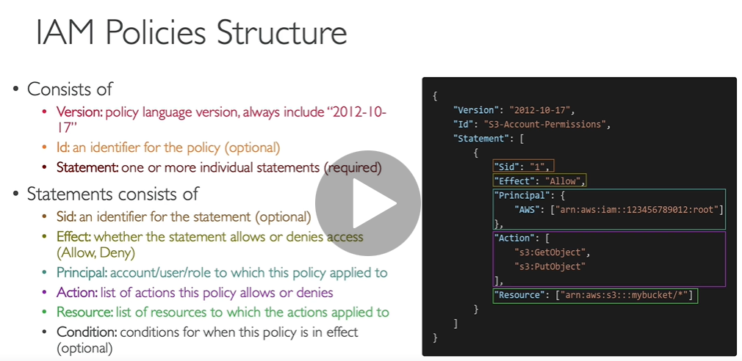

## **What class of EC2 instance type is recommended for database servers?**

AWS recommends that you choose **db.** **m- based or r-based Amazon RDS instances** for any enterprise database workloads. R5 instances are well suited for memory intensive applications such as high-performance databases.

<https://instances.vantage.sh/>

## **EC2 User Data script**

#!/bin/bash

# Use this foryour user data (script from your top to bottom)

# install httpd (Linux 2 version)

yum update -y

yum install -y httpd

systemctl start httpd

systemctl enable httpd

echo "<h1>Hello World from $(hostname -f)</h1>" > /var/www/html/index.html

## **Spot Instance vs Spot Fleet**

Spot Instances instances are acquired through a bidding process in which the customer specifies a price per hour he is willing to pay. When an EC2 instance becomes available at that price, the customer's instance will run.

Define max spot price and get the instance while current spot price < max

• The hourly spot price varies based on offer and capacity

• If the current spot price > your max price you can choose to stop or terminate your instance with a 2 minutes grace period

• Used for batch jobs, data analysis, or workloads that are resilient to failures.

• Not great for critical jobs or databases

A Spot Fleet is a collection, or fleet, of Spot Instances, and optionally On-Demand Instances.

• Spot Fleets = set of Spot Instances + (optional) On-Demand Instances

• The Spot Fleet will try to meet the target capacity with price constraints

• Define possible launch pools: instance type (m5.large), OS, Availability Zone

• Can have multiple launch pools, so that the fleet can choose

• Spot Fleet stops launching instances when reaching capacity or max cost

The Spot Fleet attempts to launch the number of Spot Instances and On-Demand Instances to meet the target capacity that you specified in the Spot Fleet request. The request for Spot Instances is fulfilled if there is available capacity and the maximum price you specified in the request exceeds the current Spot price. The Spot Fleet also attempts to maintain its target capacity fleet if your Spot Instances are interrupted.

What is the difference between spot fleet and spot instances?

With a normal spot instance request, you place a bid for a specific instance type in one specific AZ and hope you get it. With spot fleets, you can request a variety of different instance types that meet your requirements.

**Spot Block Instances**

By using Spot Block Instances, you reserve a set of Spot EC2 instances for a specified duration (1-6 hours) without interruption.

## **Placement Groups**

• Sometimes you want control over the EC2 Instance placement strategy

• That strategy can be defined using placement groups

• When you create a placement group, you specify one of the following

strategies for the group:

• **Cluster**—clusters instances into a low-latency group in a single Availability Zone

• **Spread**—spreads instances across underlying hardware (max 7 instances per

group per AZ)

• **Partition**—spreads instances across many different partitions (which rely on

different sets of racks) within an AZ. Scales to 100s of EC2 instances per group

(Hadoop, Cassandra, Kafka)

## **Elastic Network Interfaces (ENI)**

ENIs are virtual network cards you can attach to your EC2 instances. They are used to enable network connectivity for your instances, and having more than one of them connected to your instance allows it to communicate on two different subnets.

• The ENI can have the following attributes:

• Primary private IPv4, one or more secondary IPv4

• One Elastic IP (IPv4) per private IPv4

• One Public IPv4

• One or more security groups

• A MAC address

• You can create ENI independently and attach them on the fly (move them) on EC2 instances for failover

• Bound to a specific availability zone (AZ). You can not attach an ENI to an EC2 instance in a different AZ.

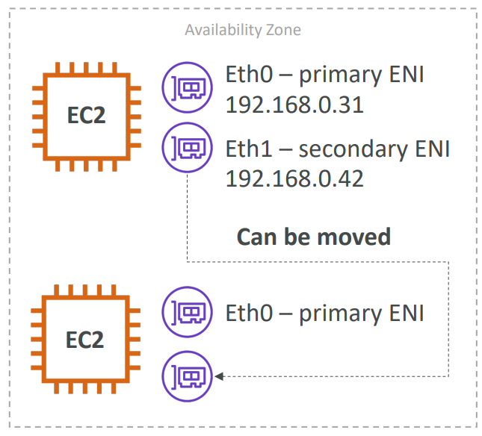

## **EBS Multi-Attach**

Using EBS Multi-Attach, you can attach the same EBS volume to multiple EC2 instances in the same AZ. Each EC2 instance has full read/write permissions.

## **Load Balancer**

Load Balancers are servers that forward traffic to multiple servers (e.g., EC2 instances) downstream

**An Elastic Load Balancer is a managed load balancer**

• It is integrated with many AWS offerings / services

• EC2, EC2 Auto Scaling Groups, Amazon ECS

• AWS Certificate Manager (ACM), CloudWatch

• Route 53, AWS WAF, AWS Global Accelerator

**AWS has 4 kinds of managed Load Balancers**

• Classic Load Balancer (v1 - old generation) – 2009 – CLB

• HTTP, HTTPS, TCP, SSL (secure TCP)

• Application Load Balancer (v2 - new generation) – 2016 – ALB

• HTTP, HTTPS, WebSocket

• Network Load Balancer (v2 - new generation) – 2017 – NLB

• TCP, TLS (secure TCP), UDP

• Gateway Load Balancer – 2020 – GWLB

• Operates at layer 3 (Network layer) – IP Protocol

**Classic Load Balancers (v1)**

• Supports TCP (Layer 4), HTTP & HTTPS (Layer 7)

• Health checks are TCP or HTTP based

• Fixed hostname XXX.region.elb.amazonaws.com

**Application Load Balancer (v2)**

• Application load balancers is Layer 7 (HTTP)

• Load balancing to multiple HTTP applications across machines (target groups)

• Load balancing to multiple applications on the same machine (ex: containers)

• Support for HTTP/2 and WebSocket

• Support redirects (from HTTP to HTTPS for example)

• Routing tables to different target groups:

• Routing based on path in URL (example.com/users & example.com/posts)

• Routing based on hostname in URL (one.example.com & other.example.com)

• Routing based on Query String, Headers (example.com/users?id=123&order=false)

• ALB are a great fit for micro services & container-based application (example: Docker & Amazon ECS)

• ALB can route to multiple target groups

• Health checks are at the target group level. Enable ELB Health Checks, your ELB won't send traffic to unhealthy (crashed) EC2 instances.

• The Auto Scaling Group can't go over the maximum capacity (you configured) during scale-out events.

• For each Auto Scaling Group, there's a Cooldown Period after each scaling activity. In this period, the ASG doesn't launch or terminate EC2 instances. This gives time to metrics to stabilize. The default value for the Cooldown Period is 300 seconds (5 minutes).

• Use ASG Lifecycle Hooks to pause the EC2 instance in the terminating state for troubleshooting

• The application servers don’t see the IP of the client directly

IP (X-Forwarded-For)

Port (X-Forwarded-Port)

proto (X-Forwarded-Proto)

Target Group Type:

• **EC2 instances** (can be managed by an Auto Scaling Group) – HTTP

**• IP Addresses** – must be private IPs

• **Lambda functions** – HTTP request is translated into a JSON event

• **ECS tasks** (managed by ECS itself) – HTTP

**Network Load Balancer (v2)**

• Network load balancers (Layer 4) allow to:

• Forward TCP & UDP traffic to your instances

• Handle millions of request per seconds

• Less latency ~100 ms (vs 400 ms for ALB)

• NLB has one static IP per AZ, and supports assigning Elastic IP (helpful for whitelisting specific IP)

• NLB target groups to EC2 instances, IP Addresses and ALB

**Gateway Load Balancer**

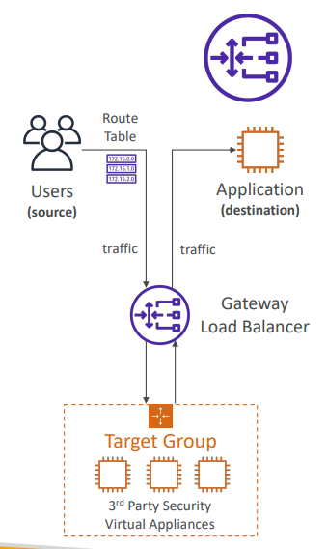

• Deploy, scale, and manage a fleet of 3rd party network virtual appliances in AWS

• Example: Firewalls, Intrusion Detection and Prevention Systems, Deep Packet Inspection Systems, payload manipulation, …

• Operates at Layer 3 (Network Layer) – IP Packets

• Combines the following functions:

• Transparent Network Gateway – single entry/exit for all traffic

• Load Balancer – distributes traffic to your virtual appliances

• Uses the GENEVE protocol on port 6081

• GLB target groups (EC2 instances, IP Addresses – must be private IPs)

**Sticky Sessions**

• It is possible to implement stickiness so that the same client is always redirected to the same instance behind a load balancer

• This works for Classic Load Balancers & Application Load Balancers

• The “cookie” used for stickiness has an expiration date you control

• Use case: make sure the user doesn’t lose his session data

• Enabling stickiness may bring imbalance to the load over the backend EC2 instances

Cookie Names

• Application-based Cookies

• Duration-based Cookies

**Cross-Zone Load Balancing**

With Cross Zone Load Balancing,each load balancer instance distributes evenly across all registered instances in all AZ

ALB: Cross-Zone Load Balancing is always on and free

NLB: Cross-Zone Load Balancing is disabled by default and can be enabled which is chargeable

**Load Balancer - SSL Certificates**

• The load balancer uses an X.509 certificate (SSL/TLS server certificate)

• You can manage certificates using ACM (AWS Certificate Manager)

**SSL – Server Name Indication (SNI)**

• SNI solves the problem of loading multiple SSL certificates onto one web server (to serve multiple websites)

• It’s a “newer” protocol, and requires the client to indicate the hostname of the target server in the initial SSL handshake

• The server will then find the correct certificate, or return the default one

• Only works for ALB & NLB (newer generation), CloudFront

• ALB & NLB: Uses SNI to support multiple listeners with multiple SSL certificates

## **Auto Scaling Group**

• Scale out (add EC2 instances) to match an increased load

• Scale in (remove EC2 instances) to match a decreased load

• ASG launch configuration

• AMI + Instance Type

• EC2 User Data

• EBS Volumes

• Security Groups

• SSH Key Pair

• Min Size / Max Size / Initial Capacity

• Network + Subnets Information

• Load Balancer Information

• Scaling Policies

**ASG Alarms**

• It is possible to scale an ASG based on CloudWatch alarms

• An Alarm monitors a metric (such as Average CPU)

• Metrics are computed for the overall ASG instances

**ASG Rules**

• Target Average CPU Usage

• Number of requests on the ELB per instance

• Average Network In

• Average Network Out

**ASG Custom Metric**

• custom metric (ex: number of connected users)

• 1. Send custom metric from application on EC2 to CloudWatch (PutMetric API)

• 2. Create CloudWatch alarm to react to low / high values

• 3. Use the CloudWatch alarm as the scaling policy for ASG

**Dynamic Scaling Policies**

• **Target Tracking Scaling**

• Most simple and easy to set-up

• Example: I want the average ASG CPU to stay at around 40%

• **Simple / Step Scaling**

• When a CloudWatch alarm is triggered (example CPU > 70%), then add 2 units

• When a CloudWatch alarm is triggered (example CPU < 30%), then remove 1

• **Scheduled Actions**

• Anticipate a scaling based on known usage patterns

• Example: increase the min capacity to 10 at 5 pm on Fridays

• **Predictive scaling**: continuously forecast load and schedule scaling ahead

**Good metrics to scale on**

• **CPUUtilization**:

Average CPU utilization across your instances

• **RequestCountPerTarget**:

to make sure the number of requests per EC2 instances is stable

• **Average Network In / Out**

(if you’re application is network bound)

• **Any custom metric**

(that you push using CloudWatch)

## **RDS**

It’s a managed DB service

• It allows you to create databases in the cloud that are managed by AWS

• Postgres

• MySQL

• MariaDB

• Oracle

• Microsoft SQL Server

• Aurora (AWS Proprietary database)

• RDS is a managed service:

• Automated provisioning, OS patching

• Continuous backups and restore to specific timestamp (Point in Time Restore)!

• Monitoring dashboards

• Read replicas for improved read performance

• Multi AZ setup for DR (Disaster Recovery)

• Maintenance windows for upgrades

• Scaling capability (vertical and horizontal)

• Storage backed by EBS (gp2 or io1)

• Automated backups:

• DB Snapshots

• Storage Auto Scaling

**RDS Read Replicas**

• Up to 5 Read Replicas

• Within AZ, Cross AZ or Cross Region

• Replication is ASYNC, so reads are eventually consistent

**RDS Multi AZ (Disaster Recovery)**

• SYNC replication

• One DNS name – automatic app failover to standby

**RDS Encryption**

• **Encrypting RDS backups**

• Snapshots of un-encrypted RDS databases are un-encrypted

• Snapshots of encrypted RDS databases are encrypted

• Can copy a snapshot into an encrypted one

• **To encrypt an un-encrypted RDS database**

• Create a snapshot of the un-encrypted database

• Copy the snapshot and enable encryption for the snapshot

• Restore the database from the encrypted snapshot

• Migrate applications to the new database, and delete the old database

**RDS Security**

• Network Security

• RDS databases are usually deployed within a private subnet, not in a public one

• RDS security works by leveraging security groups (the same concept as for EC2

instances) – it controls which IP / security group can communicate with RDS

• Access Management

• IAM policies help control who can manage AWS RDS (through the RDS API)

• Traditional Username and Password can be used to login into the database

• IAM-based authentication can be used to login into RDS MySQL & PostgreSQL

**Additional configuration**

**Log exports**

Audit log

Error log

General log

Slow query log

**How to create RDS read replica**

Select the DB

Goto Actions -> Create read replica

**Monitoring**

CPU Utilization (Percent)

DB Connections (Count)

Free Storage Space (MB/Second)

Freeable Memory (MB)

Write IOPS (Count/Second)

Read IOPS (Count/Second)

Queue Depth (Count)

Replica Lag (Milliseconds)

Binary Log Disk Usage (MB)

Write Throughput (MB/Second)

Read Throughput (MB/Second)

Swap Usage (MB)

Write Latency (Milliseconds)

Read Latency (Milliseconds)

Network Receive Throughput (MB/Second)

Network Transmit Throughput (MB/Second)

CPU Credit Usage (Count)

CPU Credit Balance (Count)

Burst Balance (Percent)

Replication Slot Disk Usage (MB)

Database Connections IPV6 (Count)

Free Local Storage (MB)

Read IOPS Local Storage (Count/Second)

Read Latency Local Storage (Milliseconds)

Read Throughput Local Storage (MB/Second)

Write IOPS Local Storage (Count/Second)

Write Latency Local Storage (Milliseconds)

Write Throughput Local Storage (MB/Second)

Total IOPS (Count/Second)

Free Local Storage (MB)

**Monitoring replication lag**

You can monitor replication lag in Amazon CloudWatch by viewing the Amazon RDS ReplicaLag metric.

Common causes for replication lag for MySQL and MariaDB are the following:

• A network outage.

• Writing to tables with indexes on a read replica. If the read_only parameter is not set to 0 on the read replica, it can break replication.

• Using a nontransactional storage engine such as MyISAM. Replication is only supported for the InnoDB storage engine on MySQL and the XtraDB storage engine on MariaDB.

## **AWS Monitoring, Audit and Performance**

## **(CloudWatch, CloudTrail & AWS Config)**

**AWS CloudWatch Metrics**

• CloudWatch provides metrics for every services in AWS

• Metric is a variable to monitor (CPUUtilization, NetworkIn…)

• Metrics belong to namespaces

• Dimension is an attribute of a metric (instance id, environment, etc…).

• Up to 10 dimensions per metric

• Metrics have timestamps

• Can create CloudWatch dashboards of metric

**EC2 Detailed monitoring**

• EC2 instance metrics have metrics “every 5 minutes”

• With detailed monitoring (for a cost), you get data “every 1 minute”

**CloudWatch Custom Metrics**

• Possibility to define and send your own custom metrics to CloudWatch

• Example: memory (RAM) usage, disk space, number of logged in users …

• Use API call **PutMetricData**

**CloudWatch Dashboards**

• Great way to setup custom dashboards for quick access to key metrics and alarms

• Dashboards are global

• Dashboards can include graphs from different AWS accounts and regions

**CloudWatch Logs**

• **Log groups**: arbitrary name, usually representing an application

• **Log stream**: instances within application / log files / containers

• Can define log expiration policies (never expire, 30 days, etc..)

• CloudWatch Logs can send logs to:

• Amazon S3 (exports)

• Kinesis Data Streams

• Kinesis Data Firehose

• AWS Lambda

• ElasticSearch

**CloudWatch Logs - Sources**

• SDK, CloudWatch Logs Agent, CloudWatch Unified Agent

• Elastic Beanstalk: collection of logs from application

• ECS: collection from containers

• AWS Lambda: collection from function logs

• VPC Flow Logs: VPC specific logs

• API Gateway

• CloudTrail based on filter

• Route53: Log DNS queries

**CloudWatch Logs Metric Filter & Insights**

• CloudWatch Logs can use filter expressions

• For example, find a specific IP inside of a log

• Or count occurrences of “ERROR” in your logs

• Metric filters can be used to trigger CloudWatch alarms

• CloudWatch Logs Insights can be used to query logs and add queries to CloudWatch Dashboards

CloudWatch Logs Agent & Unified Agent

|  |  |
| --- | --- |
| **CloudWatch Logs Agent**  • Old version of the agent  • Can only send to CloudWatch Logs | **CloudWatch Unified Agent**  • Collect additional system-level metrics such as RAM, processes, etc…  • Collect logs to send to CloudWatch Logs  • Centralized configuration using SSM Parameter Store |

**CloudWatch Unified Agent – Metrics**

• Collected directly on your Linux server / EC2 instance

• CPU (active, guest, idle, system, user, steal)

• Disk metrics (free, used, total), Disk IO (writes, reads, bytes, iops)

• RAM (free, inactive, used, total, cached)

• Netstat (number of TCP and UDP connections, net packets, bytes)

• Processes (total, dead, bloqued, idle, running, sleep)

• Swap Space (free, used, used %)

**CloudWatch Alarms**

• Alarms are used to trigger notifications for any metric

• Various options (sampling, %, max, min, etc…)

• Alarm States:

• OK

• INSUFFICIENT_DATA

• ALARM

• Period:

• Length of time in seconds to evaluate the metric

• High resolution custom metrics: 10 sec, 30 sec or multiples of 60 sec

**CloudWatch Alarm Targets**

• Stop, Terminate, Reboot, or Recover an EC2 Instance

• Trigger Auto Scaling Action

• Send notification to SNS (from which you can do pretty much anything)

**CloudWatch Events**

• Event Pattern: Intercept events from AWS services (Sources)

• Example sources: EC2 Instance Start, CodeBuild Failure, S3, Trusted Advisor

• Can intercept any API call with CloudTrail integration

• Schedule or Cron (example: create an event every 4 hours)

• A JSON payload is created from the event and passed to a target…

• Compute: Lambda, Batch, ECS task

• Integration: SQS, SNS, Kinesis Data Streams, Kinesis Data Firehose

• Orchestration: Step Functions, CodePipeline, CodeBuild

• Maintenance: SSM, EC2 Actions

**Amazon EventBridge**

• EventBridge is the next evolution of CloudWatch Events

• Default event bus: generated by AWS services (CloudWatch Events)

• Partner event bus: receive events from SaaS service or applications

(Zendesk, DataDog, Segment, Auth0…)

• Custom Event buses: for your own applications

• Event buses can be accessed by other AWS accounts

• Rules: how to process the events (similar to CloudWatch Events)

**Amazon EventBridge vs CloudWatch Events**

• Amazon EventBridge builds upon and extends CloudWatch Events.

• It uses the same service API and endpoint, and the same underlying service infrastructure.

• EventBridge allows extension to add event buses for your custom applications and your third-party SaaS apps.

• Event Bridge has the Schema Registry capability

**AWS CloudTrail**

• **Provides governance, compliance and audit for your AWS Account**

• CloudTrail is enabled by default!

• Get an history of events / API calls made within your AWS Account by:

• Console

• SDK

• CLI

• AWS Services

• Can put logs from CloudTrail into CloudWatch Logs or S3

• A trail can be applied to All Regions (default) or a single Region.

• If a resource is deleted in AWS, investigate CloudTrail first!

**CloudTrail Events**

**• Management Events:**

• Operations that are performed on resources in your AWS account

• Examples:

• Configuring security (IAM AttachRolePolicy)

• Configuring rules for routing data (Amazon EC2 CreateSubnet)

• Setting up logging (AWS CloudTrail CreateTrail)

• By default, trails are configured to log management events.

• Can separate Read Events (that don’t modify resources) from Write Events (that may modify resources)

**• Data Events:**

• By default, data events are not logged (because high volume operations)

• Amazon S3 object-level activity (ex: GetObject, DeleteObject, PutObject): can separate Read and Write Events

• AWS Lambda function execution activity (the Invoke API)

**• CloudTrail Insights Events:**

• Enable CloudTrail Insights to detect unusual activity in your account:

• inaccurate resource provisioning

• hitting service limits

• Bursts of AWS IAM actions

• Gaps in periodic maintenance activity

• CloudTrail Insights analyzes normal management events to create a baseline

• And then continuously analyzes write events to detect unusual patterns

• Anomalies appear in the CloudTrail console

• Event is sent to Amazon S3

• An EventBridge event is generated (for automation needs)

**CloudTrail Events Retention**

• Events are stored for 90 days in CloudTrail

• To keep events beyond this period, log them to S3 and use Athena

**AWS Config**

• Helps with auditing and recording compliance of your AWS resources

• Helps record configurations and changes over time

• Questions that can be solved by AWS Config:

• Is there unrestricted SSH access to my security groups?

• Do my buckets have any public access?

• How has my ALB configuration changed over time?

• You can receive alerts (SNS notifications) for any changes

• AWS Config is a per-region service

• Can be aggregated across regions and accounts

• Possibility of storing the configuration data into S3 (analyzed by Athena)

**Config Rules – Notifications**

• Use EventBridge to trigger notifications when AWS resources are non-compliant

**CloudWatch vs CloudTrail vs Config**

• **CloudWatch**

• Performance monitoring (metrics, CPU, network, etc…) & dashboards

• Events & Alerting

• Log Aggregation & Analysis

• **CloudTrail**

• Record API calls made within your Account by everyone

• Can define trails for specific resources

• Global Service

• **Config**

• Record configuration changes

• Evaluate resources against compliance rules

• Get timeline of changes and compliance

**Ex- For an Elastic Load Balancer**

• CloudWatch:

• Monitoring Incoming connections metric

• Visualize error codes as % over time

• Make a dashboard to get an idea of your load balancer performance

• Config:

• Track security group rules for the Load Balancer

• Track configuration changes for the Load Balancer

• Ensure an SSL certificate is always assigned to the Load Balancer (compliance)

• CloudTrail:

• Track who made any changes to the Load Balancer with API calls

## **Virtual Private Cloud (VPC)**

VPC- They are isolated in terms of network perspective.

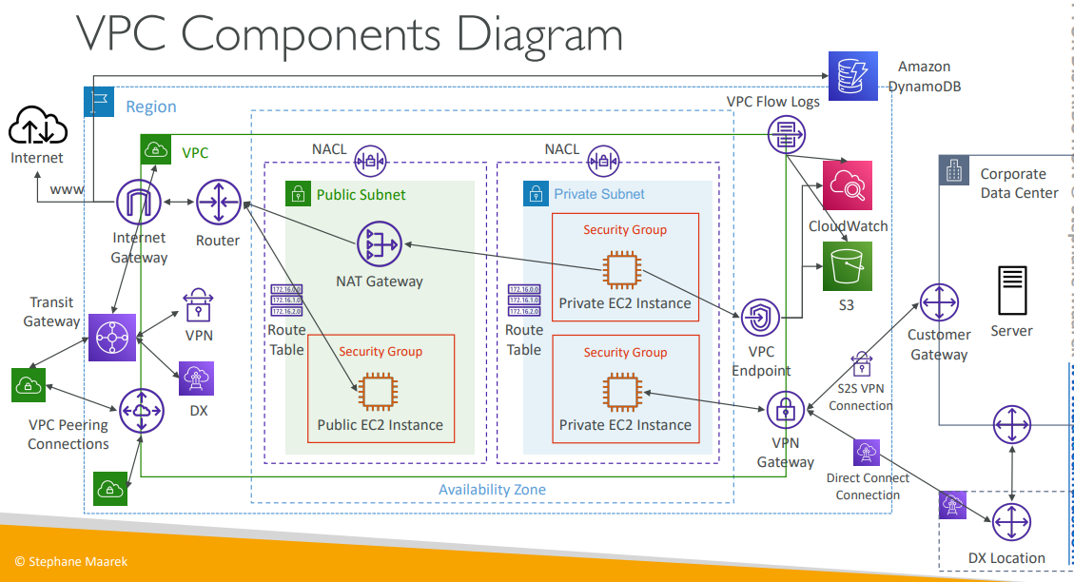

**CIDR – IPv4**

A CIDR consists of two components: Base IP and Subnet Mask

Private IP can only allow certain values:

• 10.0.0.0 – 10.255.255.255 (10.0.0.0/8) ->in big networks

• 172.16.0.0 – 172.31.255.255 (172.16.0.0/12) ->AWS default VPC in that range

• 192.168.0.0 – 192.168.255.255 (192.168.0.0/16) ->e.g., home networks

• All the rest of the IP addresses on the Internet are Public

VPC

• You can have multiple VPCs in an AWS region (max. 5 per region – soft limit)

• Max. CIDR per VPC is 5, for each CIDR:

• Min. size is /28 (16 IP addresses)

• Max. size is /16 (65536 IP addresses)

• Your VPC CIDR should NOT overlap with your other networks (e.g., corporate)

• AWS reserves 5 IP addresses (first 4 & last 1) in each subnet

• Example: if CIDR block 10.0.0.0/24, then reserved IP addresses are:

• 10.0.0.0 – Network Address

• 10.0.0.1 – reserved by AWS for the VPC router

• 10.0.0.2 – reserved by AWS for mapping to Amazon-provided DNS

• 10.0.0.3 – reserved by AWS for future use

• 10.0.0.255 – Network Broadcast Address. AWS does not support broadcast in

a VPC, therefore the address is reserved

Internet Gateway (IGW)

• Allows resources (e.g., EC2 instances) in a VPC connect to the Internet

Bastion Hosts

• We can use a Bastion Host to SSH into our private EC2 instances

• The bastion is in the public subnet which is then connected to all other private subnets

• Bastion Host security group must be tightened

NAT Gateway

• Managed by AWS, provides scalable Internet access to private EC2 instances, IPv4 only

DNS Resolution in VPC

• DNS Hostnames (enableDnsHostnames)

• By default,

• True => default VPC

• False => newly created VPCs

• Won’t do anything unless enableDnsSupport=true

• If True, assigns public hostname to EC2 instance if it has a public IPv4

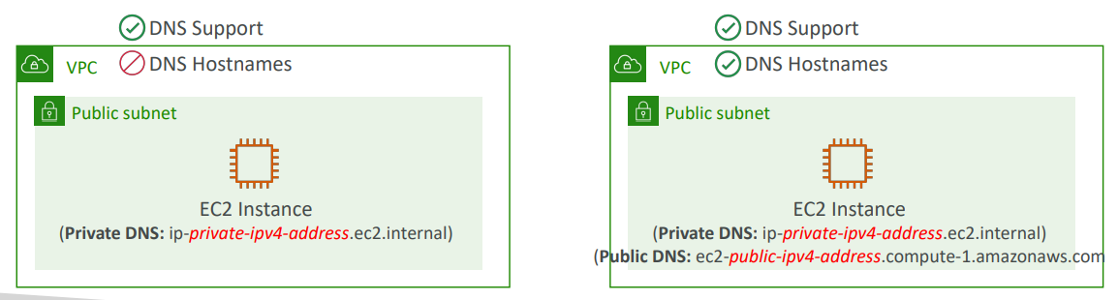

• If you use custom DNS domain names in a Private Hosted Zone in Route 53, you must set both these attributes (enableDnsSupport & enableDnsHostname) to true

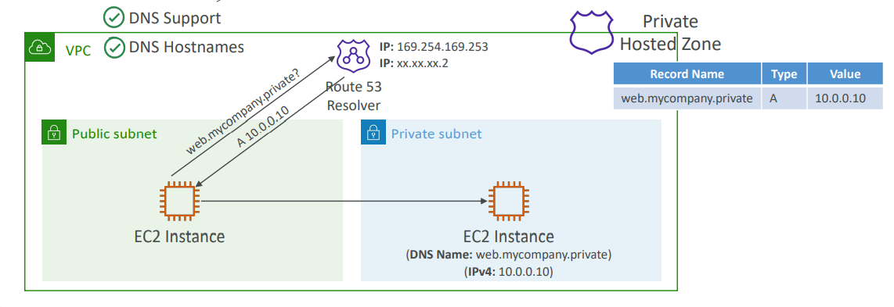

Network Access Control List (NACL)

• NACL are like a firewall which control traffic from and to subnets

• One NACL per subnet

• You define NACL Rules:

• Rules have a number (1-32766), higher precedence with a lower number

• First rule match will drive the decision

• The last rule is an asterisk (*) and denies a request in case of no rule match

• NACL are a great way of blocking a specific IP address at the subnet level

Security Group

• A security group acts as a virtual firewall for your EC2 instances to control incoming and outgoing traffic.

• You can add rules to each security group that allow traffic to or from its associated instances.

• You can modify the rules for a security group at any time.

Security Group vs. NACL

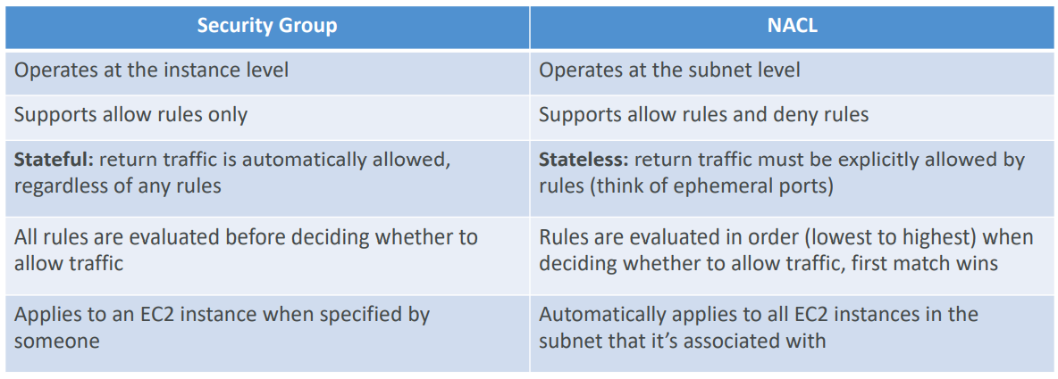

Ephemeral Ports

• An ephemeral port is a temporary communication hub used for Internet Protocol (IP) communications. It is created from a set range of port. It is used for only a short period of time for the duration of a communication session.

• allocated automatically from a predefined range

• Clients connect to a defined port, and expect a response on an ephemeral port

• Ephemeral port ranges- (Many Linux Kernels -> 32768 – 60999)

VPC – Reachability Analyzer

• A network diagnostics tool that troubleshoots network connectivity between two endpoints in your VPC(s)

• It builds a model of the network configuration, then checks the reachability based on these configurations (it doesn’t send packets)

VPC Peering

• Privately connect two VPCs using AWS’ network

• Must not have overlapping CIDRs

• VPC Peering connection is NOT transitive

• You must update route tables in each VPC’s subnets to ensure EC2 instances can communicate with each other

• You can create VPC Peering connection between VPCs in different AWS accounts/regions

VPC Endpoints (AWS PrivateLink)

• VPC Endpoints (powered by AWS PrivateLink) allows you to connect to AWS services using a private network instead of using the public Internet

• They’re redundant and scale horizontally

• They remove the need of IGW, NATGW to access AWS Services

**Types of Endpoints**

**• Interface Endpoints**

• Provisions an ENI (private IP address) as an entry point (must attach a Security Group)

• Supports most AWS services

**• Gateway Endpoints**

• Provisions a gateway and must be used as a target in a route table

• Supports both S3 and DynamoDB

VPC Flow Logs

• Capture information about IP traffic going into your interfaces:

• VPC Flow Logs

• Subnet Flow Logs

• Elastic Network Interface (ENI) Flow Logs

• Helps to monitor & troubleshoot connectivity issues

• Flow logs data can go to S3 / CloudWatch Logs

• Captures network information from AWS managed interfaces too: ELB, RDS, ElastiCache, Redshift, WorkSpaces, NATGW, Transit Gateway…

**VPC Flow Logs Syntax**

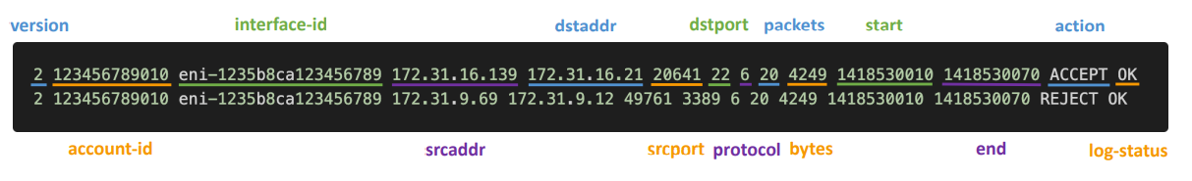

• srcaddr & dstaddr – help identify problematic IP

• srcport & dstport – help identity problematic ports

• Action – success or failure of the request due to Security Group / NACL

• Can be used for analytics on usage patterns, or malicious behavior

• Query VPC flow logs using Athena on S3 or CloudWatch Logs Insights

• **Troubleshoot SG & NACL issues: Look at the “ACTION” field**

AWS Site-to-Site VPN

• **Virtual Private Gateway (VGW)**

• VPN concentrator on the AWS side of the VPN connection

• VGW is created and attached to the VPC from which you want to create the Site-to-Site VPN connection

• Possibility to customize the ASN (Autonomous System Number)

• **Customer Gateway (CGW)**

• Software application or physical device on customer side of the VPN connection

AWS VPN CloudHub

• Provide secure communication between multiple sites, if you have multiple VPN connections

• Low-cost hub-and-spoke model for primary or secondary network connectivity between different locations (VPN only)

Direct Connect (DX)

• Provides a dedicated private connection from a remote network to your VPC

• Dedicated connection must be setup between your DC and AWS Direct Connect locations

• You need to setup a Virtual Private Gateway on your VPC

• Access public resources (S3) and private (EC2) on same connection

• Use Cases:

• Increase bandwidth throughput - working with large data sets – lower cost

• More consistent network experience - applications using real-time data feeds

• Hybrid Environments (on prem + cloud)

• Supports both IPv4 and IPv6

Direct Connect Gateway

• If you want to setup a Direct Connect to one or more VPC in many different regions (same account), you must use a Direct Connect Gateway

• Dedicated Connections: 1Gbps and 10 Gbps capacity

• Hosted Connections: 50Mbps, 500 Mbps, to 10 Gbps

• Lead times are often longer than 1 month to establish a new connection

Exposing services in your VPC to other VPC

• Option 1: make it public

• Option 2: VPC peering

• AWS PrivateLink (VPC Endpoint Services)

• Most secure & scalable way to expose a service to 1000s of VPC (own or other accounts)

Transit Gateway

• For having transitive peering between thousands of VPC and on-premises, hub-and-spoke (star) connection

**VPC Section Summary**

• **CIDR** – IP Range

• **VPC** – Virtual Private Cloud => we define a list of IPv4 & IPv6 CIDR

• **Subnets** – tied to an AZ, we define a CIDR

• **Internet Gateway** – at the VPC level, provide IPv4 & IPv6 Internet Access

• **Route Tables** – must be edited to add routes from subnets to the IGW, VPC Peering Connections, VPC Endpoints, …

• **Bastion Host** – public EC2 instance to SSH into, that has SSH connectivity to EC2 instances in private subnets

• **NAT Instances** – gives Internet access to EC2 instances in private subnets. Old, must be setup in a public subnet, disable Source / Destination check flag

• **NAT Gateway** – managed by AWS, provides scalable Internet access to private EC2 instances, IPv4 only

• **Private DNS + Route 53** – enable DNS Resolution + DNS Hostnames (VPC)

• **NACL** – stateless, subnet rules for inbound and outbound, don’t forget Ephemeral Ports

• **Security Groups** – stateful, operate at the EC2 instance level

**• Reachability Analyzer** – perform network connectivity testing between AWS

resources

• **VPC Peering** – connect two VPCs with non overlapping CIDR, non-transitive

• **VPC Endpoints** – provide private access to AWS Services (S3, DynamoDB, CloudFormation, SSM) within a VPC

• **VPC Flow Logs** – can be setup at the VPC / Subnet / ENI Level, for ACCEPT and REJECT traffic, helps identifying attacks, analyze using Athena or CloudWatch Logs Insights

• **Site-to-Site VPN** – setup a Customer Gateway on DC, a Virtual Private Gateway on VPC, and site-to-site VPN over public Internet

• **AWS VPN CloudHub** – hub-and-spoke VPN model to connect your sites

• **Direct Connect** – setup a Virtual Private Gateway on VPC, and establish a direct private connection to an AWS Direct Connect Location

• **Direct Connect Gateway** – setup a Direct Connect to many VPCs in different AWS regions

• **AWS PrivateLink / VPC Endpoint Services**:

• Connect services privately from your service VPC to customers VPC

• Doesn’t need VPC Peering, public Internet, NAT Gateway, Route Tables

• Must be used with Network Load Balancer & ENI

• **ClassicLink** – connect EC2-Classic EC2 instances privately to your VPC

• **Transit Gateway** – transitive peering connections for VPC, VPN & DX

• **Traffic Mirroring** – copy network traffic from ENIs for further analysis

• **Egress-only Internet Gateway** – like a NAT Gateway, but for IPv6

## **Why default VPC should not be used in production?**

• A default VPC is suitable for getting started quickly, however, when you deploy complex applications and use multi-tier architectures you may need to keep parts of your network private or customize the network model, therefore it is recommended to create a non-default VPC that suits your specific requirements.

• Default subnets in a default VPC are public and open to Internet traffic.

• This is great with simple applications and proof of concepts, but not for productions deployments. A DB instance should for example not be publicly available, and should there for be placed in a private subnet, something the default VPC does not have.

• Another reason may be if you are running multiple environments (DEV, QA, PROD) that are all copies of each other. In this case you would want them to be totally isolated from each other as to not risk a bad deployment in the DEV environment to accidentally affect the PROD environment.

• Nothing in the Default VPC is managed as code (it’s all automatically created for you behind the scenes by AWS), so better to create our own VPC.

## **Route 53**

**What is DNS?**

• Domain Name System which translates the human friendly hostnames into the machine IP addresses

• DNS uses hierarchical naming structure

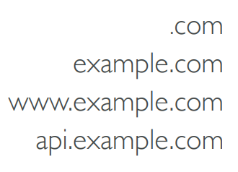

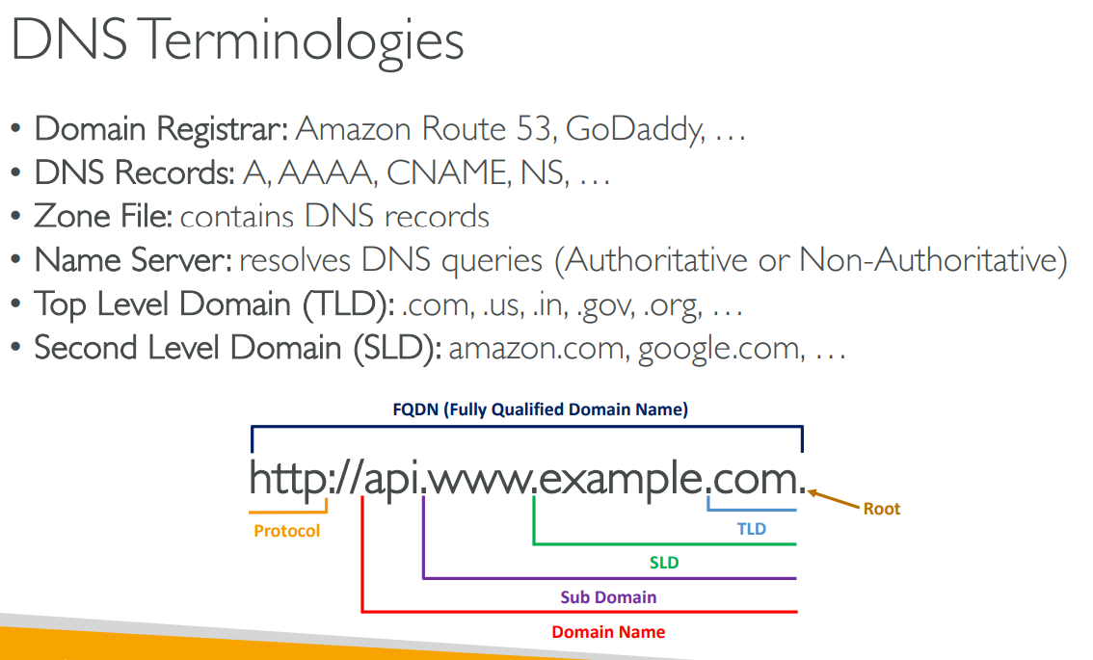

Route 53 – Records

• How you want to route traffic for a domain

• Each record contains:

• **Domain/subdomain Name** – e.g., example.com

• **Record Type** – e.g., A or AAAA

• **Value** – e.g., 12.34.56.78

• **Routing Policy** – how Route 53 responds to queries

• **TTL** – amount of time the record cached at DNS Resolvers

• Route 53 supports the following DNS record types:

• (must know) A / AAAA / CNAME / NS

• (advanced) CAA / DS / MX / NAPTR / PTR / SOA / TXT / SPF / SRV

**Route 53 – Record Types**

**• A** – maps a hostname to IPv4

**• AAAA** – maps a hostname to IPv6

**• CNAME** – maps a hostname to another hostname

• The target is a domain name which must have an A or AAAA record

• Can’t create a CNAME record for the top node of a DNS namespace (Zone Apex)

• Example: you can’t create for example.com, but you can create for www.example.com

**• NS** – Name Servers for the Hosted Zone

• Control how traffic is routed for a domain

**Route 53 – Hosted Zones**

• A container for records that define how to route traffic to a domain and its subdomains

• **Public Hosted Zones** – contains records that specify how to route traffic on the Internet (public domain names) **application1.mypublicdomain.com**

• **Private Hosted Zones** – contain records that specify how you route traffic within one or more VPCs (private domain names) **application1.company.internal**

**CNAME vs Alias**

• CNAME:

• Points a hostname to any other hostname. (app.mydomain.com => blabla.anything.com)

• ONLY FOR NON ROOT DOMAIN (aka. something.mydomain.com)

• Alias:

• Points a hostname to an AWS Resource (app.mydomain.com => blabla.amazonaws.com)

• Works for ROOT DOMAIN and NON ROOT DOMAIN (aka mydomain.com)

• Free of charge

• Native health check

**Route 53 – Alias Records**

• Maps a hostname to an AWS resource

• Automatically recognizes changes in the resource’s IP addresses

• Unlike CNAME, it can be used for the top node of a DNS namespace (Zone Apex), e.g.: example.com

• Alias Record is always of type A/AAAA for AWS resources (IPv4 / IPv6)

• You can’t set the TTL

• You cannot set an ALIAS record for an EC2 DNS name

**Route 53 – Alias Records Targets**

• Elastic Load Balancers

• CloudFront Distributions

• API Gateway

• Elastic Beanstalk environments

• S3 Websites

• VPC Interface Endpoints

• Global Accelerator accelerator

• Route 53 record in the same hosted zone

**Route 53 – Routing Policies**

• Route 53 Supports the following Routing Policies

**• Simple**

**• Weighted**

**• Failover**

**• Latency based**

**• Geolocation**

**• Multi-Value Answer**

**• Geoproximity (using Route 53 Traffic Flow feature)**

**• Simple**

• Typically, route traffic to a single resource

• Can specify multiple values in the same record

• If multiple values are returned, a random one is chosen by the client

• When Alias enabled, specify only one AWS resource

• Can’t be associated with Health Checks

**• Weighted**

• Control the % of the requests that go to each specific resource

• Weights don’t need to sum up to 100

• DNS records must have the same name and type

• Can be associated with Health Checks

• Use cases: load balancing between regions, testing new application versions…

• Assign a weight of 0 to a record to stop sending traffic to a resource

• If all records have weight of 0, then all records will be returned equally

**• Latency based**

• Redirect to the resource that has the least latency close to us

• Super helpful when latency for users is a priority

• Latency is based on traffic between users and AWS Regions

• Germany users may be directed to the US (if that’s the lowest latency)

• Can be associated with Health Checks (has a failover capability)

**• Geolocation**

• Different from Latency-based!

• This routing is based on user location

• Specify location by Continent, Country or by US State (if there’s overlapping, most precise location selected)

• Should create a “Default” record (in case there’s no match on location)

• Use cases: website localization, restrict content distribution, load balancing, …

• Can be associated with Health Checks

**• Geoproximity**

• Route traffic to your resources based on the geographic location of users and resources

• Ability to shift more traffic to resources based on the defined bias

• To change the size of the geographic region, specify bias values:

• To expand (1 to 99) – more traffic to the resource

• To shrink (-1 to -99) – less traffic to the resource

• Resources can be:

• AWS resources (specify AWS region)

• Non-AWS resources (specify Latitude and Longitude)

• You must use Route 53 Traffic Flow to use this feature

**• Multi-Value**

• Use when routing traffic to multiple resources

• Route 53 return multiple values/resources

• Can be associated with Health Checks (return only values for healthy resources)

• Up to 8 healthy records are returned for each Multi-Value query

• Multi-Value is not a substitute for having an ELB

**Route 53 – Health Checks**

• HTTP Health Checks are only for public resources

• Health Check => Automated DNS Failover:

1. Health checks that monitor an endpoint (application, server, other AWS resource)

2. Health checks that monitor other health checks (Calculated Health Checks)

3. Health checks that monitor CloudWatch Alarms (full control !!) – e.g., throttles of DynamoDB, alarms on RDS, custom metrics,… (helpful for private resources)

# Terraform

1. How you use terraform in your project? Explain the terraform script.
2. What is the tf state in terraform? What if I delete it? ( related to status file)
3. Types of terraform
4. Two ways to work with terraform script in AWS.

# Vagrant

1. What are the network keys in vagrant?
2. Multimachines in vagrant

# Kubernetes

## **Can we have multiple containers in a pod? Can we have similar containers in a pod? Let’s say i have 4 containers, one of them has failed how would you check which container has failed?**

Can we have multiple containers in a pod?

Yes, a pod can have multiple containers.

The multi-container pods are the pods that contain two or more related containers that share resources like network space, shared volumes, etc and work together as a single unit.

There are three ways that containers in the pod communicate with each other: Shared Network Namespace, Shared Storage Volumes, and Shared Process Namespace.

There are several multi-container pod design patterns the most common patterns are the **Sidecar pattern**, **Adaptor pattern**, and **Ambassador pattern**.

Sidecar pattern is useful to enhance and extend the functionality of the main application.

Ambassador pattern is useful as a proxy to make the requests to the remote service

How containers in the same pod communicate

There are three ways that containers in the pod communicate with each other: Shared Network Namespace, Shared Storage Volumes, and Shared Process Namespace.

**Shared Network Namespace**

All the containers in the pod share the same network namespace which means all containers can communicate with each other on the localhost. For example, We have two containers in the same pod listening on ports 3000 and 3001 respectively. container 1 can talk to container 2 on localhost:3000.

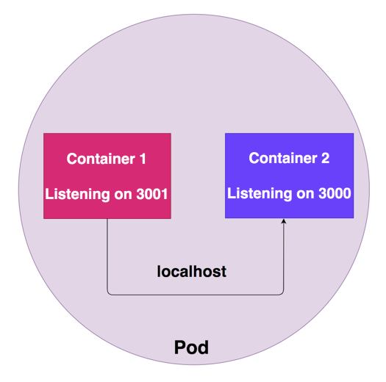

**Shared Storage Volumes**

All the containers can have the same volume mounted so that they can communicate with each other by reading and modifying files in the storage volume.

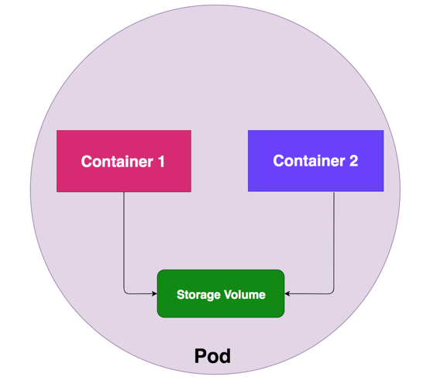

**Shared Process Namespace**

Another way for the containers to communicate with the Shared Process Namespace. With this enabled, containers inside the pod can signal with each other. For this to be enabled, we need to have this setting shareProcessNamespace to true in the pod spec.

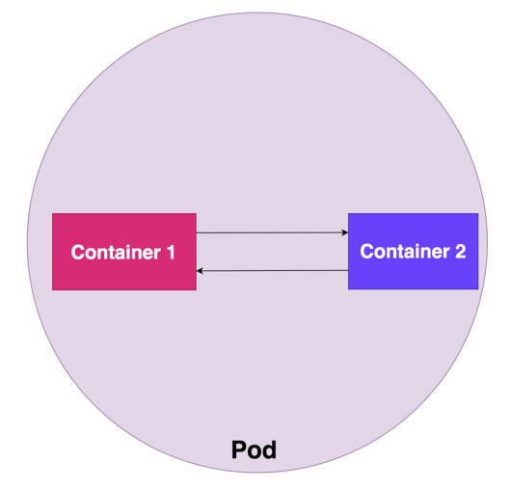

***Multi Container Design Patterns***

As we evolve there are so many design patterns discovered but, there are three commonly used multi-container design patterns: Sidecar pattern, Adaptor pattern, and Ambassador pattern.

**Sidecar pattern**

This pattern resembles the attachment of a sidecar to a motorcycle that why the name called sidecar pattern. Every application has multiple components taking care of several tasks such as monitoring, logging, configuration, etc. We have the main application running in one container and another container helps to isolate the process or tasks that help the main container. In the sidecar pattern, this extra container enhance and extend the functionality of the main container.

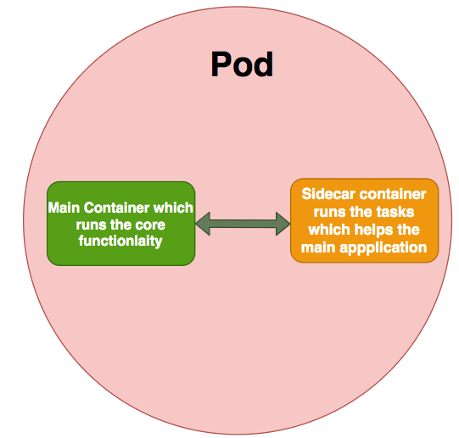

**Examples of sidecars**

There are many use cases for sidecars;

* Logging container is only one (straightforward) example.
* Reloading ConfigMaps in realtime without requiring pod restarts.
* Injecting secrets from Hashicorp Vault into your application.
* Adding a local Redis instance to your application for low-latency in-memory caching.

**Ambassador pattern**

In this pattern, the helper service can send network requests on behalf of the main application. This is considered as a proxy server that can be co-located with the main application. This pattern can be very useful while migrating your legacy application into the cloud. For example, some legacy applications are very difficult to modify and we can use ambassador patterns to handle the request on behalf of the main application.

The common use case for this pattern to offload cross-cutting connectivity concerns and build a common set of connectivity concerns to the infrastructure and this is not suitable when the network latency is critical.

**Ambassador pattern**

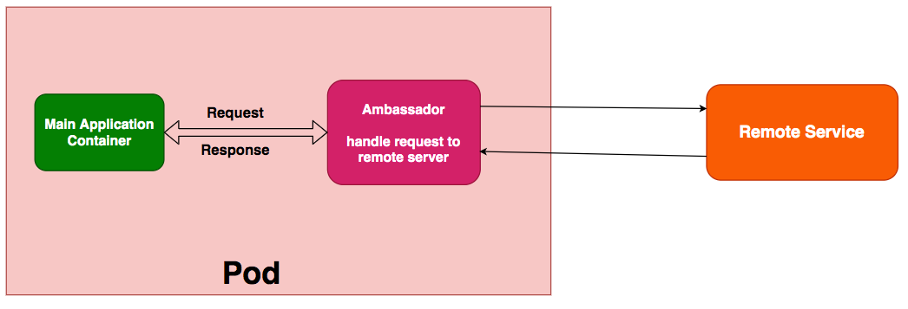

**Can we have similar containers in a pod?**

Yes, you can add multiple container with same image.

* Container names need to be unique
* Container port need to be different.

If containers would have the same port options only the last one container would be running.

**Let’s say i have 4 containers, one of them has failed how would you check which container has failed?**

Look at the state of the containers in the pod. Are they all Running? Have there been recent restarts?

kubectl describe pod <pod-name>

Look at the specific container logs as below

kubectl logs <pod-name> -c <container-name>

## **What is liveness and readiness probe? Why we need them?**

Both liveness & readiness probes are used to control the health of an application.

* Kubernetes uses readiness probes to decide when the container is available for accepting traffic.
* Kubernetes uses liveness probes to know when to restart a container.

Kubernetes supports three mechanisms for implementing liveness and readiness probes:

1) running a command inside a container,

2) making an HTTP request against a container, or

3) opening a TCP socket against a container.

The ready conditions indicate that the application inside the POD is running and is ready to accept user traffic. How does kubernetes know whether that the application inside the container is actually running or not? Here comes into the picture Readiness Probes.

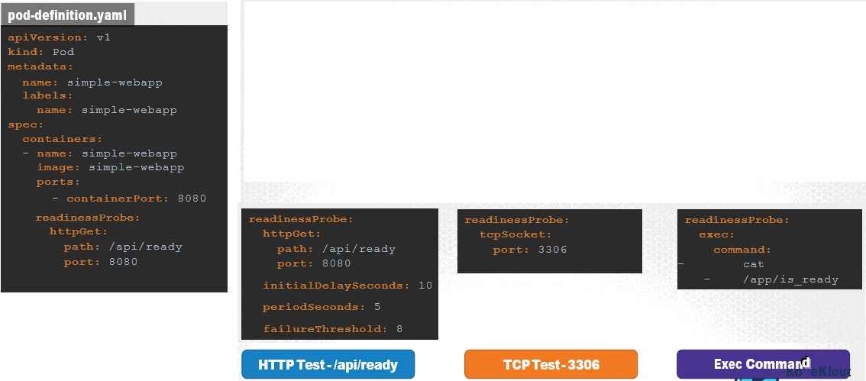

A liveness probe can be configured on the container to periodically test whether the application within the container is actually healthy. If the test fails, the container is considered unhealthy and is destroyed and recreated.

In case of a web application it could be when the API server is up and running.

In case of database, you may test to see if a particular TCP socket is listening.

Or You may simply execute a command to perform a test.

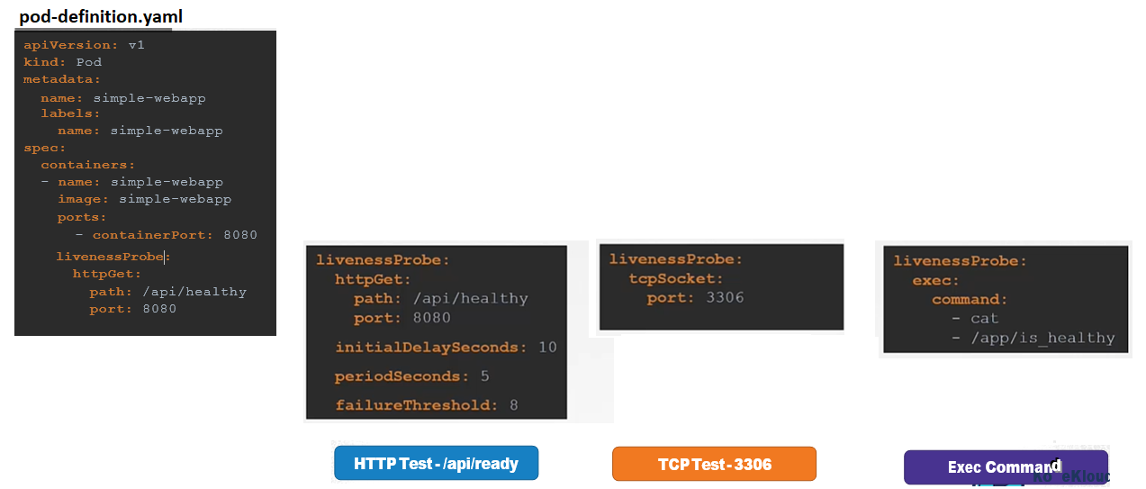

## **Have you worked on kubernetes monitoring? Which tools you have used?**

## **Can we deploy a pod on particular node?**

1. We can schedule a pod to one specific node via setting **nodeName**.

|  |
| --- |
| apiVersion: v1  kind: Pod  metadata:  name: nginx  spec:  nodeName: node1 # schedule pod to specific node  containers:  - name: nginx  image: nginx  imagePullPolicy: IfNotPresent |

1. We can also use **node selectors** to place specific pods on specific nodes

Add a label to a node

kubectl label nodes <node-name> <label-key>=<label-value>

kubectl label nodes node1 size=Large

**pod-definition.yaml**

|  |
| --- |
| apiVersion: v1  kind: Pod  metadata:  name: nginx  labels:  env: test  spec:  containers:  - name: nginx  image: nginx  imagePullPolicy: IfNotPresent  nodeSelector:  size: Large |

## **what is init container and side-car container? can you give simple scenario where we use these containers?**

Init containers are specialized containers that run before app containers in a Pod.

Init containers can contain utilities or setup scripts not present in an app image.

A Pod can have multiple containers running apps within it, but it can also have one or more init containers, which are run before the app containers are started.

Init containers are exactly like regular containers, except:

* Init containers always run to completion.
* Each init container must complete successfully before the next one starts.

If a Pod's init container fails, the kubelet repeatedly restarts that init container until it succeeds. However, if the Pod has a restartPolicy of Never, and an init container fails during startup of that Pod, Kubernetes treats the overall Pod as failed.

Also, init containers do not support lifecycle, livenessProbe, readinessProbe, or startupProbe because they must run to completion before the Pod can be ready.

If you specify multiple init containers for a Pod, kubelet runs each init container sequentially. Each init container must succeed before the next can run.

Init containers example

This example defines a simple Pod that has two init containers. The first waits for myservice, and the second waits for mydb. Once both init containers complete, the Pod runs the app container from its spec section.

**apiVersion**: v1

**kind**: Pod

**metadata**:

**name**: myapp-pod

**labels**:

**app**: myapp

**spec**:

**containers**:

- **name**: myapp-container

**image**: busybox:1.28

**command**: ['sh', '-c', 'echo The app is running! && sleep 3600']

**initContainers**:

- **name**: init-myservice

**image**: busybox:1.28

**command**: ['sh', '-c', "until nslookup myservice.$(cat /var/run/secrets/kubernetes.io/serviceaccount/namespace).svc.cluster.local; do echo waiting for myservice; sleep 2; done"]

- **name**: init-mydb

**image**: busybox:1.28

**command**: ['sh', '-c', "until nslookup mydb.$(cat /var/run/secrets/kubernetes.io/serviceaccount/namespace).svc.cluster.local; do echo waiting for mydb; sleep 2; done"]

You

**Sidecar containers** are the containers that should run along with the main container in the pod. This sidecar pattern extends and enhances the functionality of current containers without changing it.

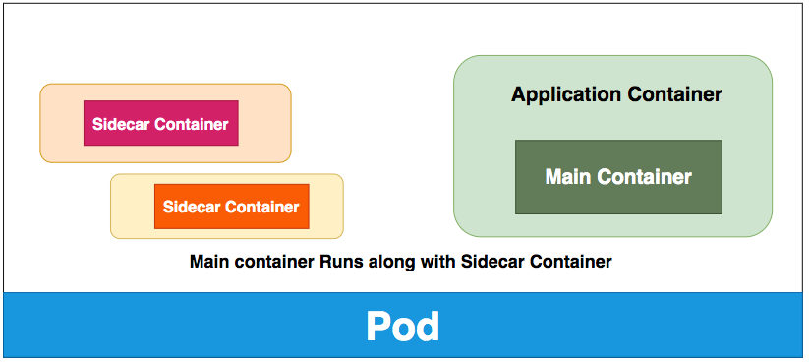

Perhaps the most well-known use case of sidecars is proxies in a service mesh architecture, but there are other examples, including **log shippers**, **monitoring agents** or **data loaders**.

Make sure all your sidecar containers are simple and small enough because you have to sum up all the resources/request limits while defining resource limits for the pod. You need to make sure Sidecar containers are also healthy by configuring health checks.

## **Which one is default deployment strategy? how it works?**

The **rolling deployment** is the standard default deployment to Kubernetes. It works by slowly, one by one, replacing pods of the previous version of your application with pods of the new version without any cluster downtime.

|  |
| --- |
| spec:  replicas: 3  strategy:  type: **RollingUpdate**  rollingUpdate:  maxSurge: 2 # how many pods we can add at a time  maxUnavailable: 0 # maxUnavailable define how many pods can be unavailable  # during the rolling update |

## **command to check the container logs in pod?**

kubectl logs <pod-name> -c <container-name>

## **what are the types of services present in kubernetes?**

Expose an application outside a Kubernetes cluster using a Service

**ClusterIP**. Exposes a service which is only accessible from within the cluster. It is the default

option.

**NodePort**. Exposes a service via a static port on each node's IP.

**LoadBalancer**. Exposes the service via the cloud provider's load balancer.

**Commands**

kubectl expose deployment source-ip-app --name=clusterip --port=80 --target-port=8080

kubectl expose deployment source-ip-app --name=nodeport --port=80 --target-port=8080 --type=NodePort

kubectl expose deployment source-ip-app --name=loadbalancer --port=80 --target-port=8080 --type=LoadBalancer

## **What is the link between pod and service?**

**pods** are "tagged" with labels, and then **services** use label selectors **to** identify the **pods** they proxy **to**. This makes it possible for **services to** reference groups **of pods**

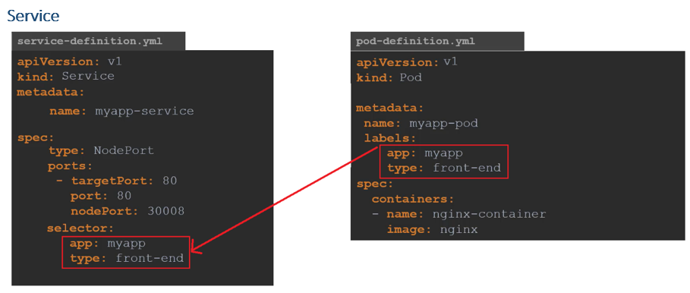

## **List objects you know in kubernetes? Give a brief about each object?**

**Pod**:

Pods are the smallest deployable units in kubernetes.

Pod can contain one or many containers

**ReplicationController**

An RC will launch a specified number of pods called replicas and makes sure that they keep running.

If a pod does crash, the Replication Controller replaces it.

**ReplicaSet**

A ReplicaSet ensures that a specified number of pod replicas are running at any given time.

ReplicaSets are similar as ReplicationControllers, except that they have more options for the selector.

**Deployment**

Deployments are upgraded and higher version of replication controller and ReplicaSet.

It has the capability to update the replica set and are also capable of rolling back to the previous version.

It has many updated features of matchLabels and selectors.

We can update, delete and rollback the deployments.

**Service**

A service can be defined as a logical set of pods.

It can be defined as an abstraction on the top of the pod which provides a single IP address and DNS name by which pods can be accessed.

With Service, it is very easy to manage load balancing configuration.

It helps pods to scale very easily.

We can expose a deployment as a service to make it accessible outside of kubernetes cluster

What are the types of Kubernetes services?

ClusterIP. Exposes a service which is only accessible from within the cluster.

NodePort. Exposes a service via a static port on each node’s IP.

LoadBalancer. Exposes the service via the cloud provider’s load balancer.

ExternalName. Maps a service to a predefined externalName field by returning a value for the CNAME record.

**ConfigMap**

A ConfigMap is an API object that lets you store configuration for other objects to use.

Use a ConfigMap to keep your application code separate from your configuration.

This lets you change easily configuration depending on the environment (development, production, testing) and to dynamically change configuration at runtime.

**Secret**

Kubernetes Secrets let you store and manage sensitive information, such as passwords, OAuth tokens, and ssh keys.

## **Command to list pods and deployments**

kubectl get pods

kubectl get deployments

## **Components in kubernetes architecture?**

**Control plane (master) Components**

kube-apiserver

etcd

kube-scheduler

kube-controller-manager

**Node Components**

kubelet

kube-proxy

Container runtime

**The Control plane (master)**  
The Control plane is made up of the kube-api server, kube scheduler, cloud-controller-manager and kube-controller-manager. Kube proxies and kubelets live on each node, talking to the API and managing the workload of each node.  
  
As the control plane handles most of Kubernetes’ ‘decision making’, nodes which have these components running generally don’t have any user containers running - these are normally named as master nodes.  
  
**Cloud-controller-manager**  
The cloud-controller-manager runs in the control plane as a replicated set of processes (typically, these would be containers in Pods). The cloud-controller-manager is what allows you to connect your clusters with the cloud provider’s API and only runs controllers specific to the cloud provider you’re using.  
  
*Just note:* If you’re running Kubernetes on-prem, your cluster won’t have a cloud-controller-manager.  
  
**Etcd**  
etcd is a distributed key-value store and the primary datastore of Kubernetes. It stores and replicates the Kubernetes cluster state.  
  
To run etcd, you first need to have a Kubernetes cluster and the command-line tool configured to communicate with said cluster.  
  
If you don’t already have a Kubernetes cluster, follow our tutorial to play around with Kubernetes and create one.  
  
**Kubelet**  
The kubelet functions as an agent within nodes and is responsible for the runnings of pod cycles within each node. Its functionality is watching for new or changed pod specifications from master nodes and ensuring that pods within the node that it resides in are healthy, and the state of pods matches the pod specification.  
  
**Kube-proxy**  
Kube-proxy is a network proxy that runs on each node. It maintains network rules, which allow for network communication to Pods from network sessions inside or outside of a cluster. Kube-proxy is used to reach kubernetes services in addition to load balancing of services.  
  
**Kube-controller-manager**  
The Kubernetes controller manager is a collection of controllers bundled within a single binary and run in a single process. The following controllers are present within this manager:

* **NODE CONTROLLER:** Responsible for identifying changes in nodes within the cluster
* **REPLICATION CONTROLLER:** Responsible for maintaining replications of objects in the cluster (such as replicasets)
* **ENDPOINT CONTROLLER**: Responsible for provisioning of endpoints (such as service endpoints)

Service account and token controllers: Responsible the management of service accounts within each namespace, as well as API access tokens  
  
**Kube-API Server**  
The Kube-API server, a component within the control plane, validates and configures data for API objects, including pods and services. The API Server provides the frontend to the cluster's shared state, which is where all of the other components interact. This means that any access and authentication such as deployments of pods and other Kubernetes API objects via kubectl are handled by this API server.  
  
**Kube-scheduler**  
Running as part of the control plane, the kube-scheduler’s responsibility is to assign pods to nodes within your cluster. The scheduler will use information such as compute requests and limits defined within your workload (if any), as well as finding the right node candidate based on its available resources to appropriately assign your workload to a particular node.  
  
**Node**  
Kubernetes runs workloads by placing your pods into nodes. Depending on your environment, a node can represent a virtual or physical machine. Each node will contain the components necessary to run pods. There are two distinct classifications of a node within Kubernetes: Master and Worker nodes.

* **WORKER NODES:**Worker nodes will have an instance of kubelet, kube-proxy and a certain container runtime (such as Docker, containerd) running on each node, and are used to run user defined containers. These nodes are managed by the control plane.
* **MASTER NODES:**A master node, or sometimes called control-plane nodes will have the control plane binaries bootstrapped, and will only be responsible for all components within the control plane, such as runnings of etcd and the kube-api-server. In order to achieve high availability with etcd to establish a quorum, there are normally more than 3 master nodes within a cluster.

## **What are statefulsets in kuberentes?**

StatefulSet is the workload API object used to manage stateful applications.

Manages the deployment and scaling of a set of [Pods](https://kubernetes.io/docs/concepts/workloads/pods/), and provides guarantees about the ordering and uniqueness of these Pods.

StatefulSets are valuable for applications that require one or more of the following.

* Stable, unique network identifiers.
* Stable, persistent storage.
* Ordered, graceful deployment and scaling.
* Ordered, automated rolling updates.

## **Command to find which container has failed in pod and command to get logs of container**

Look at the state of the containers in the pod. Are they all Running? Have there been recent restarts?

kubectl describe pod <pod-name>

Look at the specific container logs as below

kubectl logs <pod-name> -c <container-name>

## **Tools to maintain kubernetes log files**

The ELK Stack (a.k.a. the Elastic Stack)-ELK is an acronym for Elasticsearch, Logstash, and Kibana

AWS CloudWatch

Fluentd

## **Helm chart in k8s**

Helm is a tool that streamlines installing and managing Kubernetes applications. Think of it like Apt/Yum/Homebrew for K8S. Helm uses a packaging format called charts. A chart is a collection of files that describe a related set of Kubernetes resources.

## **How to build an application cluster in k8s?**

We can create K8S cluster using below ways.

Kubeadm

Kops

EKS

## **Can I spin up a new container using k8s on-demand?**

**Scaling** is accomplished by changing the number of replicas in a Deployment

kubectl scale --current-replicas=2 --replicas=3 deployment/mysql

## **What are mini-cubes in k8s?**

**minikube** is a tool that lets you run Kubernetes locally. **minikube** runs a single-node Kubernetes cluster on your personal computer (including Windows, macOS and Linux PCs) so that you can try out Kubernetes, or for daily development work.

## **Canary deployment**

Release small portion of the traffic to the newer version, if it is working fine then direct all traffic tonewer version else rollback the newer version.

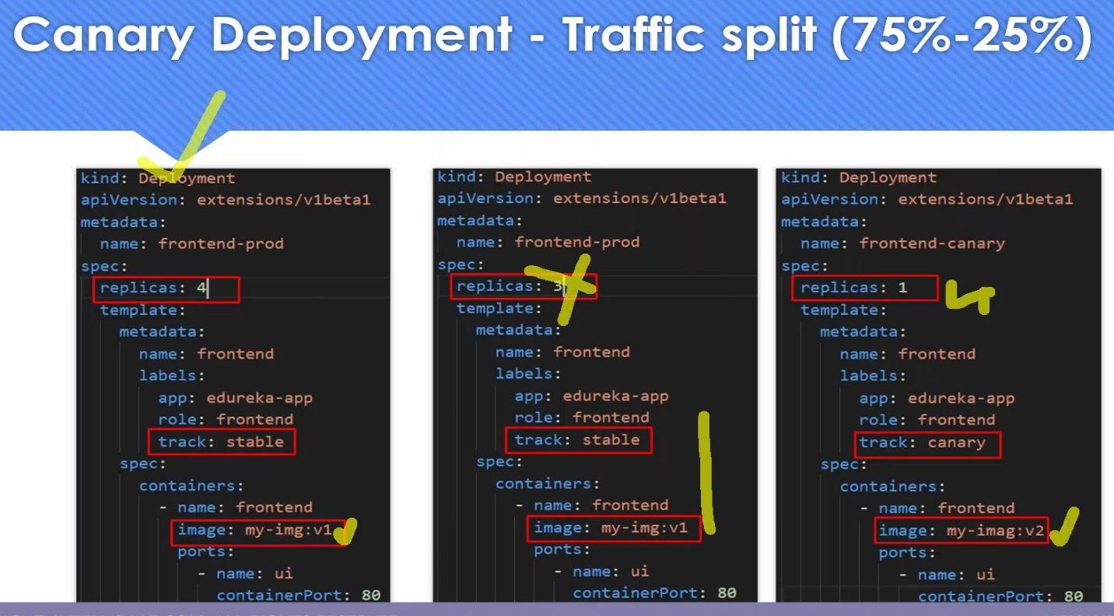

## **StatefulSets**

<https://www.magalix.com/blog/kubernetes-patterns-the-stateful-service-pattern>

* Many legacy applications were not designed to be cloud-native. They need special requirements regarding how their data should be stored, how their identity should be preserved on the network, and how they require specific handling when started or shutdown. Through StatefulSets, Kubernetes offer support to most of those requirements.
* StatefulSets are meant to deploy applications that maintain their state. Their replicas are not identical as each one needs its own identity and storage.
* ReplicaSets fall short when used to deploy a stateful application because they treat all the Pods the same, give them random hostnames and IP addresses that change on restarts.
* A StatefulSet guarantees every Pod to have a unique hostname and dedicated storage. Using a StatefulSet, you ensure that no duplicate Pods get created. If the Pod needs to be moved to a different node, the new Pod does not start except when Kubernetes provides that the old one has completely shut down. This behavior ensures that no duplicate Pods exist, which is not guaranteed when using ReplicaSets.
* StatefulSet offers built-in support for Canary Release strategy. It allows you to choose a specific number of Pods to be affected by an update while the rest remain using the old version. This ensures that changes can be easily rolled back and ensures that the application does not break due to a wrong update.
* StatefulSets are typically used with databases and clustered applications that have specific requirements like quorum.

## **Kubernetes Design Pattern**

**Design Pattern usage Scenarios**

**My application is not running but K8S is still trying to run the pod:**

**we need to implement the health probe**

**When my application is shutting down it is losing some data:**

**We need to use managed lifecycle pattern- prestop hook**

**When my application is consuming more resources(CPU,Memory) more than what it should consume:**

**We need to implement predictable demands**

**When K8S is basically removing the pods, my pod is getting removed quickly, that is probably we have used "best effort" Quality of Service:**

**We need to use "burstable QoS"**

**I want to run my pod on a particular node:**

**We need to use Automated placement pattern.**

**Schedule the pod in a node which has a SSD disk and 2 core CPU:**

**We need to use Node Affinity**

**Run the Application Pod in the node where DB Pod is running:**

**We need to use Pod Affinity**

1. **Foundational Patterns**

Predictable Demands

Declarative Deployment

Health Probe

Managed Lifecycle

Automated Placement

1. **Behavioral Patterns**

Batch Job

Periodic Job

Daemon Service

Singleton Service

Stateful Service

Service Discovery

Self Awareness

1. **Structural Patterns**

Init Container

Sidecar

Adapter

Ambassador

1. **Configuration Patterns**

EnvVar Configuration

Configuration Resource

Immutable Configuration

Configuration Template

1. **Advanced Patterns**

Controller

Operator

Elastic Scale

Image Builder

## **When u do kubectl apply -f pod.yaml , what happens internally right from command to pod creation (something about apiserver and authentication and validation)**

## **What did u do in ur last organisation related to k8s.You daily activities in k8s.What k8 objects did u use in ur last company.**

## **Diif between deployment , replica set and stateful states.**

Deployments and ReplicaSets are meant for stateless usage and are rather lightweight. StatefulSets are used when state has to be persisted. Therefore, the latter use volumeClaimTemplates / claims on persistent volumes to ensure they can keep the state across component restarts.

**Deployment** is a resource to deploy a stateless application, if using a PVC, all replicas will be using the same Volume and none of it will have its own state.

You specify a PersistentVolumeClaim that is shared by all pod replicas. In other words, shared volume.

The backing storage obviously must have ReadWriteMany or ReadOnlyMany accessMode if you have more than one replica pod.

A **ReplicaSet** ensures that a specified number of pod replicas are running at any given time.However, a Deployment is a higher-level concept that manages ReplicaSets and provides declarative updates to Pods along with a lot of other useful features.

**StatefulSet** - You specify a volumeClaimTemplates so that each replica pod gets a unique PersistentVolumeClaim associated with it. In other words, no shared volume.

Here, the backing storage can have ReadWriteOnce accessMode.

StatefulSet is useful for running things in cluster e.g Hadoop cluster, MySQL cluster, where each node has its own storage.

## **Do u think ip adress is retained if a pod is deleted in a stateful set.**

Regardless of amount of restarts, pod is assigned with the same DNS name. Note, IP addresses might be still different, so consumers should depend on DNS name

## **Pod is not coming up in a node ? what may be reasons why pod is not initiated? (memory issue, taint,tolerations).**

kubectl describe pods ${POD_NAME}

If a pod is stuck in Pending it means that it can not be scheduled onto a node. Generally this is because there are insufficient resources of one type or another that prevent scheduling. Look at the output of the kubectl describe ... command above. There should be messages from the scheduler about why it can not schedule your pod.

Reasons include:

**Insufficient resources**

You may have exhausted the supply of CPU or Memory in your cluster.

If a pod is stuck in the Waiting state, then it has been scheduled to a worker node, but it can't run on that machine. Check for **taints and tolerations** also.

The most common cause of Waiting pods is a failure to pull the image.

## **How to do autoscaling of deployment and pods and k8s clusters ? (HPA,VPA,EKS).**

## **Container not coming up , how do u check that ? (kubectl logs , get pods ).**

## **If we need logs of complete k8 cluster , where to get that.**

## **Different componets of k8s.**

## **Diff between helm and operator framework? what is use case scenario of both with example.**

## **What diff between local and remote storage in k8s ? types of volumes in k8s . how to retain data if pod goes down ?**

## **Differnence between managed k8 service like EKS and traditional k8 cluster.**

## **Bare metal k8s vs EKS ? which one is better**

## **If u have 3 enviroments , dev,qa,prod ? how to manage that? how to store secret envirorent variables in ur yaml file.**

## **How to make ur application highly available on pod level ? (speak about probes , hpa,vba and other stuffs).**

## **Single container pod , multi container pod. explain use cases. Can we have 2 nginx container in same pod ?**

## **What is init container and sidecar container ,real time use cases.**

## **What is the use of service account.**

## **Once u write a deployment yaml and apply it , how to access the application from outside world ?(through browser). speak about node port service and ingress controller.**

## **What is the use of cluster IP ?**

The ClusterIP provides a load-balanced IP address. One or more pods that match a label selector can forward traffic to the IP address. The ClusterIP service must define one or more ports to listen on with target ports to forward TCP/UDP traffic to containers.

ClusterIP is the default kubernetes service. This service is created inside a cluster and can only be accessed by other pods in that cluster. So basically we use this type of service when we want to expose a service to other pods within the same cluster. This service is accessed using kubernetes proxy.

## **UR app needs some file available in ur desktop pc? how to transfer that file to the pods (config maps).**

## **Different between secrets and config maps? use case scenario.**

Both, ConfigMaps and Secrets store data as a key value pair. The major difference is, Secrets store data in base64 format meanwhile ConfigMaps store data in a plain text.

If you have some critical data like, keys, passwords, service accounts credentials, db connection string, etc then you should always go for Secrets rather than Configs.

And if you want to do some application configuration using environment variables which you don't want to keep secret/hidden like, app theme, base platform url, etc then you can go for ConfigMaps

## **Explain static pods (/etc/maintainance ).**

Static pods are managed directly by kubelet daemon on a specific node, without API server observing it. It does not have associated any replication controller, kubelet daemon itself watches it and restarts it when it crashes. There is no health check though. Static pods are always bound to one kubelet daemon and always run on the same node with it.

Kubelet automatically creates so-called mirror pod on Kubernetes API server for each static pod, so the pods are visible there, but they cannot be controlled from the API server.

## **Why daemon sets are required?**

DaemonSets are useful for deploying ongoing background tasks that you need to run on all or certain nodes, and which do not require user intervention.

The DaemonSet feature is used to ensure that some or all of your pods are scheduled and running on every single available node. This essentially runs a copy of the desired pod across all nodes. When a new node is added to a Kubernetes cluster, a new pod will be added to that newly attached node.

Communicating with a DaemonSet

* Specify hostPort in the DaemonSet's pod spec to expose it on the node. You can then communicate with it directly by using the IP of the node it is running on.
* Create a service with the same pod selector as the DaemonSet and then use the service to reach your DaemonSet.

## **When u write a deployment /replica set, it creates pods on nodes , not in master ? why pods are not created in master (speak about taints, toleration). how to deploy on master**

When the Kubernetes cluster is first set up, a Taint is set on the master node. This automatically prevents any pods from being scheduled on this node. You can see this as well as modify this behavior if required. However, a best practice is not to deploy application workloads on a master server.

you could disable the “NoSchedule” property so master node could run pod as well.

Below command can be used to remove taint from node.

kubectl taint nodes controlplane node-role.kubernetes.io/master:**NoSchedule-**

## **How to deploy pod on a particular node . speak about node selector and node affinity.**

**nodeSelector**

Add a nodeSelector field to your pod configuration

apiVersion: v1

kind: Pod

metadata:

name: nginx

labels:

env: test

spec:

containers:

- name: nginx

image: nginx

imagePullPolicy: IfNotPresent

nodeSelector:

disktype: ssd

**Node affinity**

Node affinity is conceptually similar to nodeSelector -- it allows you to constrain which nodes your pod is eligible to be scheduled on, based on labels on the node.

There are currently two types of node affinity, called requiredDuringSchedulingIgnoredDuringExecution and preferredDuringSchedulingIgnoredDuringExecution. You can think of them as "hard" and "soft" respectively

apiVersion: v1

kind: Pod

metadata:

name: with-node-affinity

spec:

affinity:

nodeAffinity:

requiredDuringSchedulingIgnoredDuringExecution:

nodeSelectorTerms:

- matchExpressions:

- key: kubernetes.io/e2e-az-name

operator: In

values:

- e2e-az1

- e2e-az2

preferredDuringSchedulingIgnoredDuringExecution:

- weight: 1

preference:

matchExpressions:

- key: another-node-label-key

operator: In

values:

- another-node-label-value

containers:

- name: with-node-affinity

image: k8s.gcr.io/pause:2.0

## **How to upgrade old k8 version to new k8 version while pods are running ? will pod work on K8 version which is 3 version old.**

## **What is namespace ? by default how many namespace are there in k8s (4).**

**namespaces** provides a mechanism for isolating groups of resources within a single cluster. Names of resources need to be unique within a namespace, but not across namespaces. Namespace-based scoping is applicable only for namespaced objects (e.g. Deployments, Services, etc) and not for cluster-wide objects (e.g. StorageClass, Nodes, PersistentVolumes, etc).

Namespaces are intended for use in environments with many users spread across multiple teams, or projects.

Kubernetes starts with four initial namespaces:

1. **default** The default namespace for objects with no other namespace
2. **kube-system** The namespace for objects created by the Kubernetes system
3. **kube-public** This namespace is created automatically and is readable by all users (including those not authenticated). This namespace is mostly reserved for cluster usage, in case that some resources should be visible and readable publicly throughout the whole cluster. The public aspect of this namespace is only a convention, not a requirement.
4. **kube-node-lease** This namespace holds Lease objects associated with each node. Node leases allow the kubelet to send heartbeats so that the control plane can detect node failure.

## **How to restrict cpu resources , memory limit on pod and namespace (resource quota).**

Create a ResourceQuota andapply to namespace

quota-mem-cpu.yaml

apiVersion: v1

kind: **ResourceQuota**

metadata:

name: mem-cpu-demo

spec:

hard:

requests.cpu: "1"

requests.memory: 1Gi

limits.cpu: "2"

limits.memory: 2Gi

kubectl apply -f quota-mem-cpu.yaml --namespace=quota-mem-cpu-example

## **Why use of networking solution is needed like flannel,calico,weavenet ? explain with example.**

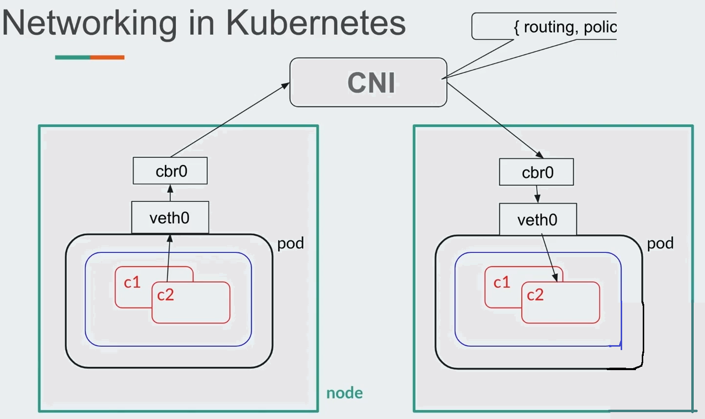

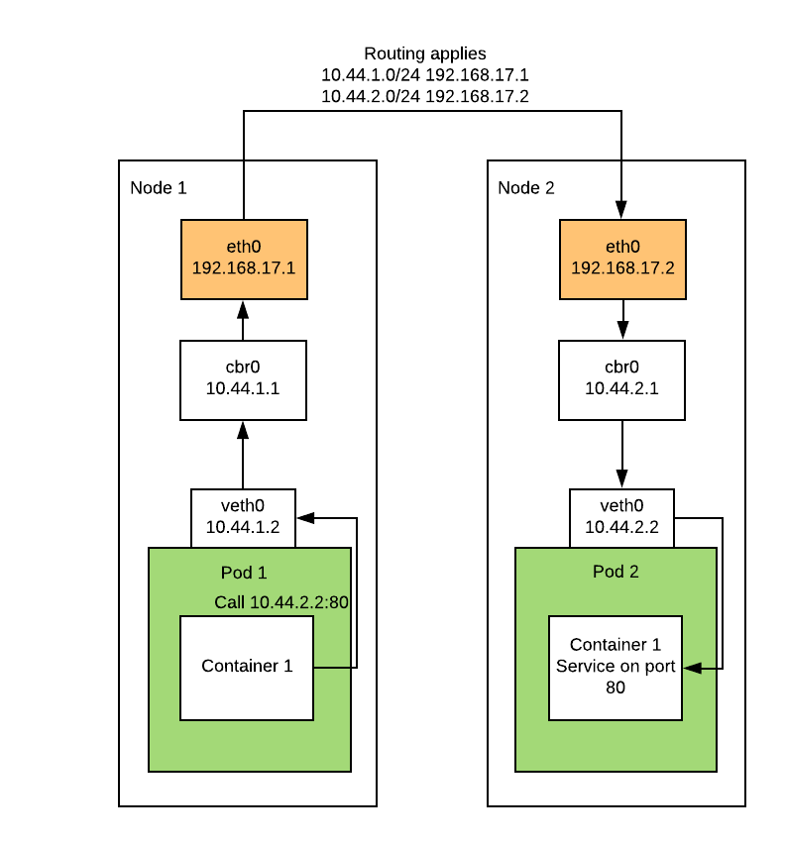

Kubernetes requires networks to follow these rules:

* All pods can communicate with each other without NAT
* All nodes can communicate with pods without NAT, in both directions
* The IP seen by a container is the same as the IP seen by external components

1. Networking in Kubernetes is not a kubernetes thing.
2. CNI defines the specification for networking.
3. Network plugins implement this.

The CNI plugin is responsible wiring up the container. That is – it needs to do all the work to get the container on the network. In Docker, this would include connecting the container network namespace back to the host somehow.

Kubernetes uses CNI as an interface between network providers and Kubernetes pod networking.

**flannel,calico,weavenet provide the CNI solution in kubernetes**

## **What is rbac**

RBAC, **Role-based access control**, is an authorization mechanism for managing permissions around Kubernetes resources. RBAC allows configuration of flexible authorization policies that can be updated without cluster restarts.

## **Use of PV and PVC**

A **PersistentVolume (PV)** is a piece of storage in the cluster that has been provisioned by an administrator or dynamically provisioned using Storage Classes. It is a resource in the cluster just like a node is a cluster resource. PVs are volume plugins like Volumes, but have a lifecycle independent of any individual Pod that uses the PV.

A **PersistentVolumeClaim (PVC)** is a request for storage by a user. It is similar to a Pod. Pods consume node resources and PVCs consume PV resources. Pods can request specific levels of resources (CPU and Memory). Claims can request specific size and access modes (e.g., they can be mounted ReadWriteOnce, ReadOnlyMany or ReadWriteMany

## **Explain ingress in k8s**

Ingress exposes HTTP and HTTPS routes from outside the cluster to services within the cluster. Traffic routing is controlled by rules defined on the Ingress resource.

Here is a simple example where an Ingress sends all its traffic to one Service:

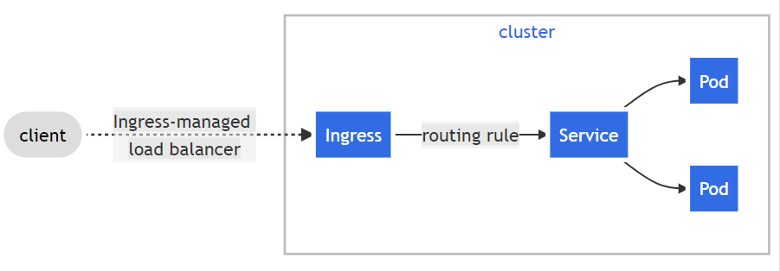

An Ingress may be configured to give Services externally-reachable URLs, load balance traffic, terminate SSL / TLS, and offer name-based virtual hosting. An Ingress controller is responsible for fulfilling the Ingress, usually with a load balancer, though it may also configure your edge router or additional frontends to help handle the traffic.

An Ingress does not expose arbitrary ports or protocols. Exposing services other than HTTP and HTTPS to the internet typically uses a service of type Service.Type=NodePort or Service.Type=LoadBalancer.

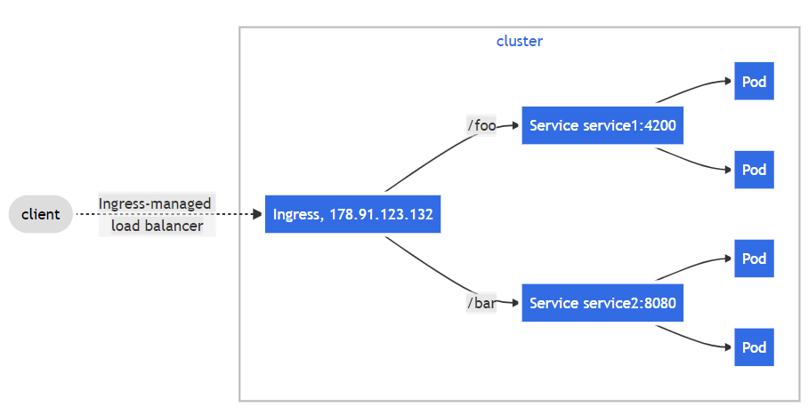

## **Did u setup any monitoring tools on ur k8 cluster**

I have set up Kubernetes monitoring with Prometheus

## **Ambassador container pattern**

An Ambassador container is a sidecar container that is in charge of proxying connections from the application container to other services.You might be wondering, why do we need to proxy the application connection requests? Because we need to follow the separation of concerns principle. Each container should do its task and do it well. If there are other tasks that require the application’s function in order to work correctly, we may hand those tasks to the sidecar container.

For example, almost all applications need a database connection at some phase. In a multi-environment place, there would be a test database, a staging database, and a production database. When writing the Pod definition for their application’s container, developers must pay attention to which database they’ll be connecting to. A database connection string can be easily changed through an environment variable or a configMap. We could also use a sidecar pattern that proxies DB connections to the appropriate server depending on where it runs. Developers needn’t change the connection string, they could leave the DB server at localhost as usual. When deployed to a different environment, the Ambassador container detects which environment it is running on (possibly through the Reflection pattern), and connects to the correct server.

Another well-known use case for the Ambassador container is when your application needs to connect to a caching server like Memcached or Redis. Let’s have a Redis example scenario to demonstrate this pattern.

Scenario: Connecting to Multiple Redis Servers

Let’s assume that your application needs to connect to a caching server like Redis. In the development environment, Redis is installed on your laptop and listening on the localhost. In other environments, you have more than one Redis instance for high availability. You need to configure your application and select a healthy node then connect to it. One possible solution to this case is to use an Ambassador container that proxies connections to the backend Redis servers. The Ambassador container listens on the localhost as it is sharing the same Pod as the application container. In our example, we use [Twemproxy](https://github.com/twitter/twemproxy) to handle connecting to the Redis instances. The scenario can be depicted in the following illustration:

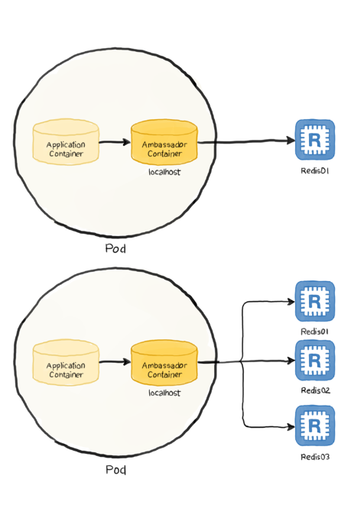

Our definition file may look as follows:

apiVersion: v1

kind: Pod

metadata:

name: ambassador-example

spec:

containers:

- name: redis-client

image: redis

- name: ambassador

image: malexer/twemproxy

env:

- name: REDIS_SERVERS

value: redis-st-0.redis-svc.default.svc.cluster.local:6379:1 redis-st-1.redis-svc.default.svc.cluster.local:6379:1

ports:

- containerPort: 6380

The definition defines two Pods:

* The application Pod: It is the first pod in the list that runs Redis image, but we are using it as a client to other Redis servers.
* The ambassador Pod: It is the second container that runs the [Twemproxy](https://github.com/twitter/twemproxy) as we discussed. We used the [malexer/twemproxy](https://github.com/malexer/docker-twemproxy) image, which needs the Redis instances passed as environment variables (lines 11-13) in this form address:port:weight.
* The container by default listens on port 6380 (for advanced configurations, please visit the image’s project page at [malexer/twemproxy](https://github.com/malexer/docker-twemproxy)).

**Therefore, the workflow can be summarized as follows:**

1. The application (simulated by the Redis client) initiates a request to localhost:6380. As far as the application is concerned, this is the Redis server.
2. The Ambassador container picks up the request and relays it to the Redis servers defined in its configuration.

## **On what basis HPA autoscales pods ?**

In Kubernetes, a HorizontalPodAutoscaler automatically updates a workload resource (such as a Deployment or StatefulSet), with the aim of automatically scaling the workload to match demand.

Horizontal scaling means that the response to increased load is to deploy more Pods. This is different from vertical scaling, which for Kubernetes would mean assigning more resources (for example: memory or CPU) to the Pods that are already running for the workload.

If the load decreases, and the number of Pods is above the configured minimum, the HorizontalPodAutoscaler instructs the workload resource (the Deployment, StatefulSet, or other similar resource) to scale back down.

Horizontal pod autoscaling does not apply to objects that can't be scaled (for example: a DaemonSet.)

The HorizontalPodAutoscaler is implemented as a Kubernetes API resource and a controller. The resource determines the behavior of the controller. The horizontal pod autoscaling controller, running within the Kubernetes control plane, periodically adjusts the desired scale of its target (for example, a Deployment) to match observed metrics such as average CPU utilization, average memory utilization, or any other custom metric you specify.

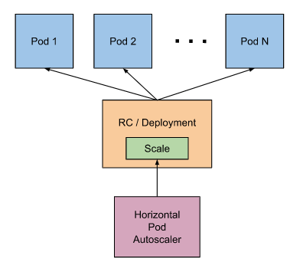

## **Bare metal k8 or eks , which one is cheap?**

Bare metal K8S is cheap.

## **My app has a application server and a DB. which k8 objects are u going to create for application server and db?**

Deployment is an object that can represent an application running on your cluster.

We can deploy a database to Kubernetes as a stateful application. Usually, when we deploy pods they have their own storage, but that storage is ephemeral - if the container kills its storage, it’s gone with it.

So, we’ll have a Kubernetes object to tackle that scenario: when we want our data to persist we attach a pod with a respective persistent volume claim. By doing it this way, if our container kills our data, it will be in the cluster, and the new pod will access the data accordingly.

Pod -> PVC -> PV

PV = Persistent Volume

PVC = Persistent Volume Claim

## **While writing deployment strategies , u must have encountered rolling updates, canary, etc. explain those**

**Intro To Deployment Strategies: Blue-Green, Canary, And More**

**Deployment Strategies For Continuous Delivery. Which Deployment Strategy Should You Use: Basic, Multi-Service, Rolling, Blue/Green, Canary, A/B Testing?**

Whether we mean to or not, software deployments look different across organizations, teams, and applications. This can make pushing the deployment button feel like playing a game of craps: you roll the dice and try to stay alive. Luckily, there are a few ways to limit the variance in success. This blog post will discuss the different strategies and practices that can help you succeed with your production deployments.

### **Deployment Strategies to Consider**

Deployment strategies are practices used to change or upgrade a running instance of an application. The following sections will explain six deployment strategies. Let’s start with discussing the basic deployment.

### **The Basic Deployment**

In a basic deployment, all nodes within a target environment are updated at the same time with a new service or artifact version. Because of this, basic deployments are not outage-proof and they slow down rollback processes or strategies. Of all the deployment strategies shared, it is the riskiest.

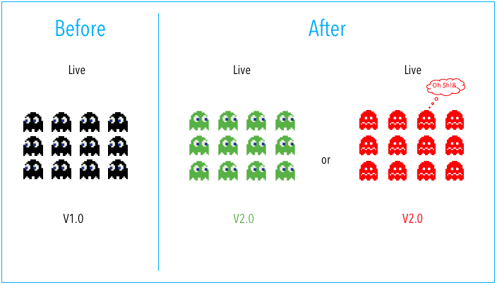

#### **Pros:**

The benefits of this strategy are that it is simple, fast, and cheap. Use this strategy if 1) your application service is not business, mission, or revenue-critical, or 2) your deployment is to a lower environment, during off-hours, or with a service that is not in use.

#### **Cons:**

Of all the deployment strategies shared, it is the riskiest and does not fall into best practices. Basic deployments are not outage-proof and do not provide for easy rollbacks.

### **The Multi-Service Deployment**

In a multi-service deployment, all nodes within a target environment are updated with multiple new services simultaneously. This strategy is used for application services that have service or version dependencies, or if you’re deploying off-hours to resources that are not in use.

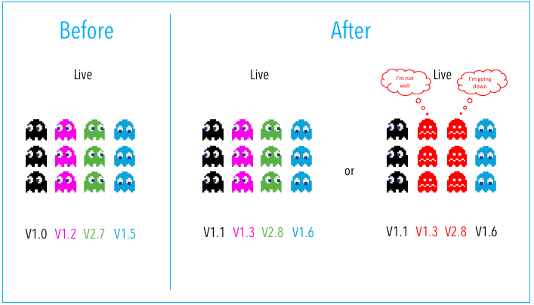

#### **Pros:**

Multi-service deployments are simple, fast, cheap, and not as risk-prone as a basic deployment.

#### **Cons:**

Multi-service deployments are slow to roll back and not outage-proof. Using this deployment strategy also leads to difficulty in managing, testing, and verifying all the service dependencies.

### **Rolling Deployment**

A rolling deployment is a deployment strategy that updates running instances of an application with the new release. All nodes in a target environment are incrementally updated with the service or artifact version in integer N batches.

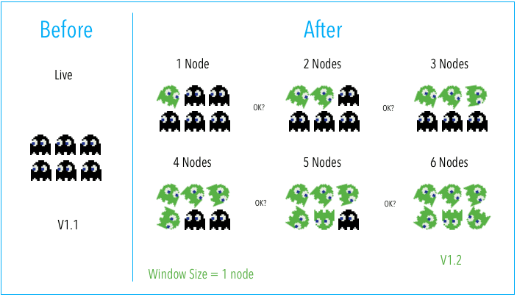

#### **Pros:**

The benefits of a rolling deployment are that it is relatively simple to roll back, less risky than a basic deployment, and the implementation is simple.

#### **Cons:**

Since nodes are updated in batches, rolling deployments require services to support both new and old versions of an artifact. Verification of an application deployment at every incremental change also makes this deployment slow.

### **Blue-Green Deployment**

Blue-green deployment is a deployment strategy that utilizes two identical environments, a “blue” (aka staging) and a “green” (aka production) environment with different versions of an application or service. Quality assurance and user acceptance testing are typically done within the blue environment that hosts new versions or changes. User traffic is shifted from the green environment to the blue environment once new changes have been testing and accepted within the blue environment. You can then switch to the new environment once the deployment is successful.

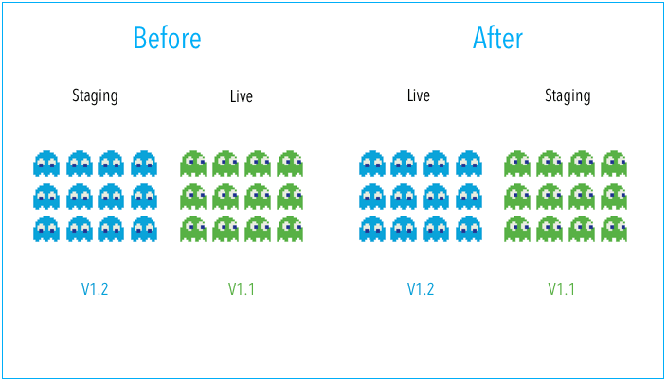

#### **Pros:**

One of the benefits of the blue-green deployment is that it is simple, fast, well-understood, and easy to implement. Rollback is also straightforward, because you can simply flip traffic back to the old environment in case of any issues. Blue-green deployments are therefore not as risky compared to other deployment strategies.

#### **Cons:**

Cost is a drawback to blue-green deployments. Replicating a production environment can be complex and expensive, especially when working with microservices. Quality assurance and user acceptance testing may not identify all of the anomalies or regressions either, and so shifting all user traffic at once can present risks. An outage or issue could also have a wide-scale business impact before a rollback is triggered, and depending on the implementation, in-flight user transactions may be lost when the shift in traffic is made.

### **Canary Deployment**

A canary deployment is a deployment strategy that releases an application or service incrementally to a subset of users. All infrastructure in a target environment is updated in small phases (e.g: 2%, 25%, 75%, 100%). A canary release is the lowest risk-prone, compared to all other deployment strategies, because of this control.

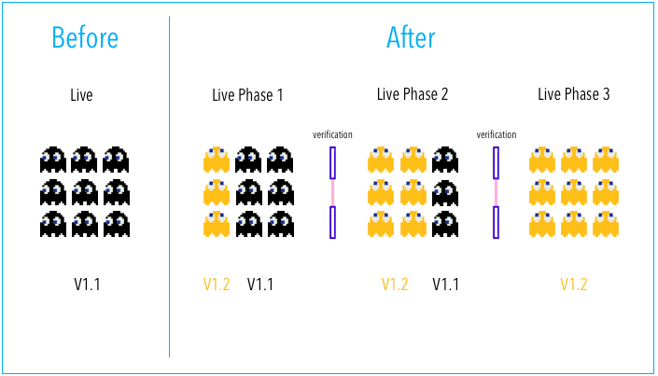

#### **Pros:**

Canary deployments allow organizations to test in production with real users and use cases and compare different service versions side by side. It’s cheaper than a blue-green deployment because it does not require two production environments. And finally, it is fast and safe to trigger a rollback to a previous version of an application.

#### **Cons:**

Drawbacks to canary deployments involve testing in production and the implementations needed. Scripting a canary release can be complex: manual verification or testing can take time, and the required monitoring and instrumentation for testing in production may involve additional research.

### **A/B Testing**

In A/B testing, different versions of the same service run simultaneously as “experiments” in the same environment for a period of time. Experiments are either controlled by feature flags toggling, A/B testing tools, or through distinct service deployments. It is the experiment owner’s responsibility to define how user traffic is routed to each experiment and version of an application. Commonly, user traffic is routed based on specific rules or user demographics to perform measurements and comparisons between service versions. Target environments can then be updated with the optimal service version.

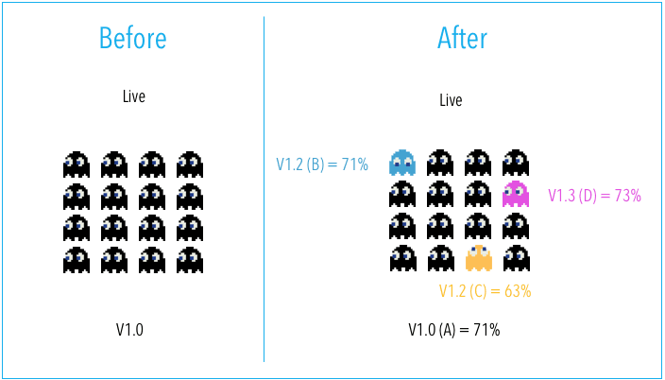

The biggest difference between A/B testing and other deployment strategies is that A/B testing is primarily focused on experimentation and exploration. While other deployment strategies deploy many versions of a service to an environment with the immediate goal of updating all nodes with a specific version, A/B testing is about testing multiple ideas vs. deploying one specific tested idea.

#### **Pros:**

A/B testing is a standard, easy, and cheap method for testing new features in production. And luckily, there are many tools that exist today to help enable A/B testing.

#### **Cons:**

The drawbacks to A/B testing involve the experimental nature of its use case. Experiments and tests can sometimes break the application, service, or user experience. Finally, scripting or automating AB tests can also be complex.

**Which Deployment Strategy Should I Use?**

Now that we know different deployment techniques, a commonly asked question may be, which deployment strategy should I use? The answer depends on the type of application you have and your target environment.

Based on conversations with Harness customers, most teams use blue-green or canary deployments for mission-critical web applications. Customers have minimal to little business impact when migrating from the blue-green deployment strategy to a canary deployment strategy. It’s also common for teams to create their strategy based on combining the strategies we shared in this blog post. For example, some customers will do multi-service canary deployments.

**Eliminating After-Hours Deployments**

Software delivery is challenging. Anyone who has a deployment horror story can attest to this. One way that we can eliminate toil and spend time and efforts where it really matters is to leverage some deployment strategies and practices that can help with operationalizing our services.

* Some practices or standards to consider implementing include: service-specific deployment checklists
* [Continuous Integration](https://harness.io/blog/what-is-continuous-integration/) (CI) and [Continuous Delivery](https://harness.io/blog/what-is-continuous-delivery/) (CD)
* Well-defined and understood environments
* Build automation tooling
* Configuration management tools
* Communication channels like Slack
* An on-call or incident response playbook
* Automated rollbacks

A good portion of these practices can help with server or service downtime, software bugs, continuous feedback, and new application deployments. Aside from creating a foundation for better software delivery, there are also opportunities to leverage automation alongside our metrics and monitoring tools through the practice of Continuous Verification (CV).

## **Explain k8s operators**

A Kubernetes operator is a method of packaging, deploying, and managing a Kubernetes application.

It builds upon the basic Kubernetes resource and controller concepts, but includes domain or application-specific knowledge to automate the entire life cycle of the software it manages.

## **Explain headless services in k8s ? where have u used it?**

During the development of one of our apps we came across an issue where we needed to communicate with all associated pods instead of load-balancing. Our backend has 7 pods, all with the same image but different secrets to update databases at different locations.

A headless service is a service with a service IP but instead of load-balancing it will return the IPs of our associated Pods. This allows us to interact directly with the Pods instead of a proxy. It's as simple as specifying None for .spec.clusterIP and can be utilized with or without selectors - you'll see an example with selectors in a moment.

Instead of writing a service for each location and creating a ton of overhead with repetitive yaml files, changing the deployed service to a headless service was the best way to go.

Headless service is typically used with StatefulSets where the name of the pods are fixed. This is useful in situations like when you're settling up a MySQL cluster where you need to know the name of the master. StatefulSets appends an ordinal number to the name of the pod and it will always assign the same ordinal number of the pod is restarted or migrated by the scheduler.

apiVersion: v1

kind: Service

metadata:

name: my-headless-service

spec:

**clusterIP: None** # <--

selector:

app: test-app

ports:

- protocol: TCP

port: 80

targetPort: 3000

## **Advantages of k8s over docker swarm**

### **Pros of Kubernetes**

* [Open-source community](https://kubernetes.io/) that is very active in developing the code base
* Fast-growing KubeCon conferences throughout the year that are more than doubling attendance numbers
* Battle-tested by big players like Google and our own IBM workloads and runs on most operating systems
* Largest adoption in the market
* Available on the public cloud or for on-premises — managed or non-managed offerings from all the big cloud providers (IBM Cloud, AWS, Microsoft Azure, Google Cloud Platform, etc.)
* Broad Kubernetes support from an ecosystem of cloud tool vendors, such as Sysdig, LogDNA, and Portworx (among many others)
* Key functionalities include service discovery, [ingress](https://www.ibm.com/cloud/blog/kubernetes-ingress) and [load balancing](https://www.ibm.com/cloud/learn/load-balancing), self-healing, storage orchestration, horizontal scalability, automated rollouts and rollbacks, and batch execution
* Unified set of APIs and strong guarantees about the cluster state

### **Cons of Kubernetes**

* Management of the Kubernetes master takes specialized knowledge
* Updates from open source community are frequent and require careful patching in order to avoid disrupting workloads
* Too heavyweight for individual developers to set up for simplistic apps and infrequent deployments
* Often need additional tools (e.g., kubectl CLI), services, continuous integration/continuous deployment (CI/CD) workflows and other DevOps practices to fully manage access, identity, governance and security

### **Pros of Docker Swarm**

* Built for use with the Docker Engine (Docker is a container platform used for building and deploying containerized applications)
* Has its own Swarm API
* Smoothly integrates with Docker tools like Docker Compose and Docker CLI (uses the same command line interface (CLI) as Docker Engine)
* Tools, services, and software that run with Docker containers will also work well with Swarm
* Is easy to install and set up for Docker environments
* Uses a filtering and scheduling system to provide intelligent node selection, allowing you to pick the optimal nodes in a cluster for container deployment

### **Cons of Docker Swarm**

* Limited customizations and extensions
* Less functionality-rich than Kubernetes
* No easy way to separate Dev-Test-Prod workloads in DevOps pipeline

## **How contexts maps a user to their respective cluster**

We can configure access to multiple clusters.After your clusters, users, and contexts are defined in one or more configuration files, you can quickly switch between clusters by using the kubectl config use-context command.

A file that is used to configure access to a cluster is sometimes called a kubeconfig file. This is a generic way of referring to configuration files. It does not mean that there is a file named kubeconfig.

config-demo.yaml

apiVersion: v1

kind: **Config**

preferences: {}

clusters:

- cluster:

name: development

- cluster:

name: scratch

users:

- name: developer

- name: experimenter

contexts:

- context:

name: dev-frontend

- context:

name: dev-storage

- context:

name: exp-scratch

A configuration file describes clusters, users, and contexts. Your config-demo file has the framework to describe two clusters, two users, and three contexts.

**Add cluster details to your configuration file:**

kubectl config --kubeconfig=config-demo set-cluster development --server=https://1.2.3.4 --certificate-authority=fake-ca-file

kubectl config --kubeconfig=config-demo set-cluster scratch --server=https://5.6.7.8 --insecure-skip-tls-verify

**Add user details to your configuration file:**

kubectl config --kubeconfig=config-demo set-credentials developer --client-certificate=fake-cert-file --client-key=fake-key-seefile

kubectl config --kubeconfig=config-demo set-credentials experimenter --username=exp --password=some-password

**Note:**

To delete a user you can run kubectl --kubeconfig=config-demo config unset users.<name>

To remove a cluster, you can run kubectl --kubeconfig=config-demo config unset clusters.<name>

To remove a context, you can run kubectl --kubeconfig=config-demo config unset contexts.<name>

**Add context details to your configuration file:**

kubectl config --kubeconfig=config-demo set-context dev-frontend --cluster=development --namespace=frontend --user=developer

kubectl config --kubeconfig=config-demo set-context dev-storage --cluster=development --namespace=storage --user=developer

kubectl config --kubeconfig=config-demo set-context exp-scratch --cluster=scratch --namespace=default --user=experimenter

Each context is a triple (cluster, user, namespace). For example, the dev-frontend context says, "Use the credentials of the developer user to access the frontend namespace of the development cluster".

**Set the current context:**

kubectl config --kubeconfig=config-demo use-context dev-frontend

Run the following command before executing the kubectl commands, and it will save the namespace for all subsequent kubectl commands for your current context:

kubectl config set-context $(kubectl config current-context) --namespace=mynamespace

## **Explain the different objects in k8s , how to get list of all objects present in k8s**

**1. Using kubectl get all**

kubectl get all -n dev

The above command will get the following resources running in your namespace, prefixed with the type of resource:

pod

service

daemonset

deployment

replicaset

statefulset

job

cronjobs

This command will not show the custom resources running in the namespace.

**2. Using kubectl api-resources**

It list every instance of every resource type in a Kubernetes namespace.

details about each object

Use "kubectl api-resources" for a complete list of supported resources.

$ kubectl explain --help

# Get the documentation of the resource and its fields

kubectl explain pods

# Get the documentation of a specific field of a resource

kubectl explain pods.spec.containers

**3. Using kubectl get**

List down the resources we want to see in a namespace.

kubectl get service -n dev

kubectl get pod -n dev

kubectl get deployment -n dev

## **How to get --help in k8s , (kubectl explain)**

kubectl explain : Documentation of resources.

Possible resource types include: pods (po), services (svc), replicationcontrollers (rc), nodes (no), events (ev), componentstatuses (cs), limitranges (limits), persistentvolumes (pv), persistentvolumeclaims (pvc), resourcequotas (quota), namespaces (ns), horizontalpodautoscalers (hpa) or endpoints (ep).

kubectl explain RESOURCE

# Get the documentation of the resource and its fields

**kubectl explain pods**

# Get the documentation of a specific field of a resource

**kubectl explain pods.spec.containers**

help — get help

get — display information about a resource or resources

describe — display detailed information about a resource or resources

logs — show the logs for a container

exec— enter a running process in a container

apply —create or alter a resource

delete — delete a resource or resources

kubectl get pods --help

## **You have an app , ur app needs a DB service and a frontend API service to run . which k8s objects to setup,**

Frontend app will be a deployment and exposed as a service

DB service will be implemented as a replicaset.

## **How to use best practics and make it highly available? ***37**

## **Why for read request in db headless services are used and for read requests only cluster IP is used**

Kubernetes allows clients to discover pod IPs through DNS lookups. Usually, when you perform a DNS lookup for a service, the DNS server returns a single IP which is the service’s cluster IP. But if you don’t need the cluster IP for your service, you can set ClusterIP to None , then the DNS server will return the individual pod IPs instead of the service IP.Then client can connect to any of them.

With a Headless Service, clients can connect to it’s pods by connecting to the service’s DNS name. But using headless services, DNS returns the pod’s IPs and client can connect directly to the pods instead via the service proxy.

##### **The DNS server returns three different IPs for the pods**

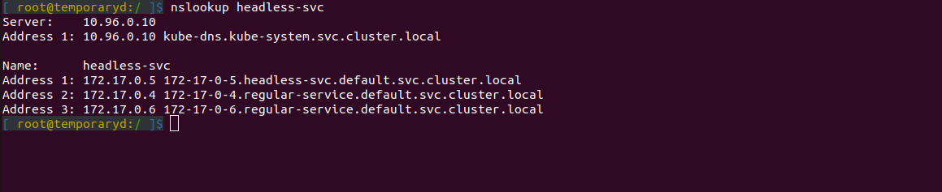

## **What are the restart policy in ur yaml file**

**Always** means that the container will be restarted even if it exited with a zero exit code (i.e. successfully). This is useful when you don't care why the container exited, you just want to make sure that it is always running (e.g. a web server). This is the default.

**OnFailure** means that the container will only be restarted if it exited with a non-zero exit code (i.e. something went wrong). This is useful when you want accomplish a certain task with the pod, and ensure that it completes successfully - if it doesn't it will be restarted until it does.

**Never** means that the container will not be restarted regardless of why it exited.

ReplicationController is only appropriate for pods with RestartPolicy = Always. Job is only appropriate for pods with RestartPolicy equal to OnFailure or Never.

## **Differnet pod statuses ? what does pod in pending state means ? what could me reasons**

Here are the possible values for phase:

**Pending** The Pod has been accepted by the Kubernetes system, but one or more of the Container images has not been created. This includes time before being scheduled as well as time spent downloading images over the network, which could take a while.

**Running** The Pod has been bound to a node, and all of the Containers have been created. At least one Container is still running, or is in the process of starting or restarting.

**Succeeded** All Containers in the Pod have terminated in success, and will not be restarted.

**Failed** All Containers in the Pod have terminated, and at least one Container has terminated in failure. That is, the Container either exited with non-zero status or was terminated by the system.

**Unknown** For some reason the state of the Pod could not be obtained, typically due to an error in communicating with the host of the Pod.

**Terminating** The pod is attempting to terminate; if a pod is stuck in this state something has happened that has prevented the process from succeeding (this could be a zombie process or, sometimes, problems with a mounted volume)

**ContainerCreating** Something is wrong with the configuration for a container required by this pod; may be a miss-typed container name or some network configuration issues

**Error** Kind of a catch-all; may not be particularly useful. If you see this a lot, it might be a good idea to check out [this doc](https://kubernetes.io/docs/tasks/debug-application-cluster/determine-reason-pod-failure/)

## **Pod is killed because of OOM ? how to resolve?**

The OOMKilled error, also indicated by exit code 137, means that a container or pod was terminated because they used more memory than allowed. OOM stands for “Out Of Memory”.

You can identify the error by running the kubectl get pods command—the pod status will appear as Terminating.

NAME READY STATUS RESTARTS AGE

my-pod-1 0/1 OOMKilled 0 3m12s

**OOMKilled: Common Causes**

The following table shows the common causes of this error and how to resolve it. However, note there are many more causes of OOMKilled errors, and many cases are difficult to diagnose and troubleshoot.

|  |  |
| --- | --- |
| **CAUSE** | **RESOLUTION** |
| Container memory limit was reached, and the application is experiencing higher load than normal | Increase memory limit in pod specifications |
| Container memory limit was reached, and application is experiencing a memory leak | Debug the application and resolve the memory leak |
| Node is overcommitted—this means the total memory used by pods is greater than node memory | Adjust memory requests (minimal threshold) and memory limits (maximal threshold) in your containers |

## **What is ImagePullBackOff error in Kubernetes**

By default Kubernetes looks in the public Docker registry to find images. If your image doesn't exist there it won't be able to pull it.

One issue that may cause an ImagePullBackOff especially if you are pulling from a private registry is if the pod is not configured with the imagePullSecret of the private registry.

An authentication error may cause an imagePullBackOff.

The issue arises when the image is not present on the cluster and k8s engine is going to pull the respective registry. k8s Engine enables 3 types of **ImagePullPolicy** mentioned :

1. **Always** : It always pull the image in container irrespective of changes in the image
2. **Never** : It will never pull the new image on the container
3. **IfNotPresent** : It will pull the new image in cluster if the image is not present.

Best Practices : It is always recommended to tag the new image in both docker file as well as k8s deployment file. So That it can pull the new image in container.

## **You have to pull some images from nexus , artifactory. How to set that up in k8s , how does k8 do authentication**

There are certain occasions during which you may want to publish your images into a private repository instead of a public repository like Dockerhub. The Nexus repository manager comes into the picture here as it can host all types of artifacts starting from jar, war, Docker images, Maven and npm packages, and more.

Setting up a Nexus Repository Manager.

How to create a Docker Registry under Nexus.

How to pull/push images from/to Nexus Docker Registry.

Setup artefactory to pull Docker image.

## **Can a pod have multiple containers ?**

Yes, we can have multiple containers in a pod.

## **Why distroless images are preffered while creating containers ?**

Distroless images are very small."Distroless" images contain only your application and its runtime dependencies. They do not contain package managers, shells or any other programs you would expect to find in a standard Linux distribution.

## **What are ephemeral containers ? where is it used**

Ephemeral containers are useful for interactive troubleshooting when kubectl exec is insufficient because a container has crashed or a container image doesn't include debugging utilities.

## **What does kubectl debug command do ?**

Debug Running Pods

how to debug Pods running (or crashing) on a Node.

You can add a debugging container using kubectl debug.

If you specify the -i/--interactive argument, kubectl will automatically attach to the console of the Ephemeral Container.

kubectl debug -it ephemeral-demo --image=busybox --target=ephemeral-demo

## **Scenario-based questions**

## **Why we need orchestration?**

Container orchestration can be used in any environment where you use containers. It can help you to deploy the same application across different environments without needing to redesign it. And microservices in containers make it easier to orchestrate services, including storage, networking, and security.

Use container orchestration to automate and manage tasks such as:

* Provisioning and deployment
* Configuration and scheduling
* Resource allocation
* Container availability
* Scaling or removing containers based on balancing workloads across your infrastructure
* Load balancing and traffic routing
* Monitoring container health
* Configuring applications based on the container in which they will run
* Keeping interactions between containers secure

## **Given 10 minutes , u need to deploy a 3 tier application. what do u use helm, deployment or adhoc commands?**

Adhoc commands will be faster to deploy.

## **My app is 3 tier , frontend ,backend and db . while from frontend i use ingress to expose a service , such as dns name when i hit that dns name in the browser , it says a error, traffic is unable to find the application ? what may be issue ? (issue regarding selectors)**

## **If u create deployment object for db, if it goes down , another fresh container will be up , how to retain data of old container**

## **Suppose i have a very huge 3 Gb file in my s3. My application container needs to download that file to do some stuffs. But i dont want to wget that file in my apps's docker image because my image size will increase exponentially .I just need to download that file and give it to my application container.In this scenario which container pattern should i consider and why ? (explain about init containers)**

## **My application container is talking to a redis caching server in aws. To connect to redis DB we write DB connection string in config map. But we dont want to do that . we need to application to connect to redis by using a proxy. Because we need to monitor our requests , see which of them are failing.**

## **Which container pattern to follow? app1 in a pod to talking with app2 in another pod via api endpoint /api/some-url. app1 sends some json data to app2 . But app2 can only accept xml data not json. what to do in this case considering we dont change anything to app(something about adapter containers)**

## **Replica set vs deployment.how to record the deployments, suppose u deployed 20 versions and want to roll back to 10th version**

## **I have a central logging system in ELK. I want fluentd to copy all the logs from containers to Elasticsearch but i dont want fluentd in my application docker image . How to do it ? (something about sidecar)**

## **You deployed 3 db instances using deployments who talk with each other , but each time a db pod goes down and new one comes up its name changes (coz deployments adds a hash value label to each pods which it creates). How to prevent that. how to follow standard naming conversion db1 , db2,db3 in ur pods (soemthing about stateful sets)**

## **If ur master node goes down what to do ? can we have 3 master nodes (something about quorum)**

## **You have 3 clusters in EKS , how to see pods running on each cluster , how to see clustus info from ur local machine (something about kube config file and using it with kubectl )**

## **You have deployed v1 of an app, now u deployed new version v2 of that app, but u dont want to expose v2 to customers , only to test engineers, how to do that? how did u make sure that application deployment was successful ?**

## **Issues faced in k8s ? how to resolve**

# **ElasticSearch**

**Overview Of ElasticSearch**

Elasticsearch is an open-source, RESTful, scalable, built on Apache Lucene library, document-based search engine. It stores retrieve and manage textual, numerical, geospatial, structured and unstructured data in the form of JSON documents using CRUD REST API or ingestion tools such as Logstash.

You can use Kibana, an open-source visualization tool, with Elasticsearch to visualize your data and build interactive dashboards for Analysis.

Elasticsearch, Apache Lucene search engine is a JSON document, which is indexed for faster searching. Due to indexing, user can search text from JSON documents within 10 seconds.

## **1) What is Elasticsearch?**

[Elasticsearch](https://www.elastic.co/what-is/elasticsearch) is an open-source distributed search and analysis engine built on Apache Lucene. With time, it has become a popular search engine that is commonly used for security intelligence, business analytics, operational intelligence, log analytics, and full-text search, and more.

## **2) What are the important features of Elasticsearch?**

Here are important features of Elasticsearch:

* Full-Text Search
* An open-source search server is written using Java
* Used to index all type of heterogeneous data
* Near Real-Time (NRT) search
* Has REST API web interface with JSON output
* Sharded, replicated searchable, JSON document store.
* Multi-language & Geolocation support
* Schema-free, REST & JSON based distributed document store

## **3) What is a cluster?**

A cluster is a group of nodes with the same cluster. name attribute which together holds data and provides joined indexing and search capabilities.

## **4) What is the ELK stack?**

In Elasticsearch, ELK Stack is a collection of three open-source products — Elasticsearch, Logstash, and Kibana.

**E stands for ElasticSearch:**used for storing logs.

**L means LogStash:**  used for both shipping, processing, and storing logs.

**K stands for Kibana:** a visualization tool.

## **5) What are the advantages of Elasticsearch?**

Some of the biggest advantages of Elasticsearch are as follows -

* Creates and stores schema-less data
* Manipulates data record by using Multi-document APIs
* Filtering and querying data for insights
* Based on Apache Lucene and provides RESTful API
* Helps you to scale vertically and horizontally

## **6) Explain ELK stack architecture?**

ELK stack allows users to fetch data from heterogeneous data sources and analyze, visualize it in real-time. ELK architecture consists of the following things -

**Logs:**First of all, the user identifies what server logs need to be analyzed

**Logstash:**Collect logs and events data. It also parses and transforms data.

**ElasticSearch:** The transformed data is then stored, searched, and indexed.

**Kibana:** Kibana uses Elasticsearch database to Explore, Visualize, and Share

## **7. What are the primary operations performed in a Document?**

Here, are important operation performed on documents:

* Indexing a document
* Fetching documents
* Updating documents
* Deleting documents

## **8. How can you delete an index in Elasticsearch?**

To delete an index in Elasticsearch, use the below command.

DELETE/index name

For eg. DELETE/website

## **9. What is a method to add a mapping in an Index?**

Elasticsearch lets you to create the mapping as per the data given by the user in the request body. Its bulk feature can be used to add more than one JSON object in the index.

For example, POST website /_bulk.

**10. What are the various ways of searching in Elasticsearch?**

We have different ways of searching in Elasticsearch:

* **Multi-index, Multitype search:** A user can search APIs that can be applied across several indices through a multi-index support system.
* **URI (uniform resource identifier) search:** A user can execute a search request using a URI by providing the requested parameters.
* **Request body search:** A search request needs to be executed by a search DSL.

## **11. Where is Elastic search stored?**

Elastic search results are stored in a distributed document in different directories. Also, a user can retrieve complex data structures that are serialized as JSON documents.

## **12. What are some of the configuration management tool supported by Elasticsearch**

Some important configuration management tool supported by Elasticsearch is as follows:

* **Puppet –** puppet-elastic search
* **Chef –** cookbook-elastic search
* **Ansible –** ansible-elastic search

## **13. What is Apache Lucene?**

Apache Lucene is an open-source information retrieval software library written in Java language.

## **14. What is NRT in Elasticsearch?**

NRT  stands for Near Real-Time Search. It is a near real-time search platform ie. there will be a slight latency (approx. one second) from indexing a document until it becomes searchable.

## **15. List out different commands available in Elasticsearch cat API?**

Command using with cat API are:

* Cat aliases, cat field data, cat allocation, cat count
* Cat health,  pending tasks, cat plugins, cat indices, cat master, cat recovery
* cat repositories, cat templates, cat snapshots

## **16. What do you mean by ingest node?**

Ingest node is used to pre-process the documents before the actual document indexing is done. It intercepts bulk and index requests and applies transformations to pass the documents back to the bulk API and index.

## **17. What is Single document APIs in Elasticsearch?**

* Get API
* Index API
* Delete API
* Update API

## **18. What do you mean by fuzzy query Elasticsearch?**

The fuzzy query returns the document that contains terms similar to the search terms. To find similar terms, a fuzzy query creates a set of possible variations of search terms within a specified edit distance. When a user searches for some terms using a fuzzy query, the system returns the most resembling terms for each expansion.

## **19. What is dynamic mapping in Elasticsearch?**

The process of automatic detection and addition of new fields is called dynamic mapping. Also, a user can customize the dynamic mapping rules to suit the requirement.

## **20. What is the explore API in Elasticsearch?**

The explore API helps in extracting and summarizing information about the documents and terms in the elastic search index. You can understand the behavior of this API by using the Graph UI to explore connections.

**21. What software is required to install Elasticsearch?**

The latest JDK or Java version 1.8.0 is a prerequisite to install Elasticsearch.

## **22. What is the step-by-step procedure to start an Elasticsearch server?**

Follow the given steps to start an elasticsearch server

* First of all open, the command prompt from the windows start menu
* Change the directory to the bin folder of the elasticsearch folder which was created after its installation
* Type/Elasticsearch.bat and press  enter to start the Elasticsearch server

By following these steps, Elasticsearch will start in CMD in the background. Further, open the browser and type http://localhost:9200, and press enter. This will show you the elasticsearch cluster name and meta value related to the database.

## **23. Can you name five companies that have an elastic search as their search engine and database for their application?**

* Uber
* Stack Overflow
* DigitalOcean
* Udemy
* Wikipedia
* Netflix

## **24. Can you explain SHARDS in Elasticsearch?**

When the number of documents increases, processing power goes down, and as a result responding to client requests gets delayed. In situations, indexed data is divided into small chunks called Shards, in order to improve the fetching of results during data search.

## **25. What is the syntax or code to add a Mapping in an Index?**

You can add a mapping in an index using the below syntax:

**Syntax:**

POST /_<index_name>/_type/_id

## Elasticsearch Interview Questions for Experienced

## **26. What is the syntax/code to retrieve a document by ID in Elasticsearch?**

GET API fetches the specified JSON document from an index.

**Syntax:**

GET <index_name>/_doc/<_id>

## **27. What are the various types of queries that Elasticsearch supports?**

Queries are categorized into two types: Full Text/Match Queries and Term-based Queries.

Text Queries include basic match, match phrase, common terms, query-string, multi-match, match phrase prefix, simple query string.

Term Queries include term exists, type, wildcard, regexp term set, range, prefix, ids, and fuzzy.

## **28. What is the difference between Term-based queries and Full-text queries?**

Full-text queries analyze the query string before executing it whereas term-level queries operate on the exact terms stored in the inverted index without analyzing.

The full-text queries are commonly used to run queries on full-text fields like the body of an email whereas term level queries are used for structured data like numbers, dates, and enums, rather than full-text fields.

## **29. What is aggregation in Elasticsearch?**

Aggregations help in collecting data through queries used in the search. Different types of aggregations are Sum and stats, Metrics, Average, Minimum, Maximum based on different purposes.

**30. What is the difference between Master node and Master eligible no4de?**

Master node functionality includes the creation of index/indices, monitor an account of nodes forming a cluster, deletion of index/indices. Whereas, Master eligible nodes are those nodes that get elected to become Master Node.

## **31. List out X-Pack commands?**

X-Pack commands are listed below:

* Certgen
* Migrate
* setup-passwords
* syskeygen
* users

## **32. How Migration API can be used as an Elasticsearch?**

Migration API is applied after the Elasticsearch version is upgraded with a newer version. With migration API, X-Pack indices get updated into a newer version of the Elasticsearch cluster.

## **33. Where and how Kibana will be useful in Elasticsearch?**

Kibana is part of the ELK Stack – log analysis solution. It is an open-source visualization tool used to analyze data available in graph formats such as pie bar, coordinate map, line, etc.

## **34. List out the use cases related to ELK log analytics?**

ELK log analytics use cases are listed below:

* Compliance
* Fraud detection
* Market Intelligence
* Risk management
* Security analysis
* E-commerce Search solution

## **35. How Elastic Stack Reporting is used?**

Reporting API is used to retrieve data in image PNG format, PDF format as well as spreadsheet CSV format that can be shared or saved as per requirement.

## **36. How Beats can be used with Elasticsearch?**

Beats is an open-source tool used to transfer data to Elasticsearch where data is processed before being viewed using Kibana. Data such as audit data, log files, window event logs, cloud data, and network traffic are transported.

## **37. What is the functionality of cat API in Elasticsearch?**

Cat API commands provide an overview of the Elasticsearch cluster including data related to aliases, allocation, indices, node attributes, etc. These cat commands use query string as a parameter that returns queried data from the JSON document.

## **38. What is the importance of installing X-Pack for Elasticsearch?**

X-Pack is an extension that gets installed with Elasticsearch. Some of the functionalities of X-Pack are security (Roles and User security, Role-based access, Privileges/Permissions), monitoring, alerting, reporting, and more.

## **39. What is an index in ElasticSearch?**

An index is similar to a table in relational databases. The difference is that relational databases would store actual values, which is optional in ElasticSearch. An index can store actual and/or analyzed values in an index.

## **40. What is a document in ElasticSearch?**

A document is similar to a row in relational databases. The difference is that each document in an index can have a different structure (fields), but should have the same data type for common fields.Each field can occur multiple times in a document with different data types. Fields can contain other documents too.

## **41. Does ElasticSearch have a schema?**

Yes, ElasticSeach can have mappings that can be used to enforce a schema on documents.

## **42. What is a document type in ElasticSearch?**

A document type can be seen as the document schema / [dynamic mapping definition](https://mindmajix.com/elasticsearch/dynamic-mapping-overview), which has the mapping of all the fields in the document along with its data types.

## **43. What is indexing in ElasticSearch?**

The process of storing data in an index is called indexing in ElasticSearch. Data in ElasticSearch can be divided into write-once and read-many segments. Whenever an update is attempted, a new version of the document is written to the index.

## **44. What is a node in ElasticSearch?**

Each instance of ElasticSearch is called a node. Multiple nodes can work in harmony to form an ElasticSearch Cluster.

## **45. What is a shard in ElasticSearch?**

Due to resource limitations like RAM, CPU, etc, for scale-out, applications need to employ multiple instances of ElasticSearch on separate machines. Data in an index can be divided into multiple partitions, each handled by a separate node (instance) of ElasticSearch. Each such partition is called a shard. By default, an ElasticSearch index has 5 shards.

## **46. What is a replica in ElasticSearch?**

Each shard in ElasticSearch has 2 copies of the shard. These copies are called replicas. They serve the purpose of high availability and fault tolerance.

## **47. What is an Analyzer in ElasticSearch?**

While indexing data in ElasticSearch, data is transformed internally by the Analyzer defined for the index, and then indexed. An analyzer is built of tokenizer and filters. Following types of Analyzers are available in ElasticSearch 1.10.

1. Standard Analyzer
2. Simple Analyzer
3. WhiteSpace Analyzer
4. Stop Analyzer
5. Keyword Analyzer
6. Pattern Analyzer
7. Language Analyzer
8. Snowball Analyzer
9. Custom Analyzer

## **48. What is a Tokenizer in ElasticSearch?**

A Tokenizer breakdown fields values of a document into a stream, and inverted indexes are created and updated using these values, and these stream of values are stored in the document.

## **49. What is a Filter in ElasticSearch?**

A Filter is all about implementing some conditions in the query to reduce the matching result set. When we use a query in Elasticsearch, the query computes a relevance score for matching the documents. But in some situations, we don’t need relevance scores when the document falls in the range of two provided timestamps.

So, for this yes/no criteria, we use Filters. We use Filters for matching particular criteria, and they are cacheable to allow faster execution. The Token filters receive a flow of tokens from a tokenizer, and they can change, add, and delete the tokens.

## **50. Please explain Elasticsearch Cluster?**

**Answer:** It is a group of one or more node instances connected responsible for the distribution of tasks, searching and indexing across all the nodes.

**Node and Shards:**

[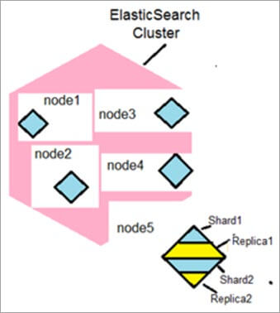](https://www.softwaretestinghelp.com/wp-content/qa/uploads/2020/03/1.jpg)

## **51. What is a Node in Elasticsearch?**

**Answer:** A node is an instance of Elasticsearch. Different node types are Data nodes, Master nodes, Client nodes and Ingest nodes.

**These are explained as follows:**

* **Data nodes** hold data and perform an operation such as CRUD (Create/Read/Update/Delete), search and aggregations on data.
* **Master nodes** help in configuration and management to add and remove nodes across the cluster.
* **Client nodes** send cluster requests to the master node and data-related requests to data nodes,
* **Ingest nodes** for pre-processing documents before indexing.

## **52. What is an index in an Elasticsearch cluster?**

**Answer:** An Elasticsearch cluster can contain multiple indices, which are database as compared with a relational database, these indices contain multiple types (tables). The types (tables) contain multiple Documents (records/rows) and these documents contain Properties (columns).

## **53. What is a Type in an Elastic search?**

**Answer:** Type, here is a table in the relational database. These types (tables) hold multiple Documents (rows), and each document has Properties (columns).

[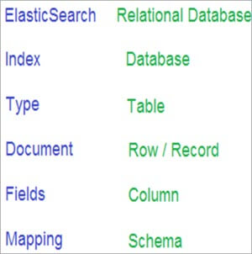](https://www.softwaretestinghelp.com/wp-content/qa/uploads/2020/03/2.jpg)